FHIR at Scale Taskforce (FAST)

Proposed Solutions Working Document: Scaling Architecture V2

Table of Contents
Revision History 2
Outstanding Work……………………………………………………………………………………………………………………………………2
Introduction & Background 3
Current State Overview 4
Scaling Architecture Considerations……………………………………………….……………………………………….……………...4
Technical Barriers ……………………………………………………………………………………………………………………………………6
Problems to be Solved 6
Recommended Future State & Intermediate Steps 7
Proposed Scaling Architecture Solution Overview 8
Overview & Description……………………………………………………………………………………………………………………………8
Supporting Diagrams & Flows 9
In Scope 11
Out of Scope 12
Assumptions 13
Pre-Conditions 13
Post-Conditions 13
Solution Component Analysis 14
Key Impacts to Timeline & Costs 14

Items for other solution documents

Revision History
Version | Date | Author | Description of Change
0.5 | 7/9/19 | Robert Dieterle | Initial draft
0.9 | 10/19/19 | Brandon Neiswender | Update prior to TLC
2.0 | 3/5/2020 | Robert Dieterle | Incorporation of all new content from TLC preparation and TLC curated feedback
2.1 | 3/5/2020 | Robert Dieterle | Updated based on DVS TT review
2.2 | 3/11/2020 | Patrick Murta | Partial Review of Document
2.3 | 3/18/2020 | Robert Dieterle | Draft Final

Proposed Solution Status: Working on refinements
- Determine scope of requirements
- Explore standards for intermediary to intermediary exchanges
- Clarify exchange services that must be supported
- Detail the specific availability and performance requirements
- Determine the best method for establishing requirements

Reference Documentation
- FAST-Technical Barriers
- FAST-Regulatory Barriers
- FAST-UC-Endpoint_Discovery-Core_Capability-CC1
- FAST-UC-Authentication_and_Authorization-Core_Capability-CC2
- FAST-UC-Version_Identification-Core_Capability-CC3
- FAST-UC-Patient_and_Provider_Identity_Management-Core_Capability-CC4
- FAST-UC-Patient_Information_Request_Plan_to_Provider
- FAST-UC-Patient_Information_Request_Provider_to_Plan
- FAST-UC-Documentation_Templates_and_Rules_Processing
- FAST-UC-Event_Based_Alerts
- FAST-UC-Quality_Reporting
- FAST-UC-Push_Patient_Information
- FAST-UC-Shared_Care_Planning
- FAST-UC-Consults_and_Referrals
- FAST-UC-Care_Team_Coordination
- FAST-UC-Scheduling

Introduction & Background
The purpose of the FHIR at Scale Taskforce (FAST) is to augment and support recent HL7® Fast Healthcare Interoperability Resources (FHIR®) efforts focused on ecosystem issues that, if mitigated, can accelerate adoption. A number of regulatory and technical barriers, as well as required core capabilities, have been identified related to Directory, Versioning and Scale. This document will outline proposed solutions to address these issues and capabilities.

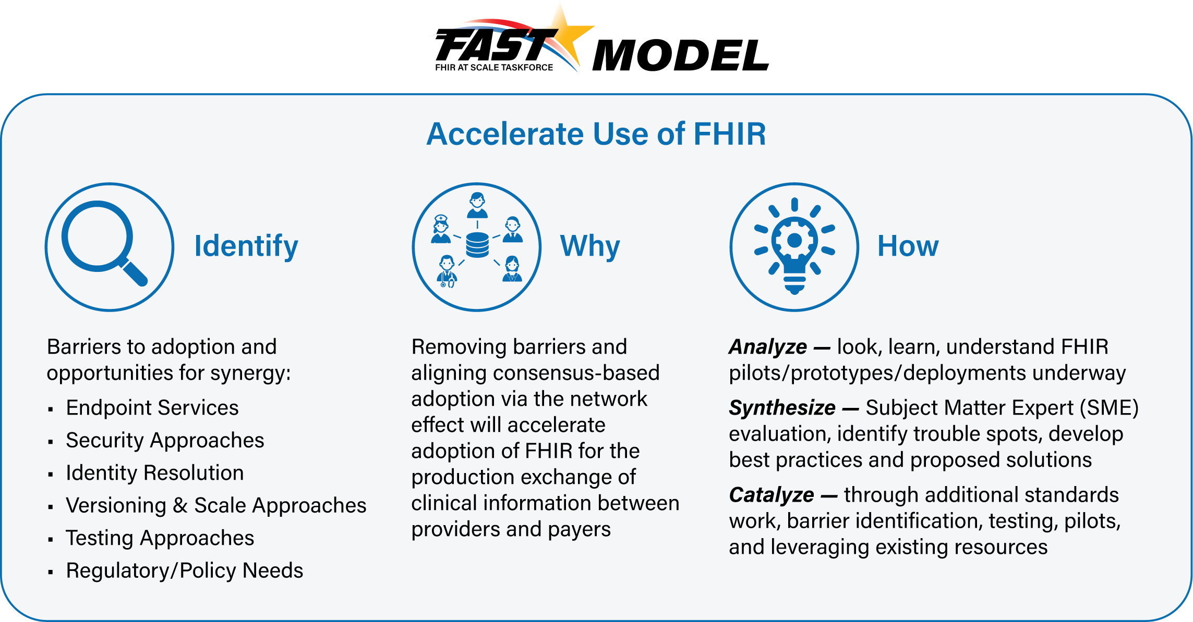

Background (why Intermediaries are part of scaling as well as point-to-point)

Current State Overview
EXPERIENCE
- Limited implementation of FHIR based solutions operating at scale to support anticipated healthcare needs
- Intermediaries such as HIEs, clearinghouses, and other health information networks routinely facilitate data exchange across healthcare organizations. However, these intermediaries typically have limited experience conducting FHIR transactions; a majority of FHIR transactions today are point-to-point
- Limited support for using FHIR for messaging relevant information to interested parties, especially through intermediaries
REGULATORY
- Inconsistent legislative, regulatory, and policy environments (delete)
- Current issues related to privacy (e.g. minimum necessary) create barriers to national adoption of FHIR at scale
EXISTING SOLUTIONS (harmonize or better define terms – scaling solution, exchange models, interoperability mode, …)
- Current scaling solutions may not handle anticipated volume and predictable response time requirements (add)
- Multiple competing, potentially incompatible, solutions for scaling (HIEs, Clearinghouses, Trust Framework based exchanges)
- Determine if there is an impact with multiple intermediaries and on performance, scaling, and synchronous transactions
STANDARDS
- Lack of experience using FHIR to handle synchronous transactions while maintaining state via intermediaries
- Impact of competing interoperability models on access to data – e.g. whether endpoints are discoverable and accessible depends on the model used

Definitions:
Intermediary – any entity that participates in a FHIR based transaction other than the ultimate requester and responder (e.g. a business associate, Clearinghouse, HIE) (does this include translation into and out of other “standards” (e.g. V2, X12))

Scaling Architecture (e.g. intermediaries) Considerations
- Intermediaries must support the following FAST solutions
  - Endpoint discovery (e.g. directory)
  - Determine endpoint services and version support
  - Version management
  - Authentication and authorization

  - Security (e.g. same version of TLS)
  - Meta data for routing
  - Certification and Testing of compliance with FAST Standards
- Intermediaries must provide
  - connectivity to other intermediaries as required to ensure transactions can be supported between any entity connected to the intermediary and any intended recipient (consider the email equivalent)
  - Expected performance regardless of volume,
  - real-time response processing regardless of synchronous or asynchronous transaction modalities,
  - transactions without endpoint awareness of the underlying integration technologies
  - consistent error handling

  - support for applicable laws and related compliance (HIPAA, etc)

- Intermediaries should

  - Support applicable commonly supported Operations (e.g. Subscription, Messaging, Operations, …)

- Intermediaries may provide one or more of the following services (not exhaustive)
  - Patient matching
  - Version translations
  - Terminology translation
  - Transformation services
  - Validation services
  - OAuth services include scope management
  - Search capabilities
  - Optional elements
  - Consent services
  - Value add services (e.g., directory, analytics, quality reporting, public health registries)

Technical Barriers
- Multiple Interoperability Models: Hybrid exchange models (e.g., spoke/hub, direct connections/point-to-point, and regionally interconnected spoke/hub) create challenges in adopting standards for scaling FHIR and implementing consistent approaches such as authentication, endpoint detection, standards for matching, and end-to-end performance.
- Lack of Predictability and Response Times: Scaling real-time transactions requires infrastructure that may not be currently available through existing intermediaries. The lack of predictable end-to-end response time limits specific use cases where providers require a response prior to proceeding with diagnosis or treatment. Some intermediary models do not support end-to-end synchronous real-time applications. The industry will need to adopt synchronous FHIR front-end interfaces and migrate to near real-time back-end solutions.
- Anticipating Increase in FHIR-Based Volume: There are currently no models to predict the volume of FHIR-based transactions as FHIR is adopted broadly in the ecosystem. This may lead to unpredictable scaling and performance challenges. Adopting real-time (e.g. RESTful) solutions to solve real-time synchronous FHIR scalability is required by the industry. Payers and providers need to increase services (and related perception of reliability) to support significant increase in real-time transactions embedded in the clinical workflow.
- Data Blocking: The industry is moving to a utilization model for access to patient data using FHIR APIs. As FHIR can make information readily available within an encounter clinical workflow and through multiple mobile, portable and wearable devices in real time, the volume of transactions will increase exponentially. If there is limited access to this information, or the cost per access/transaction is too high, it could constitute data blocking.

Problems to be Solved
The following technical and regulatory barriers to Scaling Architectures identified by the FAST team were found to impede the adoption of FHIR at scale and will be the basis for FAST-proposed scaling architecture solutions:
- Multiple Current Interoperability Models: Hybrid exchange models (e.g., spoke/hub, direct connections/point-to-point, and regionally interconnected spoke/hub) create challenges in adopting standards for scaling FHIR and implementing consistent approaches such as authentication, endpoint detection, standards for matching, and end-to-end performance.
- Lack of Predictability and Response Times: Scaling real-time transactions requires infrastructure that may not be currently available through existing intermediaries. The lack of predictable end-to-end response time limits specific use cases where providers require a response prior to proceeding with diagnosis or treatment. Some intermediary models do not support end-to-end synchronous real-time applications. The industry will need to adopt synchronous FHIR front-end interfaces and migrate to near real-time backend solutions.
- Anticipating Increase in FHIR-Based Volume: There are currently no models to predict the volume of FHIR-based transactions as FHIR is adopted broadly in the ecosystem. This may lead to unpredictable scaling and performance challenges. Adopting real-time (RESTful) solutions to solve real-time synchronous FHIR scalability is required by the industry. Payers and providers need to increase services (and related perception of reliability) to support significant increase in real-time transactions embedded in the clinical workflow.
- Data Blocking: The industry is moving to a utilization model for access to patient data using FHIR APIs. As FHIR makes information readily available within an encounter clinical workflow and through multiple mobile, portable and wearable devices in real time, the volume of transactions will increase exponentially. If there is limited access to this information, or the cost per access/transaction is too high, this will constitute a new form of data blocking. The CMS NPRM is working to address both of these issues.
Problems that may be solved by intermediaries
- Record Location: Lack of a comprehensive national patient record locator service limits the ability to discover all records for a given patient in a distributed service environment. There is no current process for universally discovering endpoints either in general or for a specific patient.
- Patient Matching: Without consistent identifiers, Patient matching will rely on the quality of demographic data stored at the requestor / responder level. Often demographics are not consistent across organizations. There is a dependency on Patient Identity Tiger Team solution.
- Data Quality: De-duplication and aggregation will be the responsibility of the receiver. Services that can map data elements from disparate organizations and serve them up in a single usable data set are imperative. Appropriate coding and data integrity will be the responsibility of the sender.
- Patient Privacy: Consent decisions are captured at every requester / responder organization. Patients have no way to understand how their data flows through the new FHIR ecosystem.

Recommended Future State & Intermediate Steps

Future State
- Support a mixed model (point to point, gateways, and via intermediaries)
- Established minimum availability and performance requirements for any scale architecture (including multiple intermediaries)
- Requirement to support synchronous transactions (e.g. maintaining “state” across intermediaries)
- Intermediaries (regardless of the number) need to support, transparently, all FHIR workflow operations (including subscription)
- Intermediaries capable of handling volume, response time, and routing to all available end points
- Consistent support of metadata for “routing” through multiple intermediaries

Intermediate Goals
- Establish voluntary performance standards for intermediary support for FHIR exchanges
- Define and test an appropriate intermediary – intermediary exchange solution
- Test performance for intermediaries

Additional Considerations from the TLC Feedback

- Add comments on impact of TEFCA and role as an intermediary (as an example of an intermediaries) (examples: carequality, HIE) try to craft short statement
- Definition of Intermediary: One or more entities in the middle between the originator of the transaction and the ultimate destination. The intermediary is responsible for ensuring delivery of any request and any response. The initial intermediary always has a formal FHIR endpoint -- that may or may not be true of others in the chain. we consider HIEs to be one form of an intermediary -- other exist such as Clearinghouses and technical switches. We have no preconceived preferences for the type of intermediary. Some “intermediaries” can act as an endpoint, if they have access to the data (add back into definition)
- Services of an Intermediary: We are assuming that the intermediary will provide services (e.g. translation, routing) and not just act as a point-point connection. The primary requirement is that there is a predictable round-trip message time to enable "real-time" transactions with a human waiting for the response. Intermediaries may provide value added services to deal with trust frameworks, on-boarding, authentication and authorization, translations, monitoring, integration with other information sources
- Intent is to make performance standards an industry requirement, the question is the path and enforcement (add recommendations)
- Clarify that we are not “planning a transition from one model to another, but rather setting requirements for current and future players to be part of the FHIR scaling ecosystem.
- Do we need to add any specific comments regarding the applicability of the solution to public health?

Deployment (placeholder for V3)

- Add section to this document for deployment considerations
- Add comments on operational support, reliability, backup, rollover/failover, etc.
- Solution must be deployable and supportable

Proposed Scaling Architecture Solution Overview
Through use case development and barrier definition, the FAST team has determined that the following core capabilities related to Scaling Architecture need to be satisfied to accelerate FHIR adoption at scale:
Core Capability | Proposed Solution(s)
- Scaling Architecture | - Ability to utilize intermediaries to reduce the complexity of connecting with a large number of endpoints and managing authentication and authorization with each  - Intermediaries will have predictable performance required to meet real-time exchanges  - Intermediaries may provide value added services to assist in patient matching, version translation, etc.

Overview & Description

The goal is for ubiquitous access to permitted endpoint regardless of the architecture (point-to-point), intermediary, multiple intermediaries). The performance reliability and availability expectations should be consistent with those for real-time point-to-point connections and in any case must be acceptable for real-time information exchange where there is a provider / patient waiting for the response before clinical workflow can continue. The intermediaries will justify their added cost by providing value-added services that minimize the overall cost associated with FHIR transactions. Such value-added services may include endpoint resolution, patient matching, record locator, version translation, error handling. The basic services and the value-add services should allow the application user, system, and API endpoint to see the rest of the world as a consistent set of endpoints.

Proposed Solution Overview
The FAST team has determined that the following core capabilities related to Scaling Architectures need to be satisfied as we propose a set of solutions that will accelerate FHIR adoption at scale:

Mixed model environment with full connectivity(future state)
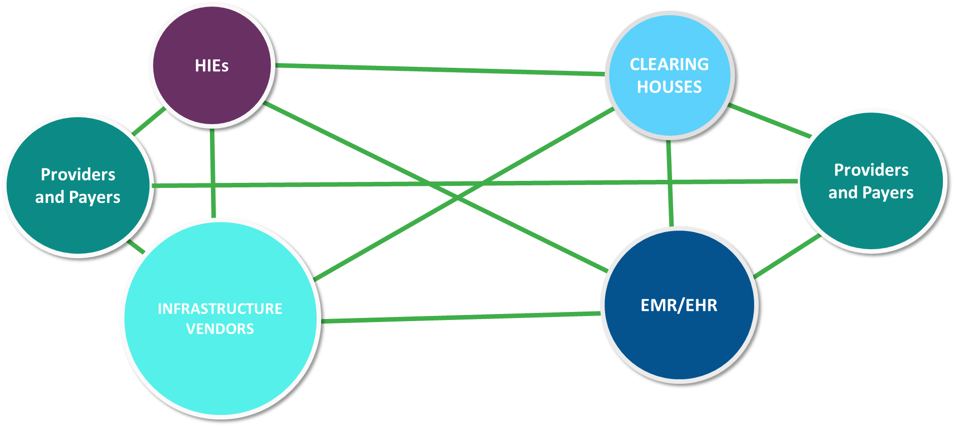
Exchange model showing: 1) Point to Pont, 2) one intermediary, and 3) two intermediaries
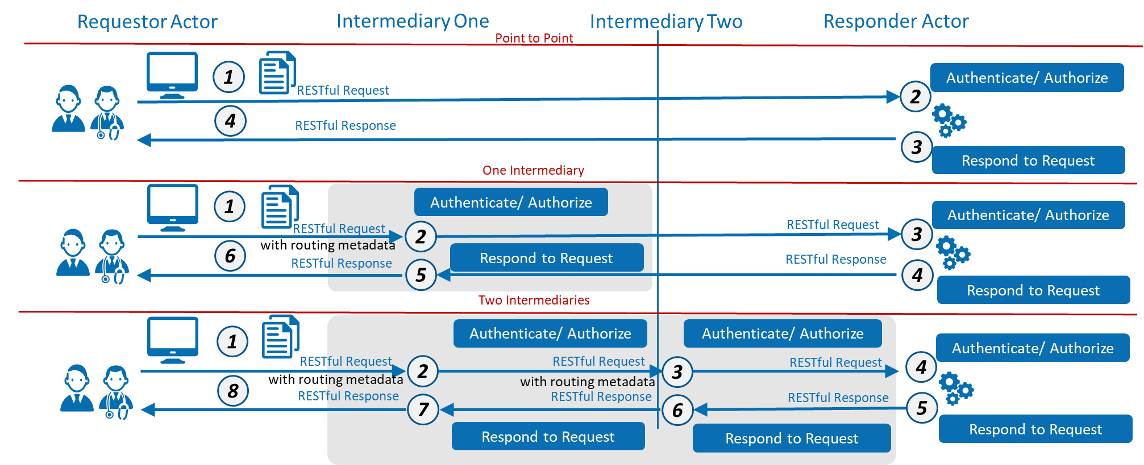
The above diagram and interaction descriptions assume that the endpoint has already been determined.

Point to Point

ID | Description | Notes
1 | Requester uses endpoint directory information to connect to the Responder endpoint and send request
2 | Responder authenticates requestor
3 | Responder process request and returns results
4 | Requestor receives response from Responder

One Intermediary

ID | Description | Notes
1 | Requester uses endpoint directory information to connect to the Intermediary endpoint and send request including routing information
2 | Intermediary, using routing information connects to Responder endpoint and sends request
3 | Responder authenticates Requestor/Intermediary
4 | Responder process request and returns results to Intermediary
5 | Intermediary returns response to Requester
6 | Requestor receives response from intermediary

Two Intermediaries

ID | Description | Notes
1 | Requester uses directory endpoint information to connect to the Intermediary endpoint and send request including routing information
2 | Intermediary using endpoint directory information connects to the Intermediary endpoint supporting the Responder and forwards the request including routing information
3 | Intermediary, using routing information connects to Responder endpoint and sends request Responder
4 | Responder authenticates requestor/intermediary
5 | Responder process request and returns results to intermediary
6 | Responder Intermediary sends response to Requester Intermediary
7 | Intermediary returns response to Requester
8 | Requestor receives response from intermediary

In Scope
- Interoperability models with, point-to- point, single and multiple intermediaries
- Issues related to RESTful exchanges via intermediaries
- Planning for future volume increase
- Establishing SLA and Performance requirements for intermediaries and endpoints
- Establishing functionality of endpoints and the method of declaration

Out of Scope
- Identification, security, directory, versioning, metadata, certification or piloting
- Ownership models
- Trust frameworks
- Legal agreements
- Non-RESTful exchange methods (e.g. Direct)
- Technical Implementation

Assumptions
- Standards exist for intermediary – intermediary exchange
- Standards exist for Point to Point exchange (including where the intermediary is one end)
- FHIR transactions include both FHIR payload and the RESTful operations for exchange of the payload
- Identification, security, directory, versioning, metadata, and certification are defined and supported by all participants
- Service level agreements/statements are established and enforced
- Value added service justify the additional cost of using intermediaries
- Value added services support data quality standards (e.g. version translation)

Pre-Conditions
- Endpoints must be available to support FHIR transactions
- Endpoints are compliant with established FHIR standards (and indicated conformance)
- Endpoints (including intermediaries) have passed testing and certification

Post Conditions
- The FHIR transaction environment works at scale with no significant issues.
- Use of intermediaries is transparent to the end-user

Solution Component Analysis
The following new components or modifications to existing components are required to address current gaps and support the proposed solution:

ID | Component | New/ Existing | Proposed Build/Modifications | Owner
1 | Standard for Intermediary to intermediary exchange | New | Defined by SDO | FAST with HL7
2 | Standard for intermediary performance (SLA) | New | Defined by FAST | FAST
3 | Testing for conformance with exchange and SLAs | New | Defined by FAST, performed by industry testing and certification entity | FAST, Industry
4 | FHIR enabled Intermediary | New/Existing | Build by interested industry parties | Industry

Key Impacts to Timeline & Cost
<FAST team to identify the key components listed above that will have the most impact on timeline and cost. Include rough order of magnitude for level of effort and comment on any known blockers or dependencies.>
ID | Component | Level of Effort | Comments
1 | Standard for Intermediary to intermediary exchange | Medium
2 | Standard for intermediary performance (SLA) | Small
3 | Testing for conformance with exchange and SLAs | Medium-Large
4 | FHIR enabled Intermediary | Large-Jumbo

