P2 FHIR Task Force

Use Case – Version Identification

Version 2.00
Table of Contents
P2 FHIR Task Force 1
Use Case – Version Identification 1
Revision History 2
Introduction & Background 3
Overview & Description 4
Variations and Extensions 4
In Scope: 4
Assumptions: 4
Primary Actors 4
Supporting Actors 4
Stakeholders and Interests 5
Pre-Conditions 5
Post Conditions 5
Requirements & Main Success Scenario 6
Supporting Diagrams & Flows 6
Special Requirements & Considerations 7
Issues 7
Frequency: 7

Revision History
Version | Date | Author | Description of change
1.00 | 9/30/2018 | Chris Johnson  Alex Kontur  Christol Green | Initial Version
2.00 | 10/18/2018 | Chris Johnson | Made changes to list as a barrier use case, add new drawings in the “Supporting Diagrams & Flows” segment.

Introduction & Background

Use Case: Versioning

ID: UC – Core Capability Versioning

The purpose of the P2 FHIR Task Force is to augment and support recent FHIR efforts focused on ecosystem issues that, if mitigated, can accelerate adoption. One of the focus areas identified is the ability to identify and validate endpoints for requestors and responders.
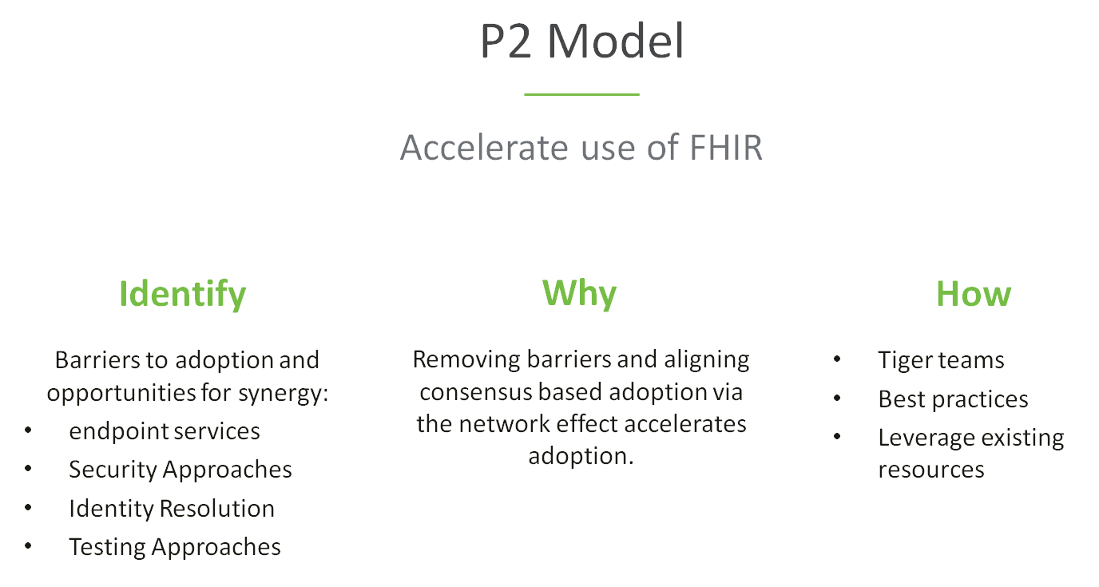

The P2 use case model is unique in that it describes ecosystem needs as opposed to specific functional needs. Use cases for P2 are derived in one of 3 approaches as described in the graphic below.

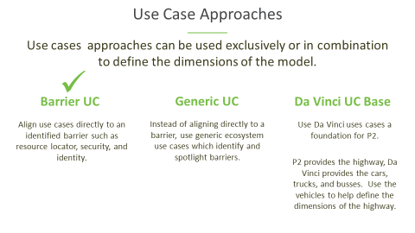

This use case focuses on the ability of the requestor to discover if an endpoint is compatible with their system. The focus is not on the clinical or administrative functionality of the use case but instead in ensuring that the ecosystem supports an efficient and scalable model.

Overview & Description
The purpose of the core use cases is to define requirements for actions/activities that are common across many or all use cases. These include but may not be limited to: endpoint determination, version identification, authentication, authorization, and patient matching. This use case focuses on identification of the FHIR versions available at the responder’s system.

Variations and Extensions

No variations or extensions

In Scope:

- Identification of FHIR versions for request and response from provider/payer/plan.

Out of Scope:

- Requirement or construction of any specific architecture.
- Authentication and Authorization (That is covered under core capability for authentication and authorization)
- Requester’s internal processing required to identify the FHIR version
- Requester’s internal processing to assess compatibility with the versions provided by the responder
- Responder’s internal processing to provide the FHIR version
- Discovery of non-FHIR endpoints

Assumptions:
There exists:
- A requester can find FHIR versions from remote systems (e.g. endpoint or directory service or other mechanism)
- The definition of “FHIR version” for this document could be:
  - Identification of the version of the FHIR server
  - Identification of the version of the individual FHIR, bundle, profile, resource or any other FHIR construct.

Primary Actors

- Endpoint Requestor – Provider’s or Payer’s clinical system that needs to discover a valid endpoint for a FHIR based information exchange.
- Endpoint Directory - Provider’s or Payer’s clinical system that contains endpoints which can be responded thru a FHIR based resource.

Supporting Actors

- E H R
- Provider/Payer systems
- Endpoint resolution capability

Stakeholders and Interests
- Requestor - Has interest in identifying a valid FHIR endpoint to request/access data from a FHIR endpoint.
- Responder - Has interest in identifying a valid FHIR endpoint to provide response/access to data against a request.

Pre-Conditions
- The process is triggered by the requestor
- Requestor has a need to connect to a FHIR endpoint
- Responder has a need to provide access to the FHIR endpoint or denial based on authentication / validation of requestor.
- The requestor has adopted the FHIR model, including those arising from the P2 initiative
- The responder has the adopted the FHIR model, including those arising from the P2 initiative

Post Conditions
- Requestor has confirmed the FHIR version available from the endpoint discovery or endpoint server handshake.
- Requestor has established a secure connection and been authorized to a responder’s FHIR endpoint
- Responder has authenticated and authorized a secure connection to the requested FHIR endpoint or has denied access to the FHIR endpoint
- In the event of an error during endpoint discovery, authentication and authorization, the information returned by the responder is descriptive enough to not leave the requestor system in a state not knowing the root cause of the error

Failure end condition:

The post conditions defined above are not met.

Trigger:

The process is triggered by the requestor (Provider/Payer clinical systems)

Requirements & Main Success Scenario

Primary Feature: As a transaction initiator (requestor), I need my system to be able to determine where the intended recipients’ endpoint is without configuring the endpoints manually. Responder should be able to provide access to endpoint or appropriate response so that requestor’s workflow continues.

  - As a requestor, I need my system to be able to locate a FHIR endpoint for a service
  - As a requestor, I need my system to be able to have access to valid and current endpoint.
  - As a requestor, I need that endpoint directory should be able to respond with information indicating that such an endpoint does or does not exist
  - As a responder, I should be should be able to give a good error response when the endpoint service is not available and workflow should be able to continue with existing, non-automated processes
  - As a responder, the endpoint directory should know the normal availability for a specific endpoint service.
  - As a responder, I should be able to update the endpoint directory to denote when the endpoint and/or service is down during unscheduled times such a production issue (like a switch saying that endpoint service is not processing at this time)
  - As a responder, the endpoint directory should ensure that requesting system has appropriate credentials/authorization to access the endpoint service

Supporting Diagrams & Flows
Actor’s actions, relationships, & flows, sequence diagram, activity diagram in swim lanes, alternate flows.

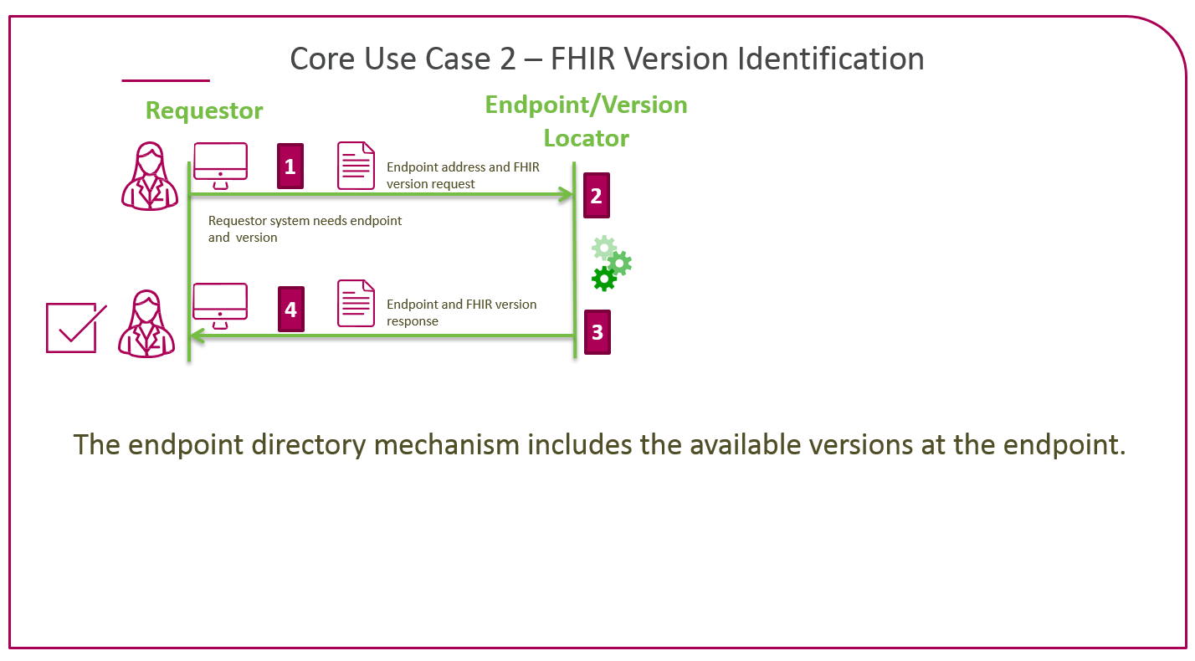
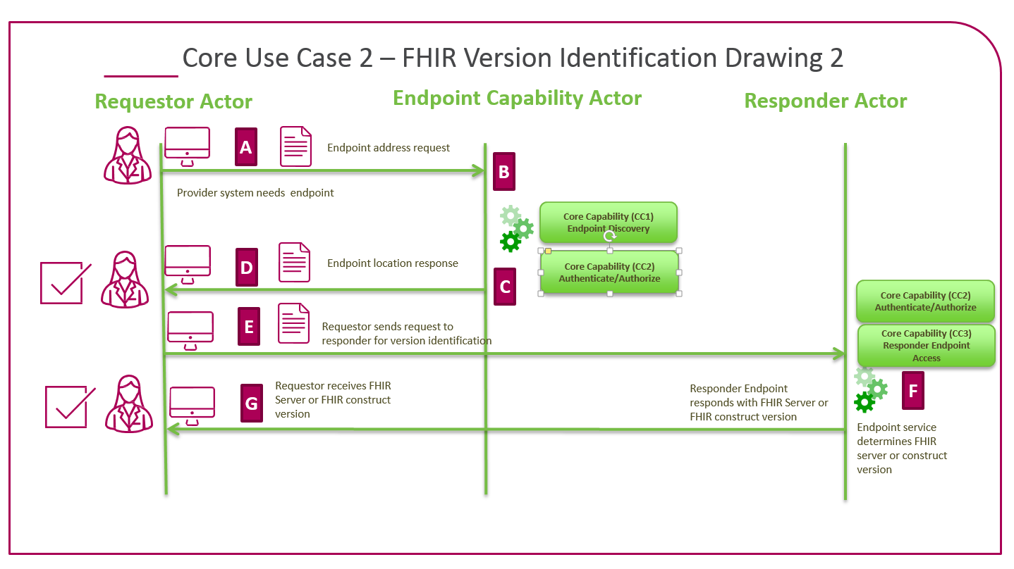

Special Requirements & Considerations

Issues

Frequency:
Depending on how this is architected, it would be with each conversation, each endpoint discovery, or once a connection is made to an service endpoint.

