FHIR at Scale Taskforce (FAST)

Use Case — Version Identification

Table of Contents
Revision History 2
Introduction & Background 3
Overview & Description 5
Scenarios 5
In Scope 5
Out of Scope 5
Assumptions 5
Primary Actors 6
Supporting Actors 6
Stakeholders & Interests 6
Pre-Conditions 6
Post Conditions 6
Failure End Condition 7
Trigger 7
Scenarios 7
Frequency 8

Revision History
Version | Date | Author | Description of Change
1.0 |  | Christol Green  Chris Johnson  Alex Kontur | Initial published version of use case

Reference Documentation
FAST Technical Barriers
FAST-UC-Endpoint_Discovery-Core_Capability-CC1

Introduction & Background
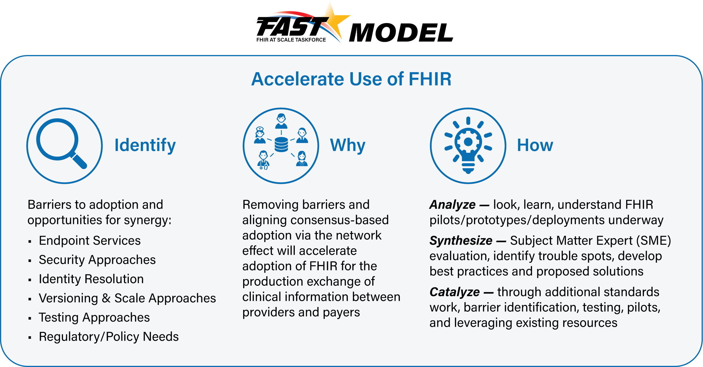
The purpose of the FHIR at Scale Taskforce (FAST) is to augment and support recent HL7® Fast Healthcare Interoperability Resources (FHIR®) efforts focused on ecosystem issues that, if mitigated, can accelerate adoption.

The FAST use case model is unique in that it describes ecosystem needs as opposed to specific functional needs. Use cases for FAST are derived in one of 3 approaches as described in the graphic below.
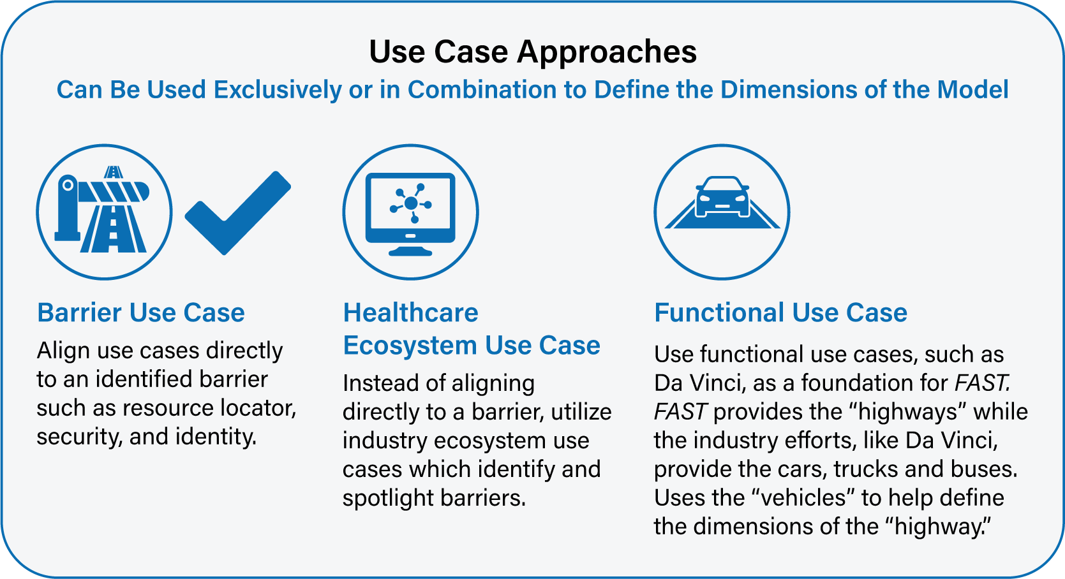

This document describes one of the core capabilities that are common across all FAST use cases, Version Identification. The purpose of the core use cases is to define requirements for actions/activities that are common across many or all use cases. These include but may not be limited to:
- Endpoint Discovery & Validation: the ability to identify and validate endpoints for requestors and responders (FAST-UC-Endpoint_Discovery-Core_Capability-CC1)
- Authentication & Authorization: the ability to authenticate and authorize each endpoint (FAST-UC-Authentication_and_Authorization-Core_Capability-CC2)
- Version Identification: the ability to discover if an endpoint is compatible with the requestor’s system (FAST-UC-Version_Identification-Core_Capability-CC3)
- Patient & Provider Identity Management: the ability to rely on trusted patient mastering and identity management (FAST-UC-Patient_and_Provider_Identity_Management-Core_Capability-CC4)
These core capabilities lay the groundwork for additional FAST use cases, which depend upon these requirements being addressed in order to be successful.
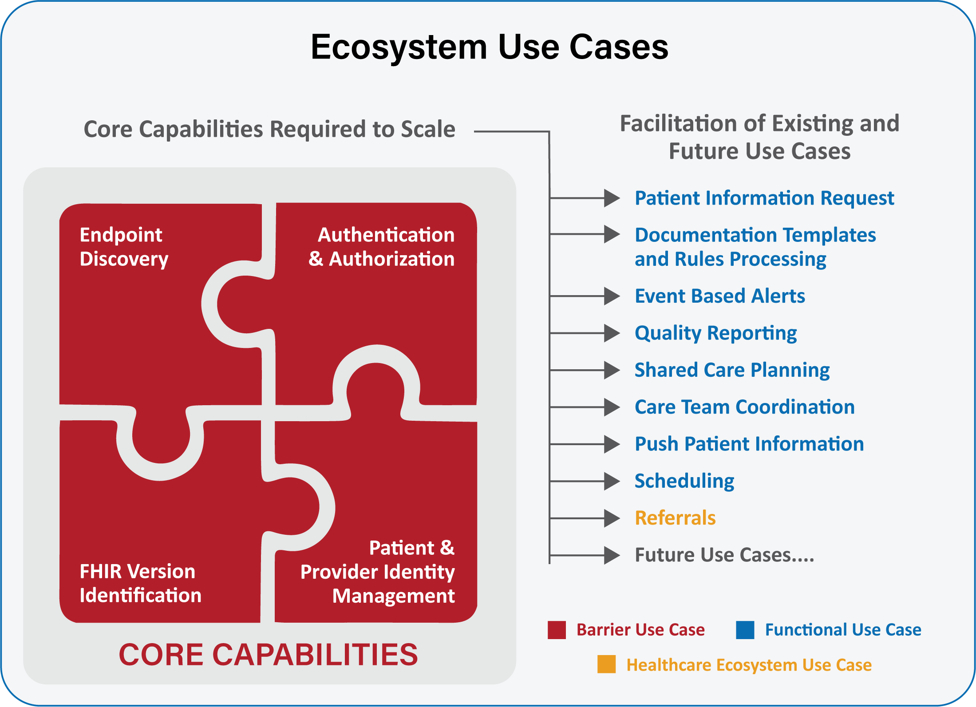

The focus is not on the clinical or administrative functionality of each use case (which is covered under other use cases such as those in the Da Vinci initiative) but is instead on the ecosystem which supports those specific functional use cases to ensure an efficient and scalable model.

Overview & Description
This use case focuses on the ability of requestors to discover if an endpoint is compatible with their system, by identifying the FHIR versions available at the responder’s system.

Scenarios
No additional scenarios.

In Scope
- Identification of FHIR versions for request and response from provider/payer/plan

Out of Scope
- Requirement or construction of any specific architecture
- Authentication and Authorization (That is covered under core capability for authentication and authorization)
- Requester’s internal processing required to identify the FHIR version
- Requester’s internal processing to assess compatibility with the versions provided by the responder
- Responder’s internal processing to provide the FHIR version
- Discovery of non-FHIR endpoints

Assumptions
- There exists:
  - A requester can find FHIR versions from remote systems (eg, endpoint or directory service or other mechanism)
  - The definition of “FHIR version” for this document could be:
    - Identification of the version of the FHIR server
    - Identification of the version of the individual FHIR, bundle, profile, resource, or any other FHIR construct

Primary Actors
- Endpoint Requestor – Provider’s or Payer’s clinical system that needs to discover a valid endpoint for a FHIR-based information exchange
- Endpoint Directory – Provider’s or Payer’s clinical system that contains endpoints which can be responded thru a FHIR-based resource

Supporting Actors
- EHR
- Provider/Payer systems
- Endpoint resolution capability

Stakeholders & Interests
- Requestor – Has interest in identifying a valid FHIR endpoint to request/access data from a FHIR endpoint
- Responder – Has interest in identifying a valid FHIR endpoint to provide response/access to data against a request

Pre-Conditions
- The process is triggered by the requestor
- Requestor has a need to connect to a FHIR endpoint
- Responder has a need to provide access to the FHIR endpoint or denial based on authentication/ validation of requestor
- The requestor has adopted the FHIR model, including those arising from the FAST initiative
- The responder has the adopted the FHIR model, including those arising from the FAST initiative

Post Conditions
- Requestor has confirmed the FHIR version available from the endpoint discovery or endpoint server handshake
- Requestor has established a secure connection and been authorized to access a responder’s FHIR endpoint
- Responder has authenticated and authorized a secure connection to the requested FHIR endpoint or has denied access to the FHIR endpoint
- In the event of an error during endpoint discovery, authentication and authorization, the information returned by the responder is descriptive enough to not leave the requestor system in a state of not knowing the root cause of the error

Failure End Condition
- The post conditions defined above are not met

Trigger
- The process is triggered by the requestor (Provider/Payer clinical systems)

Scenarios
Scenario 1
As a transaction initiator (requestor), I need my system to be able to securely determine where the intended recipient’s endpoint is without configuring the endpoints manually. Responder should be able to provide access to endpoint and FHIR versions available at that endpoint or appropriate response so that requestor’s workflow continues.
- As a requestor, I need my system to be able to locate a FHIR endpoint for a service. See FAST-UC-Endpoint_Discovery-Core_Capability-CC1.
- As a requestor, I need the version of FHIR services available at the endpoint returned to my system.
- As a requestor, I may query the endpoint locator to ask if a specific version is available at that endpoint or all versions available at that endpoint.
Supporting Diagrams & Flows
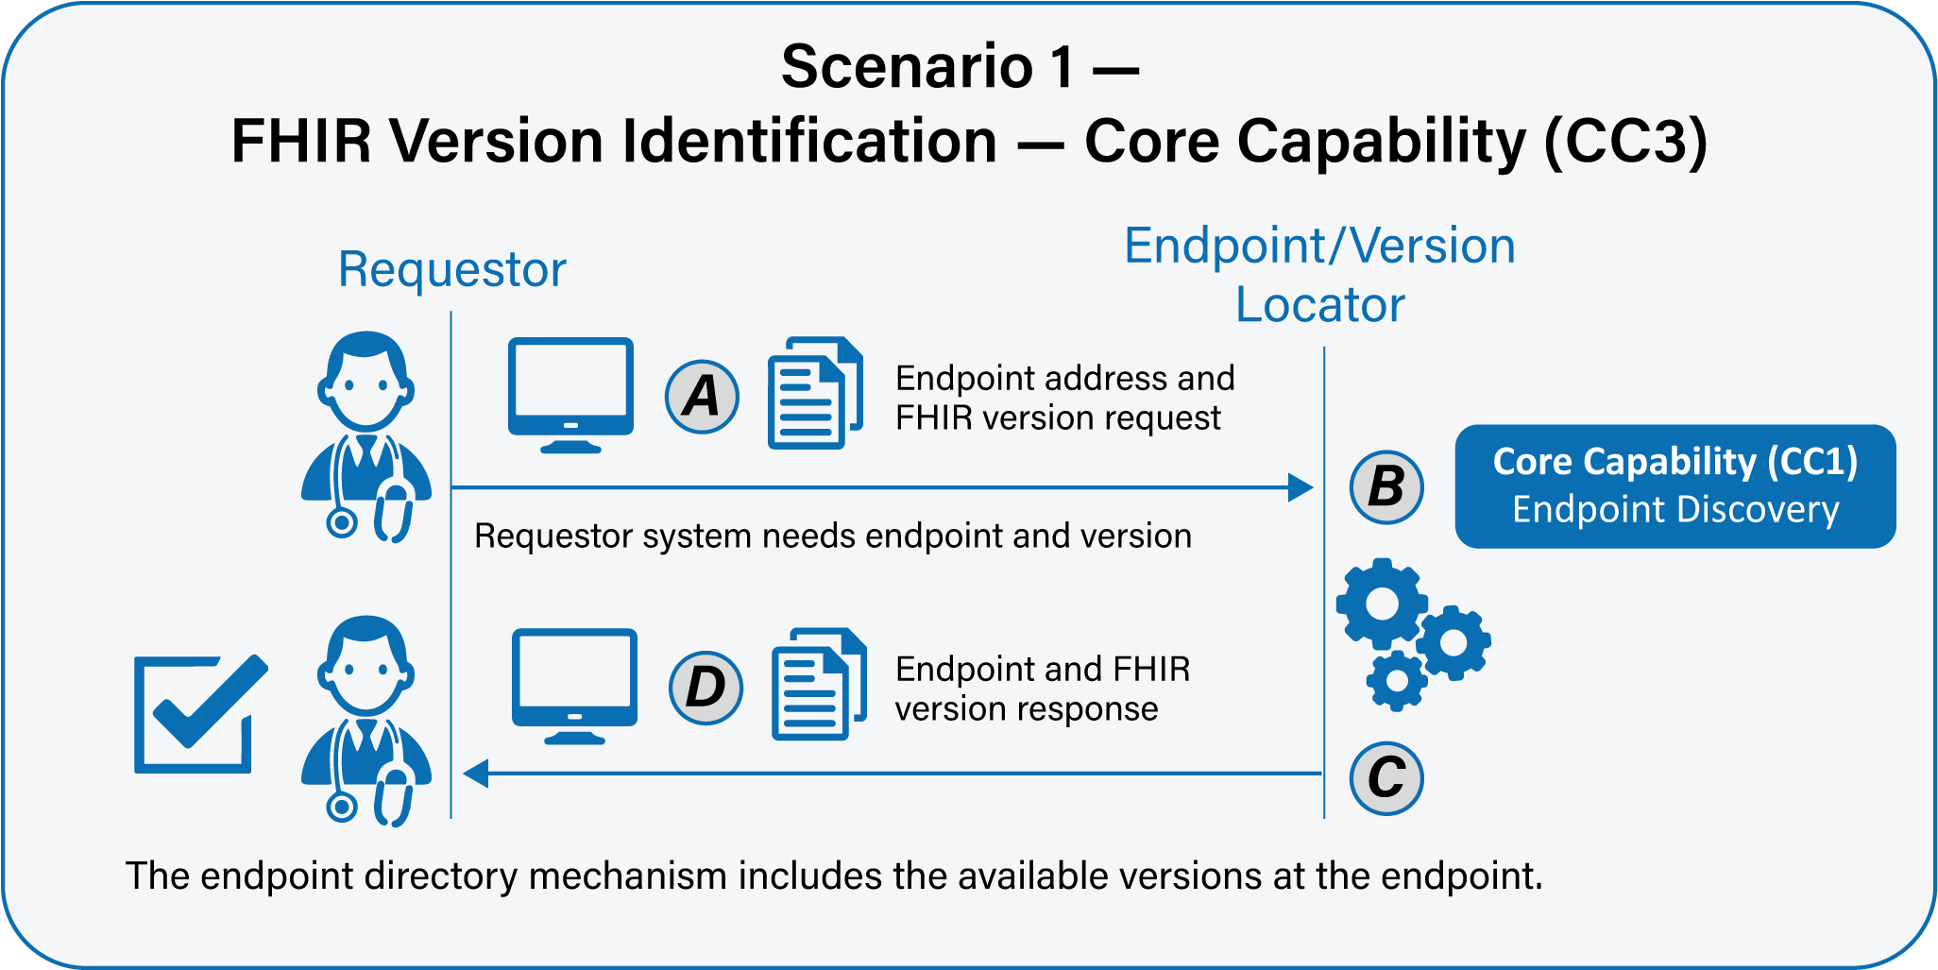

Scenario 2
As a transaction initiator (requestor), I need my system to be able to securely determine where the intended recipient’s endpoint is without configuring the endpoints manually. Responder should be able to provide access to endpoint or appropriate response so that requestor’s workflow continues. Once I have the endpoint, I then need to query that endpoint to determine which versions of FHIR are available at that endpoint.
- As a requestor, I need my system to be able to locate a FHIR endpoint for a service. See FAST-UC-Endpoint_Discovery-Core_Capability-CC1.
- As a requestor, once I have a viable endpoint service, I need the ability to query that endpoint service to determine which FHIR versions are available at that endpoint.
- As a requestor, I may query to ask if a specific version is available at that endpoint or all versions available at that endpoint.
Supporting Diagrams & Flows
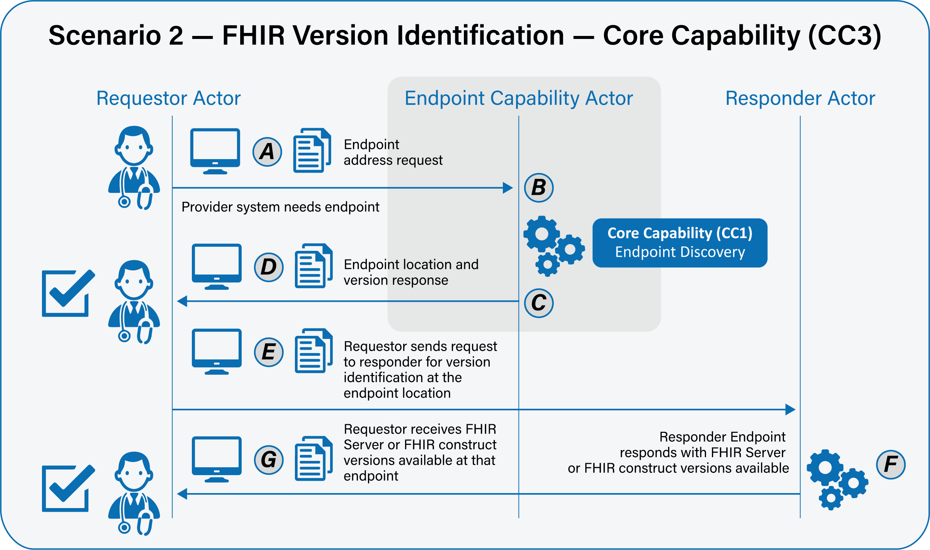

Frequency
Depending on how this is architected, it would be with each conversation, each endpoint discovery, or once a connection is made to a FHIR service endpoint.

