FHIR at Scale Taskforce (FAST)

Use Case — Event-Based Alerts

Table of Contents
Revision History 2
Introduction & Background 3
Overview & Description 4
Scenarios 4
In Scope 5
Out of Scope 5
Assumptions 5
Primary Actors 6
Types of Subscribers & Alert Sources 6
Stakeholders & Interests 6
Pre-Conditions 6
Post Conditions 6
Failure End Condition 7
Triggers 7
Scenarios 7
Scenario 1 — Subscription 7
Scenario 2 — Alert 8

Revision History
Version | Date | Author | Description of Change
1.0 |  | Christol Green  Cody Johansen | Initial published version of use case

Reference Documentation
- FAST- UC- Endpoint_Discovery-Core_Capability-CC1
- FAST-UC-Authentication_and_ Authorization-Core_Capability-CC2
- FAST-UC-Version_Identification-Core_Capability-CC3
- FAST-UC-Patient_and_Provider_Identity_ Management-Core_Capability-CC4

Introduction & Background
The purpose of the FHIR at Scale Taskforce (FAST) is to augment and support recent HL7® Fast Healthcare Interoperability Resources (FHIR®) efforts focused on ecosystem issues that, if mitigated, can accelerate adoption. One of the focus areas identified is the ability to receive alerts based off events such as an admission and/or discharge of a patient from an Emergency Department.

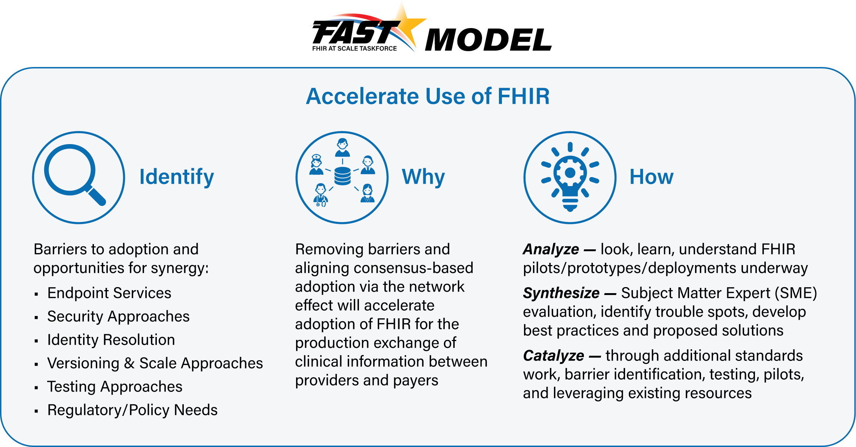

The FAST use case model is unique in that it describes ecosystem needs as opposed to specific functional needs. Use cases for FAST are derived in one of 3 approaches as described in the graphic below.
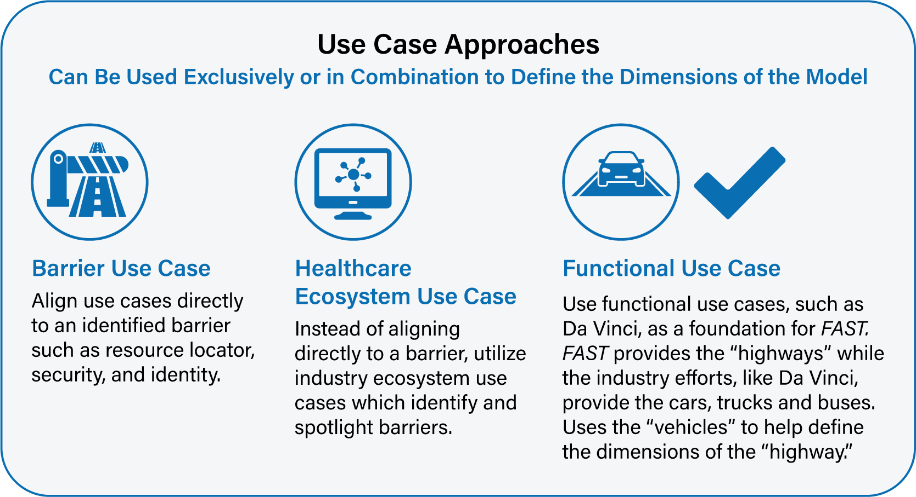

Overview & Description
This use case focuses on the ability to subscribe to as well as push alerts between a subscriber and an alerts source. A subscriber needs to programmatically be able to request to receive alerts for patients for whom they have a HIPAA covered reason to receive data. A subscriber also needs to programmatically be able to specify in the request for what types of events they would like to receive alerts. Once a patient is subscribed, the alerts source needs to programmatically be able to push an alert to the subscriber.
The focus is not on the clinical functionality of the use case (which is covered under other use cases such as those in the Da Vinci initiative). Rather, the focus is on the ecosystem which supports those specific functional use cases to ensure an efficient and scalable model where the subscriber is able to request to receive alerts and the alerts source is able to push alerts to the subscriber.

Scenarios
This use case focuses on ecosystem functionality supporting plan to provider requests for event-based alerts as well as provider to plan alerts. Variations in the primary use case help to illustrate and define the desired functionality and include the following scenarios:
- Subscription of alert from provider to plan
- Event-based alert from plan to provider
- Subscription of alert from provider to provider
- Event-based alert from provider to provider
- Subscription of alert from member/patient/authorized representative to plan/provider
- Event-based alert from plan/provider to member/patient/authorized representative

In Scope
- Request by a subscriber to receive alerts for a member/patient from an alerts source
- Push of event-based alert from the alerts source to the subscriber

Out of Scope
- Requirement for a specific architecture
- Subscriber internal processing required to generate the subscription request information
- Alerts Source internal processing of the subscription request information
- Alerts Source internal processing to create and send the alert
- Subscriber or Alerts Source internal processing to validate if request is from patient or authorized representative

Assumptions
- There exists:
The ability to subscribe to receive event-based alerts for a patient via a FHIR endpoint
The ability of the subscriber to specify the types of events for which they want to receive alerts
The ability of the alerts source to validate the request to subscribe to the patient via a FHIR endpoint
All required consents as applicable have been obtained outside of this use case
All required laws and regulations are followed (eg, HIPAA) related to the exchange of information
- Other FAST use cases and other initiatives, such as Da Vinci, are covering the clinical or administrative functional use cases
The actual validation of the treatment relationship with the provider or coverage of the plan member will be handled in the functional use cases
- The primary goal of the use case is to describe ecosystem needs to support the request to subscribe to a patient as well as to push an event-based alert via FHIR endpoints
- Responses communicating the result of the request for subscribing to a patient as well as for the push of the alert to the subscriber will be synchronous
- The request to subscribe to a patient may be initiated by a system or by an individual/organization, but will always be performed by a system to system communication
- This use case does not consider alerting mechanisms based off the content of the message or clinical information for the patient (eg, a patient’s lab that is out of range)

Primary Actors
- Subscriber
- Alert Source

Types of Subscribers & Alert Sources
- EHR
- Provider
- Provider on behalf of Patient
- Plan
- Plan on behalf of Patient
- HIE
- Member/Patient/Authorized Representative

Stakeholders & Interests
- Subscriber – Has interest in subscribing to patients for whom they would like to receive event-based alerts via a FHIR endpoint and in receiving the alerts once subscribed.
- Alerts Source – Has interest in receiving requests to subscribe to patients via a FHIR endpoint and pushing alerts to the subscribers

Pre-Conditions
- The subscription process is triggered by the subscriber
- A subscriber has a need to be notified of patient events that occur from alert sources
- An alerts source has a need to allow subscribers to subscribe to and receive alerts for patients
- The subscriber has adopted the FHIR model, including those arising from the FAST initiative
- The alerts source has adopted the FHIR model, including those arising from the FAST initiative

Post Conditions
- Subscriber has established a subscription for a patient with an alerts source via the FHIR endpoint
- Alerts source has authorized or denied the subscription of the patient via the FHIR endpoint
- Alerts source has pushed an alert for a patient on the subscriber’s subscription
- Subscriber has received an alert for a patient to whom they have subscribed
- In the event of an error during the authorization of the subscription or the push of the event-based alert, the information returned by the subscriber or alerts source is descriptive enough to not leave the subscriber or alerts source system in a state of not knowing the root cause of the error
- Requests to subscribe and pushes of alerts are auditable in a standardized manner

Failure End Condition
- The post conditions defined above are not met

Triggers
- A request to subscribe to a patient is triggered by the subscriber
- A push of an alert is triggered by an alerts source

Scenarios
Scenario 1 – Subscription
Primary Feature: As a transaction initiator (Subscriber), I need my system to be able to request to subscribe to patients from an Alert Source. As a transaction receiver (Alert Source), I need my system to either authorize or deny the subscription with a meaningful response.
- As a transaction initiator, I need my system to be able to securely determine the endpoint and version of a transaction receiver’s resource. Please see FAST-UC-Endpoint_Discovery-Core_Capability-CC1 and FAST-UC-Version_Identification-Core_Capability-CC3. (A:B:C:D referencing CC1 and CC3)
- As a transaction initiator in the ecosystem, I need to be able to request to subscribe to patients from a transaction receiver. (E:F:G referencing CC2 and CC4)
  - As a transaction initiator, I need my system to be able to subscribe in a trusted and secure way and to ensure proper authentication and authorization. See FAST-UC-Authentication_and_Authorization-Core_Capability-CC2. (E:F)
  - As a transaction receiver, I need to be able to conform to the FAST-UC-Patient_and_Provider_Identity_Management-Core_Capability-CC4 use case to ensure the patient is uniquely identified and access to that patient’s health information is properly authorized (F)
  - As a transaction initiator, I need to be able to specify for which type of events I want to be notified
    - For Example:
      - Emergency Admits and Discharges
      - Inpatient Admits and Discharges
      - Outpatient Admits and Discharges
      - Transfers to other facilities
- As a transaction receiver in the ecosystem, I need to be able to authorize or deny the subscription (based on the relationship between the transaction receiver and transaction initiator). For example, a patient not covered by a payer would be denied a subscription by a provider with a meaningful response. (F:G referencing CC2 and CC4)
Supporting Diagrams & Flows
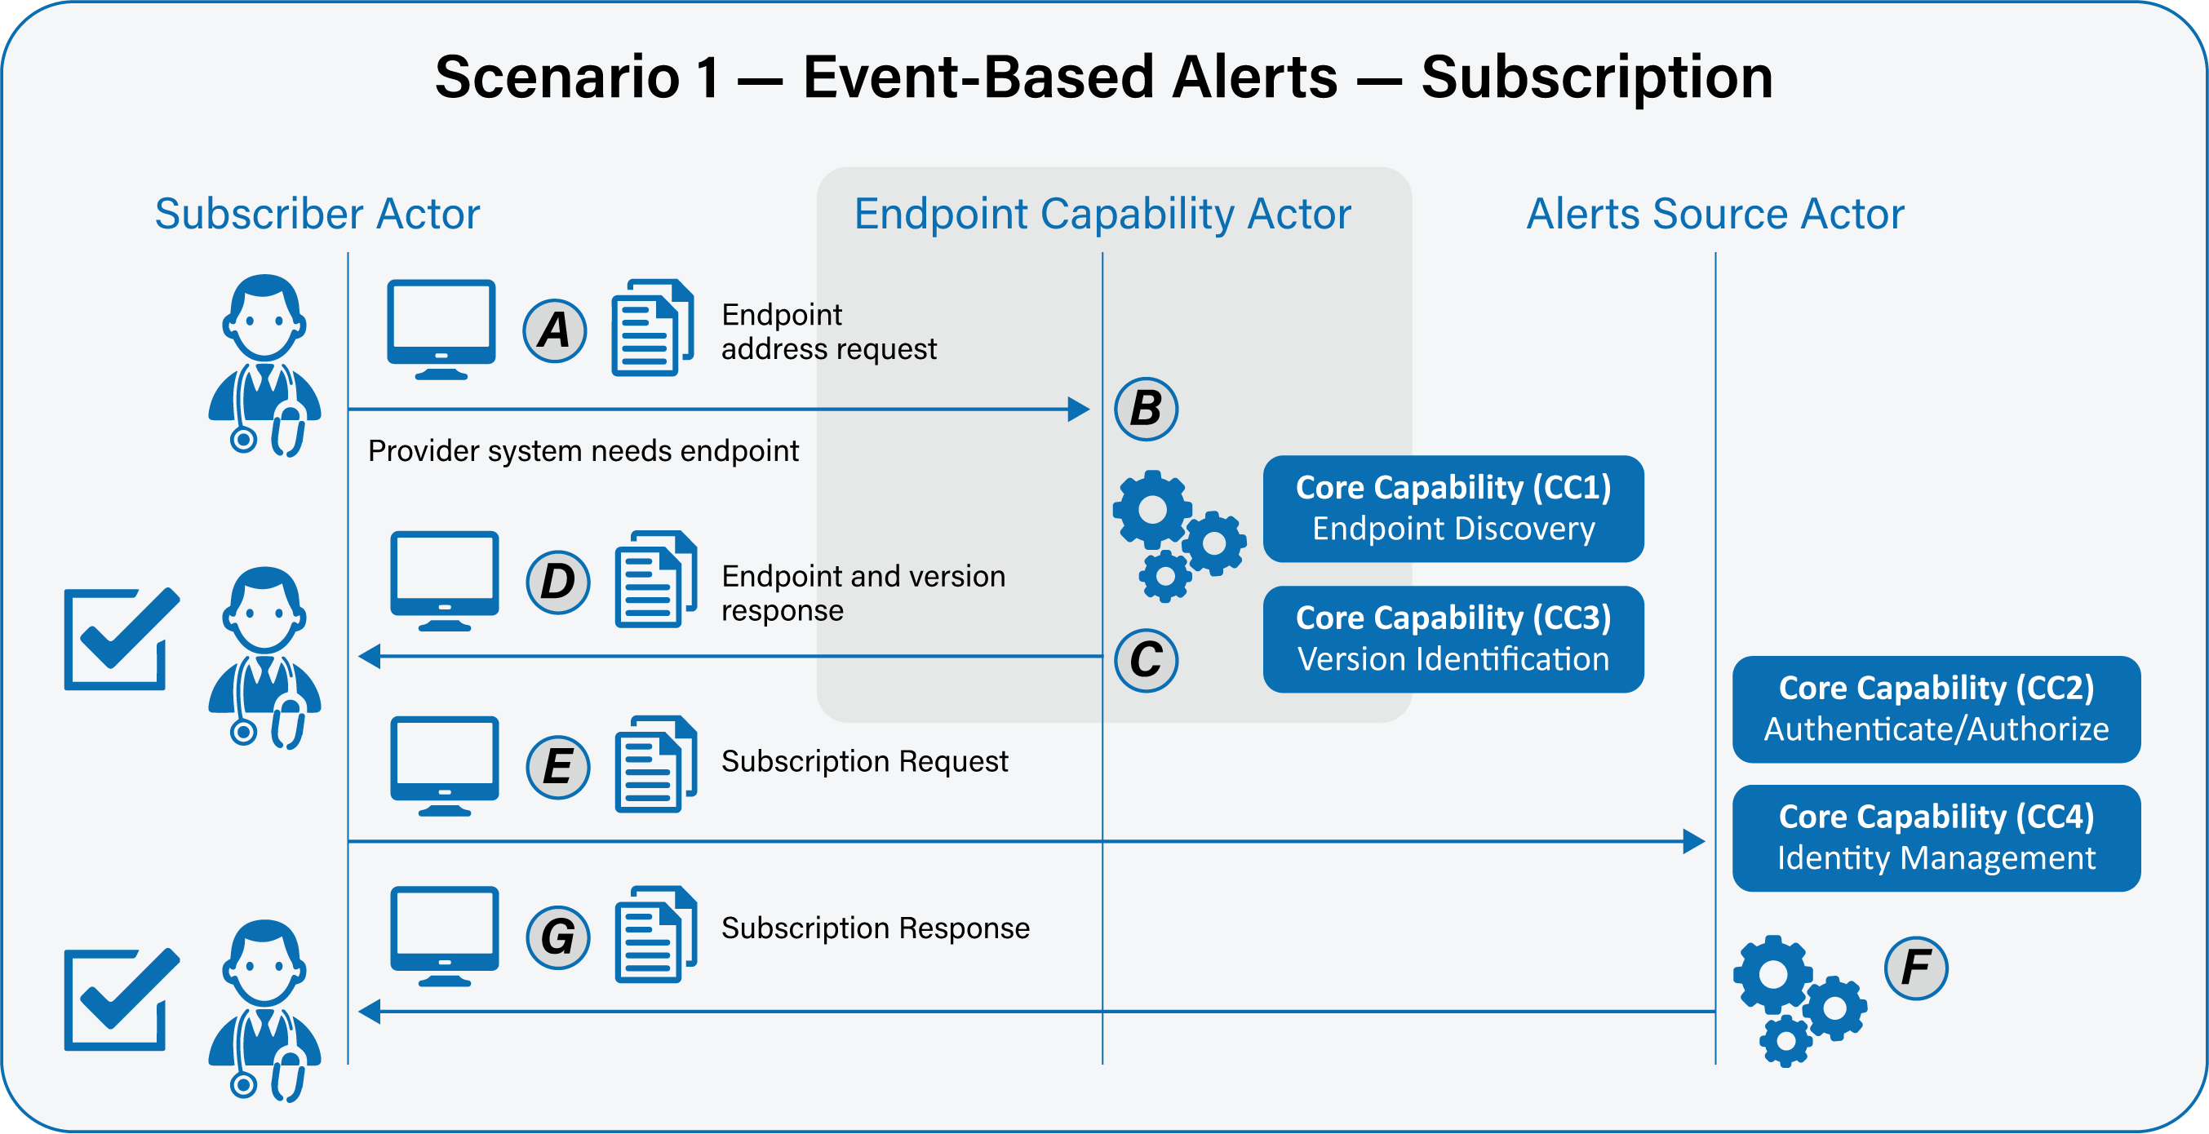
Scenario 2 – Alert
Primary Feature: As a transaction initiator (Alert Source), I need my system to be able to push an event-based alert to Subscribers that have subscribed to the patient. As a transaction receiver (Subscriber), I need my system to either accept or deny the alert with a meaningful response.
- As a transaction initiator, I need my system to be able to securely determine the endpoint and version of a transaction receiver’s resource. Please see FAST-UC-Endpoint_Discovery-Core_Capability-CC1 and FAST-UC-Version_Identification-Core_Capability-CC3. (A:B:C:D referencing CC1 and CC3)
- As a transaction initiator in the ecosystem, I need to be able to push an event-based alert to a transaction receiver and receive a meaningful response. (E:F:G referencing CC2)
  - As a transaction initiator, I need my system to ensure proper authentication and authorization. See FAST-UC-Authentication_and_Authorization-Core_Capability-CC2. (E:F)
- As a transaction receiver in the ecosystem, I need to be able to receive an event-based alert from a transaction initiator and reply with a meaningful response. (F:G referencing CC2)
Supporting Diagrams & Flows
