FHIR at Scale Taskforce (FAST)

Proposed Solution Working Document: Versioning (V2)

Table of Contents
Revision History 2
Outstanding Work……………………………………………………………………………………………………………………………………2
Introduction & Background 3
Current State Overview 4
Technical Barriers ……………………………………………………………………………………………………………………………………5
Problems to be Solved 6
Recommended Future State & Intermediate Steps 7
Proposed Versioning Solution Overview 8
Overview & Description…………………………………………………………………………………………………………………………..9
Supporting Diagrams & Flows 9
In Scope 11
Out of Scope 11
Assumptions 11
Pre-Conditions 11
Post-Conditions 12
Solution Component Analysis 12
Key Impacts to Timeline & Costs 13

Revision History
Version | Date | Author | Description of Change
0.5 | 7/9/2019 | Robert Dieterle | Initial draft
1.0 | 8/29/2019 | Robert Dieterle | Updated initial draft from tiger team review
1.1 | 8/8/2019 | Alix Goss | Review and Comment
1.2 | 10/31/2019 | Rick Geimer | Review and Comment
2.0 | 2/20/2020 | Robert Dieterle | Incorporation of all new content from TLC preparation and TLC curated feedback
2.1 | 2/20/2020 | Robert Dieterle | Updated based on DVS TT review
2.1 AG | 2/27/2020 | Alix Goss | Documents review
2.2 | 3/9/2020 | Robert Dieterle | V2 Draft Final
2.3 | 2/10/2021 | Robert Dieterle | Update V2 Draft Final
2.4 | 3/3/2021 | Tiger Team | Team final review

Outstanding Work (move appropriate items to next steps)
- Collaborate on direction proposed in this document with HL7 FHIR leadership to ensure alignment with FHIR standard release plans
- Identify impact on current and future ONC and CMS regulations
- Determine ability to translate non-normative resources
- Determine impact on HL7 FHIR extensions, profiles and Implementation Guides
- Determine how version management works overtime in response to new data portability requirements. A current record may contain multiple versions of data or the current record may be the result of multiple data translations.
- Need to consider proliferation of IGs and Profiles that provide for different solutions to the same fundamental use case (is this a core capability issue or just an HL7 issue?)
- Incompatible profile constraints on underlying resource in ways that do not permit reuse by other implementation guides (e.g., US Core constraints that do not support specific IGs requirements, such as PractitionerRole for Directory) (Is this FAST or HL7 FHIR issues? May be both if we want policy and technical resolution?)

(Note to editors: ensure standard front matter content is current and accurate. Changes in Reference Documentation need to be carried over to Support Documentation and Flows section. Final version will also need application of consistent fonts and formatting. )
Reference Documentation
- FAST-Technical Barriers
- FAST-Regulatory Barriers
- FAST-UC-Endpoint_Discovery-Core_Capability-CC1
- FAST-UC-Authentication_and_Authorization-Core_Capability-CC2
- FAST-UC-Version_Identification-Core_Capability-CC3
- FAST-UC-Patient_and_Provider_Identity_Management-Core_Capability-CC4
- FAST-UC-Patient_Information_Request_Plan_to_Provider
- FAST-UC-Patient_Information_Request_Provider_to_Plan
- FAST-UC-Documentation_Templates_and_Rules_Processing
- FAST-UC-Event_Based_Alerts
- FAST-UC-Quality_Reporting
- FAST-UC-Push_Patient_Information
- FAST-UC-Shared_Care_Planning
- FAST-UC-Consults_and_Referrals
- FAST-UC-Care_Team_Coordination
- FAST-UC-Scheduling

Introduction & Background
The purpose of the FHIR at Scale Taskforce (FAST) is to augment and support recent HL7® Fast Healthcare Interoperability Resources (FHIR®) efforts focused on ecosystem issues that, if mitigated, can accelerate adoption. A number of regulatory and technical barriers, as well as required core capabilities, have been identified related to Directory, Versioning and Scale. This document will outline proposed solutions to address these issues and capabilities.

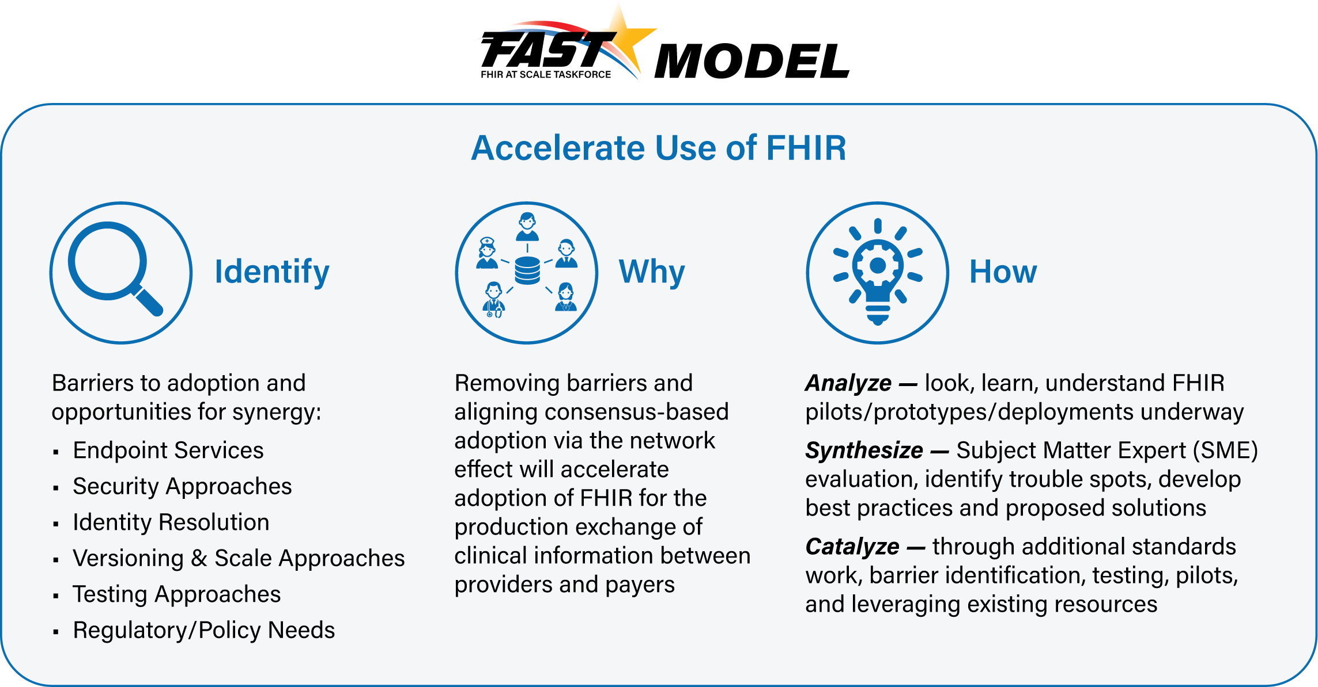

Current State Overview
- Interoperability initiatives and federal policy objectives are advancing FHIR standard and IGs to address gaps and support innovation
- Multiple incompatible versions of FHIR are in production (DSTU2, STU3, R4)
- Version(s) are not fully backward or forward compatible, except where resources are normative
- Breaking changes may exist between versions except where resources are normative
- Limited ability to convert data between versions without loss of fidelity for most clinical resources. In contrast, most conformance resources have the capability to maintain fidelity (StructureDefinition, ValueSet, etc.).
- Most FHIR endpoints only support one version of FHIR
- Resources, extensions, profiles, value sets are version specific and, frequently, have significant changes between versions
- Implementation guides are version specific
- A single exchange of FHIR content (e.g. a FHIR bundle) is limited to one version of FHIR
- CapabilityStatement resources are
  - often used inappropriately or not at all
  - often inaccurate reflections of endpoint capability (despite FHIR specification requirements)
  - currently has a scope that is in flux (especially as regards to security/authentication)

Technical Barriers
- Multiple Versions and Production

Trading partners may need to support multiple versions of FHIR with no guarantee of backward compatibility across versions except for those resources which are normative. While transforms exist for some resources to convert from one version to another, their quality and completeness vary from resource to resource and do not exist for IGs.
- Continued Evolution of the Standard

Supporting new functionality creates timing and adoption challenges (e.g., lag time to support new resources, operations, etc.). Since vendors may support different functions at different times, the capability statement becomes an essential part of determining current endpoint support for specific functionality.
- Variable Adoption of the Standard

Vendors adopt support for the ability to read or read/write specific resources. Maintaining capability statements and periodically pulling/processing statements are challenges.
- Using Different FHIR versions for the Record of a Single Patient

Depending on architectural models deployed for receiving and storing data, multiple FHIR versions may seriously impact decision support or negatively impact the ability to communicate the complete record to another entity.
- Profiles that are Version Specific

Profiles and implementation guides are version specific. This creates complexities when supporting multiple versions of FHIR and migrating from one version to the next, leading to substantial implementation issues.

Problems to be Solved The following technical and regulatory barriers to Versioning identified by the FAST team were found to impede the adoption of FHIR at scale and will be the basis for FAST-proposed scalability solutions:
- Multiple Versions & Production: Trading partners may need to support multiple versions of FHIR and corresponding implementation guides (IGs) with no guarantee of backward compatibility across versions except for those resources which are normative. Regulatory recognition of multiple versions of FHIR creates further confusion and challenges. While transforms exist for some resources to convert from one version to another, their quality and completeness vary from resource to resource and do not exist for IGs.
- Continued Evolution of Standard: Supporting new functionality creates timing and adoption challenges (e.g., lag time to support new resources, operations, etc.). Since vendors may support different functions at different times, the capability statement becomes an essential part of determining current endpoint support for specific functionality.
- Variable Adoption of the Standard: Vendors vary in their support for the ability to read or read/write specific resources. Maintaining capability statements and periodically pulling/processing statements present operational and maintenance challenges.
- Using Different FHIR Versions for the Record for a Single Patient: Depending on architectural models deployed for receiving and storing data, multiple FHIR versions may seriously impact decision support or negatively impact the ability to communicate the complete record to another entity.
- Profiles That Are Version Specific: Profiles and implementation guides are version specific. This creates complexities when supporting multiple versions of FHIR and migrating from one version to the next, leading to substantial implementation issues.
- Complexities Created by Extensions: A new version of FHIR introduces new content that impacts the definitions of the extensions or how the extensions are used in Implementation Guides/Resources.
- Capability Statement Maturity: While the CapabilityStatement resource is normative, there a significant number of flagged elements that are marked as “for trial use”. Until the relevant flags are also normative or removed, the CapabiltityStatement resource may also change in significant ways from FHIR release to release.

Recommended Future State & Intermediate Steps

Future State
- Most commonly used HL7 FHIR resources are “normative”.
- FHIR versions solutions focus on US Realm with considerations for international solutions to address health care for US citizens globally
- Variation between releases is focused on new functionality and edge cases
- Any new version shall be backward compatible for all normative content
- All FHIR artifacts shall provide version information as part of any exchange
- Current process for version adoption for transactions and APIs mandated by regulation continues to be supported
  - HHS/ONC adoption of a base standard version of FHIR (floor) through rule making for all covered FHIR exchanges
  - ONC has regulatory authority to set the standards regarding FHIR versions and version adoption for all Federal Agency regulatory requirements regarding FHIR.
  - Adoption of a new base standard version of FHIR (floor) shall require rule making by HHS/ONC
  - Adoption of new “ceiling” version(s) based on sub-regulatory process (e.g. SVAP)
  - Willing trading partners (without any financial incentives or penalties), may choose to adopt newer versions as long as they continue to support the floor.
  - HHS/ONC will determine the current version of FHIR and any specific implementation guides that will be required to meet certification and other programmatic regulations (e.g. CMS regulations)
  - Technical corrections will not be considered “new” versions for regulatory versions (e.g. V1.0.0 to V1.0.1) just the new base
- During migration to a new floor version:
  - The concept of a two-year window to sunset an old floor version assumes the starting point (date) for the two-year window is when a newer version is required to be supported.
  - Existing FHIR services shall be supported for at least 2 years after adoption of a new version or until there is no production activity at the endpoint for 3 months.
  - Any incompatible changes (non-normative) between versions shall be fully defined and where possible, HL7 tooling shall be created to manage translation between versions.
  - Historical information (based on inconsistent/incompatible versions) has been migrated to the normative version to the extent possible (there may be issues with semantics between original and current version that are well understood and accepted)

Intermediate Goals
- All endpoints shall support capability statement query and the $versions operation that returns the supported version(s)
- Relevant flags in the capability statement are normative or removed
- All endpoint or validated health care directory entries shall include information regarding the version(s) of FHIR supported (e.g. expanded support for the endpoint resource as part of the new directory exchange IG)
- Incompatible changes between version shall have improved HL7 tooling, where possible, to manage translation between versions
- Reconcile issues with incompatible changes between R4 and future minor releases (especially as related to MedicationKnowledge)
- HL7 maintained transforms exist and are supported by FHIR endpoints for all USCDI resources and profiles to convert to/from versions of FHIR cited in regulation, or via sub-regulatory process
- Support for endpoint version and validation of support is in-scope for the directory and testing/validation Tiger Teams and will be part of those final solutions
- Support industry education programs (via HL7?) to reinforce the understanding and use of version adoption and version related issues.

Proposed Versioning Solution Overview
Through use case development and barrier definition, the FAST team has determined that the following core capabilities related to Versioning need to be satisfied as we propose a set of solutions that will accelerate FHIR adoption at scale:
Core Capability | Proposed Solution(s)
- Resource Version Identification  - Support for multiple versions | - Standards requirements for resources, profiles and bundles  - Directory metadata for an endpoint  - Capability statements  - Testing and Validation for endpoints to conform to directory metadata and capability statements  - Ability to identify endpoint version(s)  - Ability to identify FHIR data version (resource and any applicable profile) if endpoint supports more than one version  - Ability to translate adopted [by regulation or sub-regulatory process (e.g., SVAP)] FHIR objects (resources, profiles, extensions, value sets) versions (from any adopted prior version -- to the current adopted version)  - Ability to document translations where appropriate (e.g., provenance)

Overview & Description

An entity, referred to as a requestor actor, needs to obtain information from another entity, known as the responder actor. The requestor actor initiates a request for an endpoint, if not already known, from the endpoint directory. After completing the necessary authentication and authorization steps, the requestor actor requests and receives the capability statement from the responder actor which includes details on the version(s) supported. (when intermediaries are involved, which capability statement should be returned – the intermediary or the destination?)

Supporting Diagrams & Flows

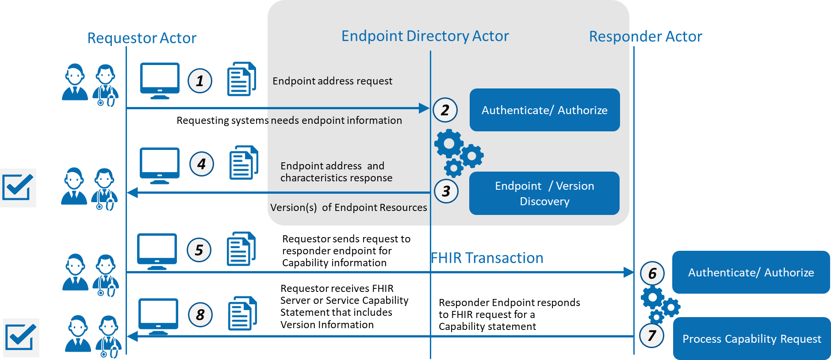

ID | Description | Notes
1 | Requestor queries the endpoint directory | Refer to Core Capability 1:  FAST-UC-Endpoint_Discovery-Core_Capability-CC1
2 | Endpoint directory authenticates and authorizes requestor | Refer to Core Capability 2:  FAST-UC-Authentication_and_Authorization-Core_Capability-CC2
3 | Endpoint directory responds with endpoint address and related characteristics
4 | Requestor consumes response to support generation of specific request to Responder
5 | Requestor sends a request for the FHIR capability statement to responder (or their designated intermediary)
6 | Responder (or their designated intermediary) authenticates and authorizes requestor | Refer to Core Capability 2:  FAST-UC-Authentication_and_Authorization-Core_Capability-CC2
7 | Responder processes capability request
8 | Requester consumes capability statement response that includes version information | Refer to Core Capability 3:  FAST-UC-Version_Identification-Core_Capability-CC3

In Scope
- Managing multiple versions of FHIR and FHIR objects (resources, profiles, extensions, value sets)
- Identification of supported version for a specific endpoint
- Transform / Translation mapping service considerations
- Ability to appropriately manage exchange of information across multiple versions of FHIR

Out of Scope
- Specifying a single version of FHIR
- Requiring forward/backward compatibility for non-normative resources
- Addressing support for multiple versions in a single exchange (leave with HL7 FHIR community to resolve)

Assumptions
- HL7 will continue to release versions of the FHIR standard
- Multiple FHIR versions will be in active production use at the same time
- ONC will set the floor for the “current” version of FHIR for APIs
- ONC/CMS will set floor for version support and use SVAP to adopt new allowed versions
- A directory endpoint entry will have the version(s) supported as endpoint metadata
- Resources, Profiles and Bundles will have metadata that identifies the version
- Implementation Guides and Bundles will continue to be based on one version only
- Patient record portability and health care interoperability regulations will drive the need for payers and providers platformsto support multiple versions and/or define if FHIR version translation was performed (to identify potential loss of fidelity)
- New versions of FHIR and implementation guide specifications will provide additional or refined capabilities that influence adoption

Pre-Conditions
- One or more standard release(s) of FHIR
- FHIR based information exchanged between the Responder and the Requester using core capabilities
- Ability to determine the version of the endpoint prior to exchange

Post Conditions
- Ability to determine the version of FHIR used for each exchange at any point in the lifecycle of an exchange
- Ability to appropriately manage exchange of information across multiple versions of FHIR
- Ability to use applicable IGs for information exchange
- Standard methods for translation between versions
- Ability to exchange identification of data translation(s) performed (e.g., provenance)

Solution Component Analysis
The following new components or modifications to existing components are required to address current gaps and support the proposed solution:
ID | Component | New/ Existing | Proposed Build/Modifications | Owner
Interaction 1 | Endpoint Directory | New | See Directory Solution Document for proposed approach | CMS/ONC
Interaction 2 | Capability Statement | Existing (need compliance) | FHIR standard requirement | HL7 FHIR and Testing / Certification TT
General | Testing for Version Support | New / Existing | Need tools, scripts, process | HL7 FHIR and Testing / Certification TT
Exchanges | Version on all exchanged artifacts | Existing (needs compliance) | FHIR standard requirement | All / HL7 FHIR and Testing / Certification TT
Translation | Translation / Mapping | Existing/New | FHIR release support | HL7 release management

Key Impacts to Timeline & Cost
ID | Component | Level of Effort | Comments
 | Endpoint Directory | Significant | HL7 directory related specifications in development; Asset build of endpoint directory to be determined.
 | Capability Statement | Nominal | Need to test/certify
 | Testing for Version Support | Minor | Need tool, test scripts, and process
 | Version on all exchanged artifacts | Moderate | Need to add to US profiles
 | Translation / Mapping | Moderate | Should be Part of FHIR release tooling

