FHIR at Scale Taskforce (FAST)

Proposed Solutions Working Document: Scale

Table of Contents
Revision History 3
Introduction & Background 4
Current State Overview 5
Problems to be Solved 5
Recommended Future State & Intermediate Steps 7
Proposed Solution Overview 7

Scale 8
<Solution 1> 8
Overview & Description 8
Supporting Diagram & Flows 8
In Scope 10
Out of Scope 10
Assumptions 10
Pre-Conditions 10
Post-Conditions 10
Solution Component Analysis 11
Key Impacts to Timeline & Costs 12

Appendix 14

Revision History
Version | Date | Author | Description of Change
0.5 |  |  | Initial draft

Reference Documentation
- FAST-Technical Barriers
- FAST-Regulatory Barriers
- FAST-UC-Endpoint_Discovery-Core_Capability-CC1
- FAST-UC-Authentication_and_Authorization-Core_Capability-CC2
- FAST-UC-Version_Identification-Core_Capability-CC3
- FAST-UC-Patient_and_Provider_Identity_Management-Core_Capability-CC4
- FAST-UC-Patient_Information_Request_Plan_to_Provider
- FAST-UC-Patient_Information_Request_Provider_to_Plan
- FAST-UC-Documentation_Templates_and_Rules_Processing
- FAST-UC-Event_Based_Alerts
- FAST-UC-Quality_Reporting
- FAST-UC-Push_Patient_Information
- FAST-UC-Shared_Care_Planning
- FAST-UC-Consults_and_Referrals
- FAST-UC-Care_Team_Coordination
- FAST-UC-Scheduling

Introduction & Background
The purpose of the FHIR at Scale Taskforce (FAST) is to augment and support recent HL7® Fast Healthcare Interoperability Resources (FHIR®) efforts focused on ecosystem issues that, if mitigated, can accelerate adoption. A number of regulatory and technical barriers, as well as required core capabilities, have been identified related to Directory, Versioning and Scale. This document will outline proposed solutions to address these issues and capabilities.

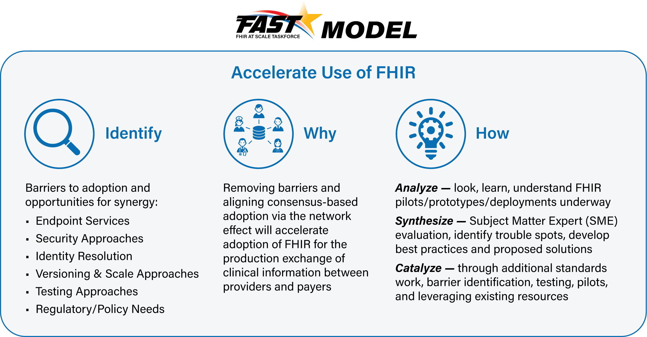

Current State Overview
Scale Current State: (includes 7/9/2019 notes)
- Limited experience with FHIR based solutions operating at scale to support anticipated healthcare needs.
- Current scaling solutions cannot handle anticipated volume and response time requirements
  - Lack of predictability of response times
  - Uncertain ability to handle anticipated increase in transaction volume
- Multiple competing potentially incompatible solutions for scaling (HIE, CH, Sequoia, Careequality, Commonwell…)
- Inconsistent legislative, regulatory, and policy environments
- Current issues related to privacy and security create barriers to national adoption of FHIR at scale
- No standard to determine location of patient/member records creates repeative tasks and data gaps as well as incremental transaction volume
- Limited ability to push relevant information to interested parties
- Lack of documented standards to handle synchronous exchanges and maintain state via intermediaries
- Concern with multiple intermediaries and impact on performance, scaling, synchronous transactions
- Limited practical experience in scaling FHIR transactions via intermediaries
- Impact of competing interoperability models on access to data – e.g. are endpoints inaccessable depending on the model used
Note: defining intermediaries as BAs, ClearingHouses, HIEs, “Switches”

Problems to be Solved
The following technical and regulatory barriers to Scaling identified by the FAST team were found to impede the adoption of FHIR at scale and will be the basis for FAST-proposed scalability solutions:
Scaling
- Multiple Current Interoperability Models: Hybrid exchange models (e.g., spoke/hub, direct connections/point-to-point, and regionally interconnected spoke/hub) create challenges in adopting standards for scaling FHIR and implementing consistent approaches such as authentication, endpoint detection, standards for matching, and end-to-end performance.
- Lack of Predictability and Response Times: Scaling real-time transactions requires infrastructure that may not be currently available through existing intermediaries. The lack of predictable end-to-end response time limits specific use cases where providers require a response prior to proceeding with diagnosis or treatment. Some intermediary models do not support end-to-end synchronous real-time applications. The industry will need to adopt synchronous FHIR front-end interfaces and migrate to near real-time backend solutions.
- Record Location: Lack of a national patient record locator service limits the ability to discovery all records for a given patient in a distributed service environment. There is no current process for universally discovering endpoints either in general or for a specific patient.
- Anticipating Increase in FHIR-Based Volume: There are currently no models to predict the volume of FHIR-based transactions as FHIR is adopted broadly in the ecosystem. This may lead to unpredictable scaling and performance challenges. Adopting real-time (RESTful) solutions to solve real-time synchronous FHIR scalability is required by the industry. Payers and providers need to increase services (and related perception of reliability) to support significant increase in real-time transactions embedded in the clinical workflow.
- Data Blocking: The industry is moving to a utilization model for access to patient data using FHIR APIs. As FHIR makes information readily available within an encounter clinical workflow and through multiple mobile, portable and wearable devices in real time, the volume of transactions will increase exponentially. If there is limited access to this information, or the cost per access/transaction is too high, this will constitute a new form of data blocking. The CMS NPRM is working to address both of these issues.

Recommended Future State & Intermediate Steps
Future state for scaling options (includes 7/19/2019 notes)
- Mixed model fully supported
- Intermediaries capable of handling volume, response time, and routing to all available end points
- Legislative, standards, and legal trust framework allowing unlimited, authorized access to information for stated purpose

Note: Compare and contrast today’s HIE’s and Clearinghouses with the functionality we want for the future. Especially as it relates to end point information (and eventually address for scaling).

Proposed Solution Overview
Through use case development and barrier definition, the FAST team has determined that the following core capabilities related to Scaling need to be satisfied as we propose a set of solutions that will accelerate FHIR adoption at scale:
Core Capability | Proposed Solution(s)
- Scaling | - Preferred <Proposed Solution 1>  - Alternatives (In Appendix)  - Others Considered and Not Selected (In Appendix)

Scaling
<Proposed Solution 1>

Overview & Description

Supporting Diagrams & Flows
<FAST team to insert an annotated swim lane diagram to describe proposed process. Please use the diagram design elements embedded in the PPT below to create the diagram. Right-click on the PPT and select “Presentation Object” and then “Edit”. Note that diagrams will be re-designed/cleaned up as needed, so no need to spend time making it look pretty as long as it is functionally accurate).>

ID | Description | Notes
1
2
3
4
5
<FAST team to optionally insert an annotated wiring diagram to describe the proposed technology. Example below. Please use the diagram design elements embedded in the PPT below to create the diagram. Right-click on the PPT and select “Presentation Object” and then “Edit”. Note that team diagrams will be re-designed/cleaned up as needed, so no need to spend time making it look pretty as long as it is functionally accurate).>

Look at exchange metadata for example of intermediaries as part of the diagram.
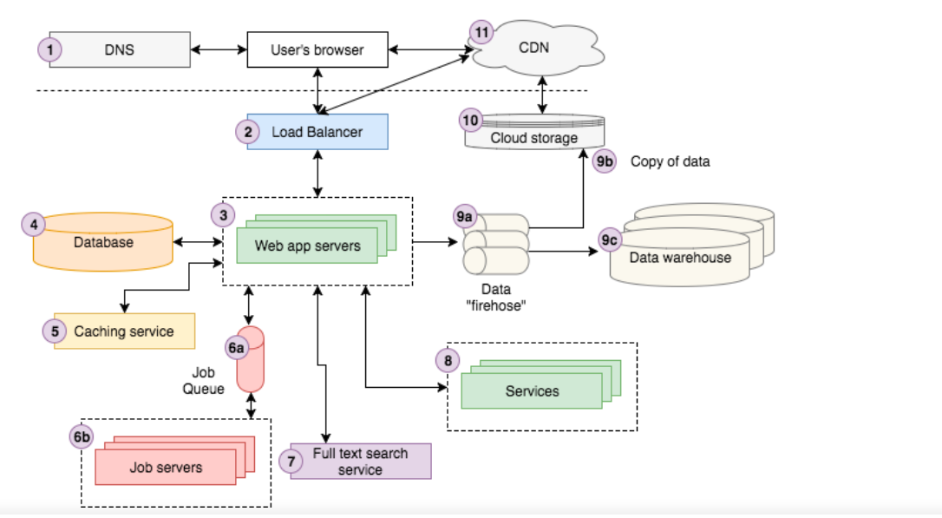

- Pt-Pt
- Via one intermediary
- Via multiple intermediaries
- Connection to one payer via each of the above routes from 3 different providers as the example

ID | Description | Notes
1
2
3
4
5

In Scope
- Interoperability models with, pt-pt, single and multiple intermedaries
- Issues related to RESTful exchanges via intermediaries
- Planning for future volume increase
- Establishing SLA and Performance requirements for intermediaries and endpoints
- Establishing functionality of endpoints and and the method of declaration

Out of Scope
- Identification, security, directory, versioning, metadata, certification or piloting
- Ownership models
- Trust frameworks
- Legal agreements
- Non-RESTful exchange methods (e.g. Direct)
- Technical Implementation

Assumptions
- FHIR transactions include both FHIR payload and the RESTful operations for exchange of the payload
- Identification, security, directory, versioning, metadata, and certification are defined and supported by all participants
- Service level agreements/statements are established and enforced

Pre-Conditions
- Endpoints must be available to support FHIR transactions
- Endpoints are compliant with established FHIR standards (and indicated conformance)

Post Conditions
- The FHIR transaction environment works at scale with not significant issues.

Solution Component Analysis
The following new components or modifications to existing components are required to address current gaps and support the proposed solution:

Need drawing before completing this section – Patrick to create draft drawing with color commentary from Bob
ID | Component | New/ Existing | Proposed Build/Modifications | Owner
Map to annotated diagram components above | List components proposed in solution diagrams above | New or if Existing, what is the existing component | If new, describe what needs to be built.  If existing, describe what needs to be modified or enhanced. | Who owns building the new component or making the proposed modifications?

Key Impacts to Timeline & Cost
<FAST team to identify the key components listed above that will have the most impact on timeline and cost. Include rough order of magnititude for level of effort and comment on any known blockers or dependencies.>
ID | Component | Level of Effort | Comments
 |  | Small, Medium, Large, or Jumbo

Appendix
Alternative Solutions

Additional Solutions Considered and Not Selected

