P2 FHIR Task Force

(FAST – FHIR At Scale Taskforce)

Use Case –Push Patient Information

Version 3.00
Table of Contents
Revision History 2
Introduction & Background 3
Overview & Description 4
Variations and Extensions 4
In Scope: 4
Assumptions: 4
Primary Actors 4
Supporting Actors 5
Stakeholders and Interests 5
Pre-Conditions 5
Post Conditions 5
Requirements & Main Success Scenario 6
Special Requirements & Considerations 8
Issues 8
Frequency: 8
TBD 8

Revision History
Version | Date | Author | Description of change
1.00 | 01/07/2019 | Ranjan Saxena | Initial Version
2.00 | 03/07/2019 | Ranjan Saxena | Updated the version based on scope in XL sheet (FAST Use Cases)
3.00 | 03/21/2019 | Ranjan Saxena | Updated some language and added picture for plan to provider & provider to provider.  - Discussion on including patient to share clinical information (if needed will revisit in next meeting). A decision from steering and executive committee is awaited.  - Discussion on Synchronous and Asynchronous  - Added provider to provider in scope and flow accordingly.

Introduction & Background

Use Case: Push Patient Information
ID: UC_Push_Patient_Information

The purpose of the P2 FHIR Task Force is to augment and support recent FHIR efforts focused on ecosystem issues that, if mitigated, can accelerate adoption. One of the focus areas identified is the ability to push patient information to payer. 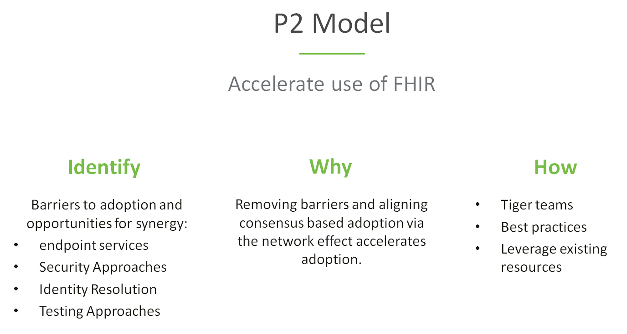

The P2 use case model is unique in that it describes ecosystem needs as opposed to specific functional needs. Use cases for P2 are derived in one of 3 approaches as described in the graphic below.

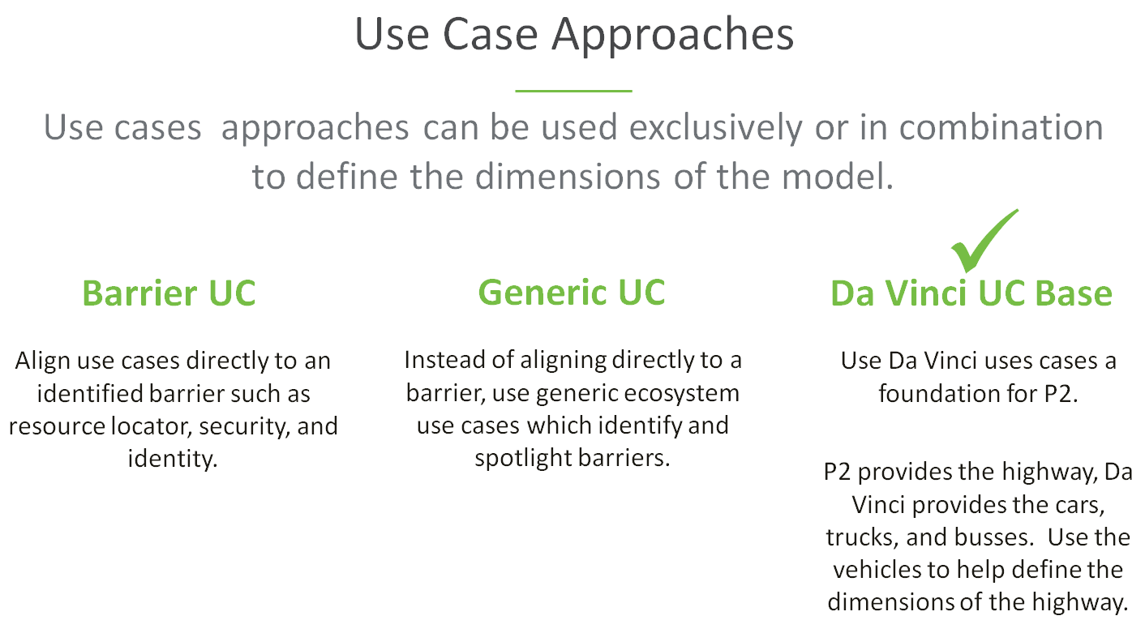

Overview & Description
This use case focuses on the ability to push required patient information from provider to plan or plan to provider with respect to the data sharing to support value based care arrangements. The focus is not on the clinical or administrative functionality of the use case, instead in ensuring that the ecosystem supports an efficient and scalable model.

Variations and Extensions
This use case focuses on ecosystem functionality supporting push of patient information from provider to plan or plan to provider based on events. Variations in the primary use case help to illustrate and define the desired functionality and include the following scenarios:

- Provider push of patients information to plan
- Plan push of patients information to provider

In Scope:
Provider to Plan
- Push of encounter based patient’s clinical data i.e. full medical record or any specific section (e.g. problem list) to plan
- Push of patient’s clinical data to plan based on medical history available with provider.
- Push of medication adherence notification to plan.

Plan to Provider
- Push of patient’s full clinical summary to provider which may include problems, gaps in care, medication details etc. or share part of the clinical summary based on need.
- Push of patients clinical data bases on events e.g. admit/discharge or based on actions taken as part of care planning etc.
Provider to Provider
- Push of encounter based patient’s clinical data i.e. full medical record or any specific section (e.g. problem list) to provider.
- Push of patient’s clinical data to other provider (treating/specialist) based on medical history available with provider.
- Push of medication adherence notification to provider.

Out of Scope:
- Requirement for specific architecture.
- Provider’s systems internal processing required for pushing patient information.

Assumptions:
- Other initiatives, such as Da Vinci, are covering the clinical or administrative functional use cases.
- The primary goal of the use case is to describe ecosystem needs to support the functional use cases.
- Transactions can be synchronous or asynchronous.
- Minimum Necessary requirements will be addressed by core capability use case.
- Endpoint discovery, security, versioning and patient, plan identification are out of scope for this document.

Primary Actors
- Treating clinician or organization
- Support staff working on behalf of treating clinician or organization
- Payer/Plan

Supporting Actors

- E H R
- Provider/Payer systems
- Endpoint resolution capability
- Support staff working on behalf of treating clinician or organization

Stakeholders and Interests
- Payer/plan – As an active stakeholder has interest in receiving timely, actionable, accurate patient/member information to enable better care outcomes and participation in value based care arrangements.
- Provider – As an active stakeholder has interest in providing timely, actionable, accurate patient information to improve patient outcomes and provide value based care.
- Patient – As an active stakeholder has interest in receiving optimized care and relies on the timely, actionable, and accurate exchange of information.
- Caregiver (Typically a family member) – As an active stakeholder has interest in the patient receiving optimized care and relies on the timely, actionable, and accurate exchange of information,
- Federal and State Govt. – As a stakeholder, in long term has interest to ensure that the exchange models are highly scalable and meet ecosystem needs to help enable interoperability and efficient data exchange for better outcomes for all stakeholders.
- CMS – As an active stakeholder has interest in Medicare/Medicaid patients benefitting from the timely, actionable, and accurate exchange of information
- E H R – As a stakeholder in long term, has interest to ensure that solutions work well in their systems and the healthcare network.
- Standards Organization - As a stakeholder, in long term has interest to ensure that the exchange models are highly scalable and efficient.
- Public Health Entities: As a stakeholder, in long term have interest in patients benefitting from timely, actionable, and accurate exchange of information that prevent diseases, prolong life and promote the human health of a community or society.

Pre-Conditions
- The process is triggered by the clinician, supporting staff, or E H R on behalf of treating provider or by plan’s clinical staff.
- The provider system has the patient’s plan and identifier information prior to execution of the use case.
- The E H R or other clinical system has adopted the FHIR model, including those arising from the P2 initiative
- The treating provider and plans has adopted the FHIR model, including those arising from the P2 initiative.
- Plan system has identifier information for the provider to share the clinical data with treating provider or PCP.

Post Conditions
- Plan has received clinical data / results/outcome (where applicable) from the treating providers for each encounter.
- Plan has received the acknowledgement and clinical data from treating provider if a request for clinical data is initiated by Plan.
- Provider has received patient’s clinical data from Plan.
- The information is understandable by the clinical, support staff, or the machine
- The transaction did not cause undue burden in terms of wait time or unusable message
- In the event of an error, the information returned does not leave the clinician, support staff, or system in a state not knowing the path forward

Failure end condition:
The post conditions defined above are not met.
Trigger:
The process is triggered by clinician, supporting staff or E H R on behalf of the clinician/treating or plan’s clinical staff/system.

Requirements & Main Success Scenario

Primary Feature: As a provider, I need to be able to push patient’s (member) information to payer to improve outcomes, to promote value based care and to optimize clinical and administrative workflow.

- As a provider, I need my system to be able to securely determine the endpoint and version of a payer’s resource. Please see core capability 1 (CC1) and core capability 2 (CC2). (A:B:C:D referencing CC1 and CC2)
- As a provider, I need to send the appropriate payload to the payer for processing. See core capability 3 (CC3). (E:F referencing CC3)
- As a provider, I need some interactions to be synchronous and some to be asynchronous, but not necessarily both. If asynchronous, the request and response will be FHIR bulk data access compliant. (E:F referencing CC3)
- As a provider, in case of an error on the part of the mechanism or payer system, I need a meaningful and useful response. (E:F referencing CC3)

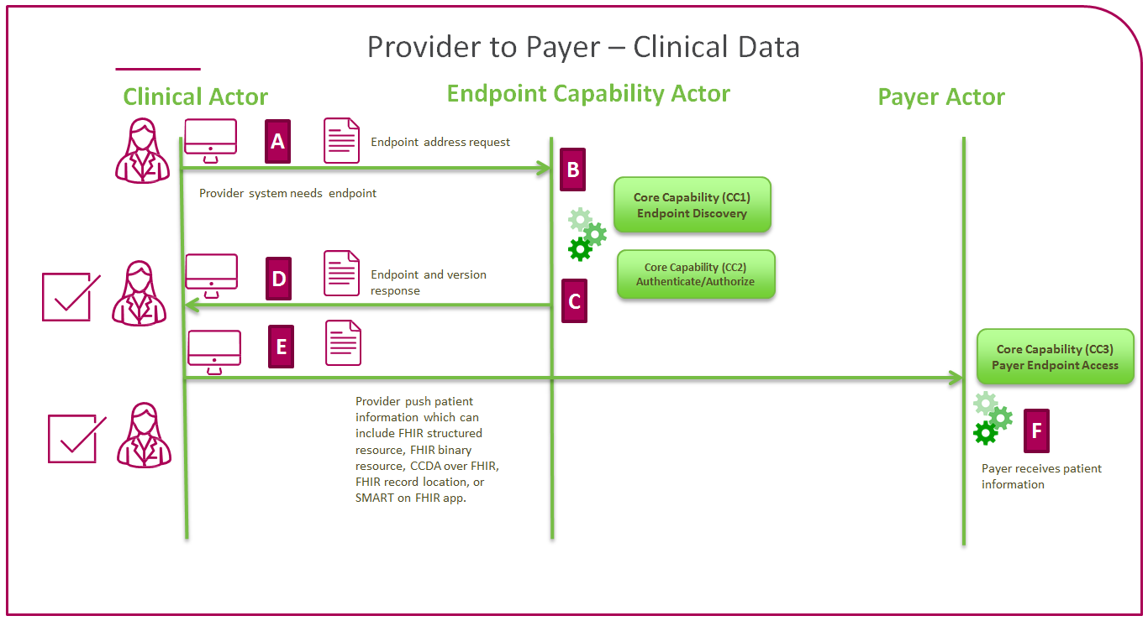

Primary Feature: As a payer, I need to be able to push patient’s (member) information to provider to improve outcomes, to promote value based care and to optimize clinical and administrative workflow.

- As a payer, I need my system to be able to securely determine the endpoint and version of a provider’s resource. Please see core capability 1 (CC1) and core capability 2 (CC2). (A:B:C:D referencing CC1 and CC2)
- As a payer, I need to send the appropriate payload to the provider for processing. See core capability 3 (CC4). (E:F referencing CC4)
- As a payer, I need some interactions to be synchronous and some to be asynchronous, but not necessarily both. If asynchronous, the request and response will be FHIR bulk data access compliant. (E:F referencing CC4)
- As a payer, in case of an error on the part of the mechanism or provider system, I need a meaningful and useful response. (E:F referencing CC4)

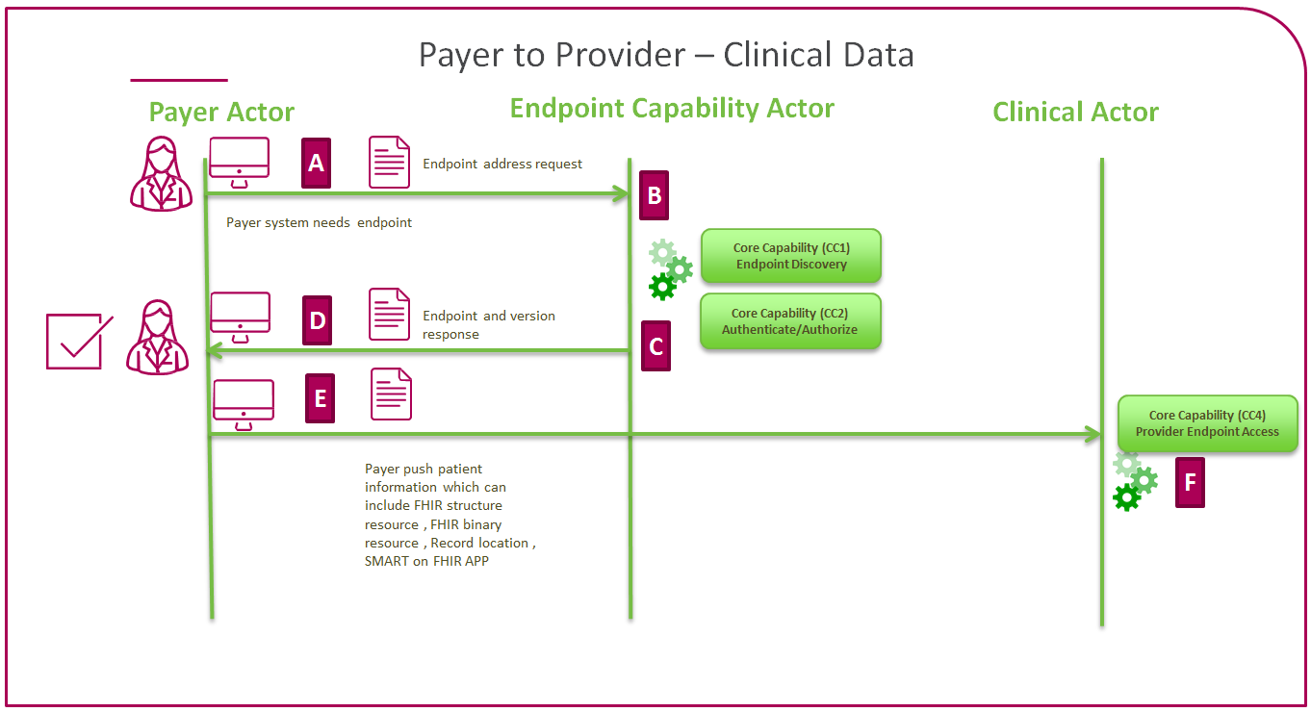

Primary Feature: As a provider, I need to be able to push patient’s (member) information to another provider (treating, specialist or any other clinical entity ) to improve outcomes, to promote value based care and to optimize clinical and administrative workflow.

- As a provider, I need my system to be able to securely determine the endpoint and version of a provider’s resource. Please see core capability 1 (CC1) and core capability 2 (CC2). (A:B:C:D referencing CC1 and CC2)
- As a provider, I need to send the appropriate payload to another provider for processing. See core capability 3 (CC4). (E:F referencing CC4)
- As a provider, I need some interactions to be synchronous and some to be asynchronous, but not necessarily both. If asynchronous, the request and response will be FHIR bulk data access compliant. (E:F referencing CC4)
- As a provider, in case of an error on the part of the mechanism or receiving provider system, I need a meaningful and useful response. (E:F referencing CC4)

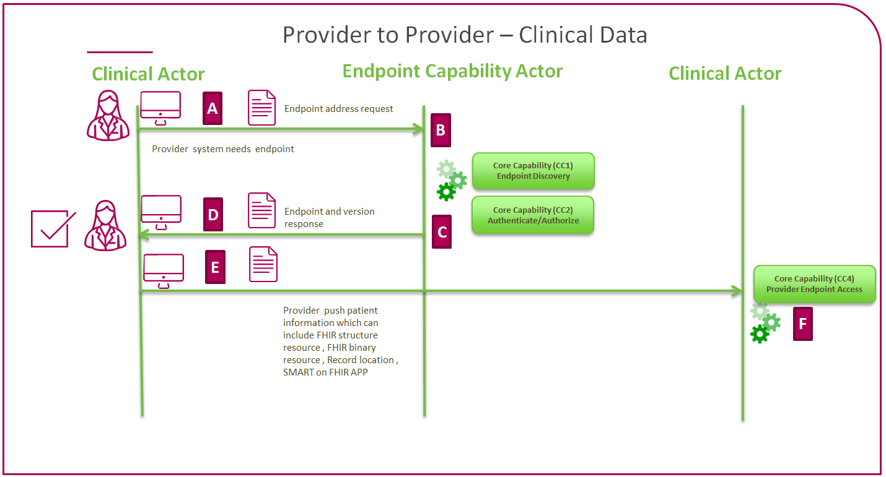

Special Requirements & Considerations

Issues

Frequency:

TBD

