FHIR at Scale Taskforce (FAST)

Use Case — Scheduling

Table of Contents
Revision History 2
Introduction & Background 3
Overview & Description 4
Scenarios 4
In Scope 5
Out of Scope 5
Assumptions 5
Primary Actors 6
Supporting Actors 6
Stakeholders & Interests 6
Pre-Conditions 7
Post Conditions 7
Failure End Condition 7
Trigger 7
Scenarios 8
Scenario 1 – Provider schedules services with other providers 8
Scenario 2 – Patient or caregiver schedules services with a provider 9
Scenario 3 – Payer schedules services with a provider 11
Scenario 4 – Provider schedules services with auxiliary services 12
Scenario 5 – Patient or caregiver schedules services with auxiliary services 14
Scenario 6 – Payer schedules services with auxiliary services 15
Scenario 7 – Provider queries other provider for scheduling information. 17
Scenario 8 – Payer queries provider for scheduling information 18
Scenario 9 – Patient or caregiver queries provider for scheduling information 19
Scenario 10 – Provider queries auxiliary service for scheduling information. 20
Scenario 11 – Payer queries auxiliary service for scheduling information 21
Scenario 12 – Patient or caregiver queries auxiliary service for scheduling information 23

Revision History
Version | Date | Author | Description of Change
1.0 |  | Chris Johnson | Initial published version of use case

Reference Documentation
- FAST-UC-Endpoint_Discovery-Core_ Capability-CC1
- FAST-UC-Authentication_and_Authorization-Core_Capability-CC2
- FAST-UC-Version_Identification-Core_Capability-CC3
- FAST-UC-Patient_and_Provider_ Identity_Management-Core_Capability-CC4
- FAST-UC-Push_Patient_Information

Introduction & Background
The purpose of the FHIR at Scale Taskforce (FAST) is to augment and support recent HL7® Fast Healthcare Interoperability Resources (FHIR®) efforts focused on ecosystem issues that, if mitigated, can accelerate adoption. One of the focus areas identified is the ability for providers and payers to schedule services for the patient.

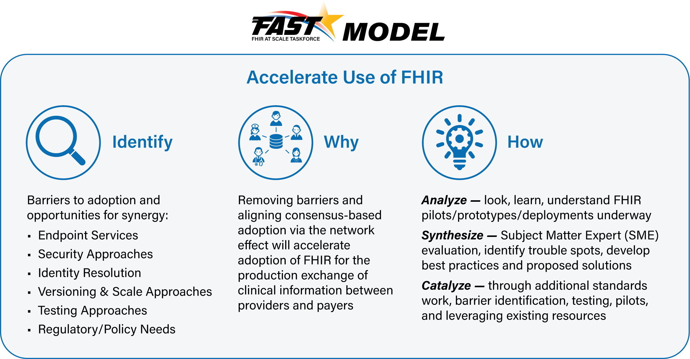

The FAST use case model is unique in that it describes ecosystem needs as opposed to specific functional needs. Use cases for FAST are derived in one of 3 approaches as described in the graphic below.
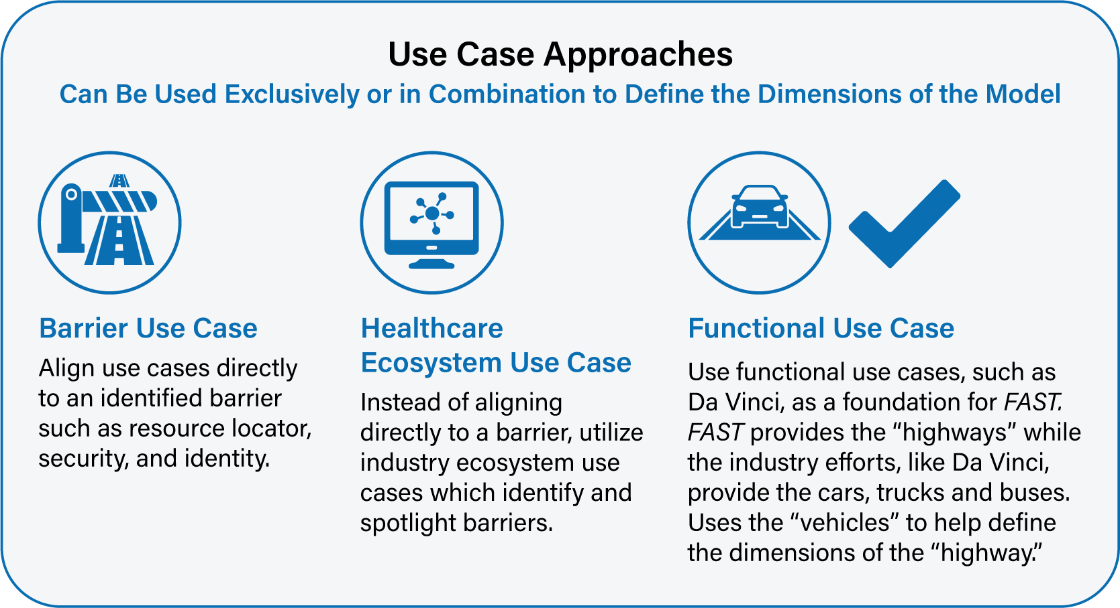

Overview & Description
This use case focuses on the ability for providers, patients, and payers to share information related to the scheduling of health care visits and services. This use case does include the administrative action of updating the Practice Management Systems or other scheduling solutions supported by the payers, patients, or providers.
The focus is not on the clinical or administrative functionality (which is covered under other use cases such as those in the Da Vinci initiative) but is instead on the ecosystem which supports those specific functional use cases to ensure an efficient and scalable model.

Scenarios
This use case focuses on ecosystem functionality supporting the ability for providers, patients, and payers to share information related to the scheduling of health care visits and services. Variations in the primary use case help to illustrate and define the desired functionality and include the following scenarios:
- Provider schedules services with other providers
- Patient or caregiver schedules services with a provider
- Payer schedules services with a provider
- Provider schedules services with auxiliary services
- Patient or caregiver schedules services with auxiliary services
- Payer schedules services with auxiliary services
- Provider queries other provider for scheduling information.
- Payer queries provider for scheduling information
- Patient or caregiver queries provider for scheduling information
- Provider queries auxiliary service for scheduling information
- Payer queries auxiliary service for scheduling information
- Patient or caregiver queries auxiliary service for scheduling information

In Scope
- Request by provider, patient, or payer to identify available time slots
- A provider, patient, or payer is able to respond with available time slots
- Request by provider, patient, or payer to reserve a time slot(s)
- Confirmation to the provider or payer of the reserved time slot(s)
- Provider or payer is able to search and confirm time slot reservation
- Some auxiliary services that are not point-of-care delivery but still affect outcomes and exist in the value-based care delivery continuum. (UBER, food delivery, and other SDOH events are examples)
- These communications can be synchronous or asynchronous

Out of Scope
- Any HIPAA defined functional transactions
- Any patient’s consent process related to information sharing
- Coverage Requirements, as this is done in another use case (see FAST -UC-Patient_Information_Request_Provider_to_Plan)
- Approval for coverage has been completed in another use case
- Determination of in-network or out-of-network services is out of scope. That is determined by the providers, payers, and patients.
- Referrals, patient history, and other supporting documentation that normally go with a scheduling process are not in scope for this use case

Assumptions
- Other initiatives, such as Da Vinci, are covering the clinical or administrative functional use cases
- The primary goal of the use case is to describe ecosystem needs to support the functional use cases
- Transactions will explicitly be declared as synchronous or asynchronous
- HIPAA Minimum Necessary requirements will be addressed by core capability use cases, Endpoint Discovery (see FAST -UC-Endpoint_Discovery-Core_Capability-CC1), Security (see FAST -UC-Authentication_and_Authorization-Core_Capability-CC2), Versioning (see FAST -UC-Version_Identification-Core_Capability-CC3) and Patient Provider Identification (see FAST -UC-Patient_and_Provider_Identity_Management-Core_Capability-CC4) are out of scope for this document
- Providers and plans will comply with federal and state laws for sharing any information
- The actors in this use case have an Application Programming Interface (API)-enabled scheduling system
- A privacy and security model that controls how caregivers can access and modify the schedule event, based on role-based permissions (see FAST -UC-Authentication_and_Authorization-Core_Capabiltiy-CC2)
- Internal capability to use and integrate the HL7 FHIR resource for scheduling

Primary Actors
- Primary providers, specialists, hospitals, other clinical caregivers
- Patient, patient’s authorized representatives and family caregivers
- Payers
- EHRs (primary actor due largely to automation of services and functions)

Supporting Actors
- Payer clinical care coordination and case management teams
- Supporting clinical entities, eg, pharmacies, laboratories, skilled nursing facilities, physical therapists, nutritionists, etc
- Community and home-based health services, eg, community clinics, community services, school clinics, urgent clinics, assisted living, foster care, nutrition services, transportation services
- Public health services such as public health agencies, social services (State Agencies)
- Other providers
- Auxiliary services such as UBER, LYFT (Social Determinants of Health)

Stakeholders & Interests
- Payer/plan – As an active stakeholder, has interest in assisting patients with the scheduling of health care services to improve the patient’s overall health and close gaps in care
- Provider – As an active stakeholder, has interest in assisting patients with the scheduling of health care services to improve the patient’s overall health and close gaps in care
- Federal and State Govt. – As a stakeholder, in long term has interest in assisting patients with the scheduling of health care services to improve the patient’s overall health and close gaps in care in order to provide a healthy population
- CMS – As an active stakeholder, has interest in Medicare/Medicaid patients benefitting from the timely, actionable, and accurate exchange of information
- EHR – As a stakeholder, has interest that payers, providers, patients, and care team members can easily schedule access to health care services
- Standards Organization – As a stakeholder, in long term has interest to ensure that the exchange models are highly scalable and efficient
- Public Health Entities – As a stakeholder, in long term have interest in patients benefitting from timely, actionable, and accurate exchange of information that prevent diseases, prolong life and promote the human health of a community or society.
- Auxiliary Service providers – For this use case, auxiliary services such as rideshare entities, food delivery services, and others that as generalized with Social Determinants of Health (SDOH) can be described as an auxiliary service provider

Pre-Conditions
- The process is triggered by the patient or caregiver, provider or supporting staff, or payer care team member
- Each actor has an electronically accessible scheduling mechanism
- The EHR or other clinical system, payer/plan, patient or care team member, and other actors have adopted the FHIR model, including those arising from the FAST initiative

Post Conditions
- Provider, patient or caregiver, or payer has been able to observe potential schedule time slots and reserve one if necessary
- Provider, patient or caregiver, or payer is able to query to discover scheduling information
- The information was received in a manner timely enough to be effective and as to not impact workflow
- The information is understandable by the clinical, support staff, patient, care team member, payer, or the machine
- The transaction did not cause undue burden in terms of wait time or unusable message
- In the event of an error, the information returned does not leave the clinician, support staff, patient, care team member, payer, or system in a state of not knowing the path forward

Failure End Condition
- The post conditions defined above are not met

Trigger
- The process is triggered by the provider or supporting staff, patient, or payer, or EHR on behalf of the provider

Scenarios
Scenario 1 – Provider schedules services with other providers
Primary Feature: As a provider, I need to be able to access and schedule calendar events with other providers to improve outcomes and provide value-based care to patients and to optimize clinical and administrative workflow. “Other providers” is not tightly defined for this use case. It could be a lab, a hospital system, a specialist, or a generalist.
Please note that core capabilities are defined in separate documents and referenced from here. Please see those documents for full details of the core capabilities.
- As a provider, I need my system to be able to securely determine the endpoint and version of another provider’s or auxiliary service’s resource. Please see FAST-UC-Endpoint_Discovery-Core_Capability-CC1 and FAST-UC-Version_Identification-Core_Capability-CC3. (A:B:C:D)
- As a provider, I need to send the appropriate payload to the other provider for processing. (E:F)
- As a provider, I need my system to be able to send the request for scheduling options to the other provider’s endpoint in a trusted and secure way and to ensure proper authentication and authorization. See FAST-UC-Authentication_and_Authorization-Core_Capability-CC2. (E:F)
- As a provider, I need some interactions to be synchronous and some to be asynchronous, but not necessarily both. If asynchronous, the request and response will be FHIR-bulk data access compliant. (E:F:G)
- As a provider in the ecosystem, I need to be able to conform to the FAST-UC-Patient_and_Provider_Identity_Management-Core_Capability-CC4 use case and the FAST-UC-Push_Patient_Information use case to ensure the patient is uniquely identified and access to that patient’s health information is properly authorized. (F:)
- As a provider, I need the other provider’s system to respond in an agreed upon time frame with scheduling options. (G:)
- As a provider, I need to be able to respond to the other provider’s system with a selected date/time for an appointment and receive a confirmation. (H:I:)
- As a provider, in the case of an error on the part of the mechanism of the other provider system, I need a meaningful and useful response. (F:G)

Supporting Diagrams & Flows
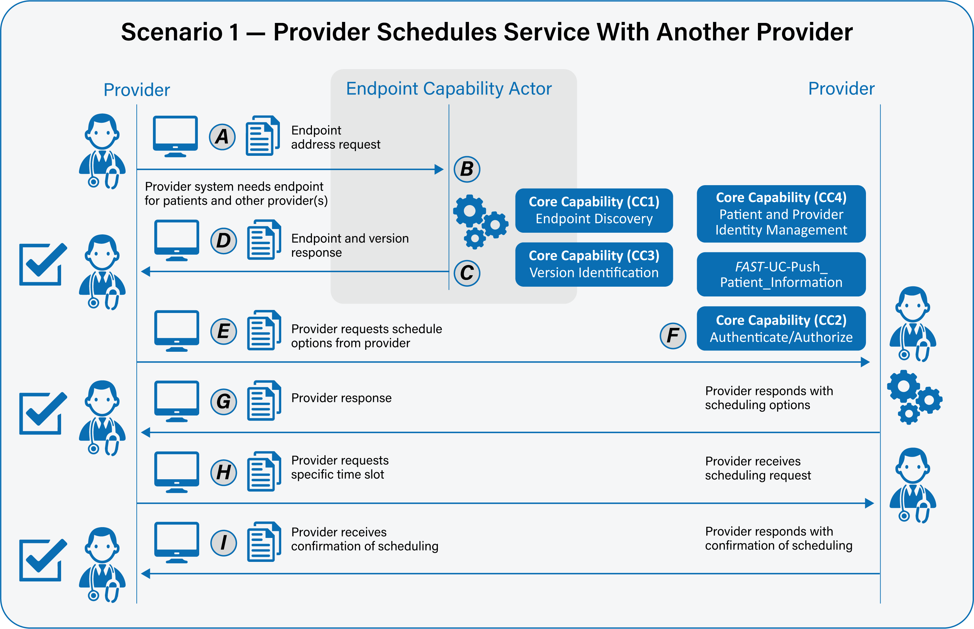

Scenario 2 – Patient or caregiver schedules services with a provider
Primary Feature: As a patient or caregiver, I need to be able to access and schedule calendar events with providers to improve outcomes for myself or my family member. “Providers” is not tightly defined for this use case. It could be a lab, a hospital system, a specialist, or a generalist.
Please note that core capabilities are defined in separate documents and referenced from here. Please see those documents for full details of the core capabilities.
- As a patient or caregiver, I need my system to be able to securely determine the endpoint and version of a provider’s resource. Please see FAST-UC-Endpoint_Discovery-Core_Capability-CC1 and FAST-UC-Version_Identification-Core_Capability-CC3. (A:B:C:D)
- As a patient or caregiver, I need to send the appropriate payload to the provider for processing. (E:F)
- As a patient or caregiver, I need my system to be able to send the request for scheduling options to the provider’s endpoint in a trusted and secure way and to ensure proper authentication and authorization. See FAST-UC-Authentication_and_Authorization-Core_Capability-CC2. (E:F)
- As a patient or caregiver, I need some interactions to be synchronous and some to be asynchronous, but not necessarily both. If asynchronous, the request and response will be FHIR- bulk data access compliant. (E:F:G)
- As a patient or caregiver in the ecosystem, I need to be able to conform to the FAST-UC-Patient_and_Provider_Identity_Management-Core_Capability-CC4 use case and the FAST-UC-Push_Patient_Information use case to ensure the patient is uniquely identified and access to that patient’s health information is properly authorized. (F:)
- As a patient or caregiver, I need the provider’s system to respond in an agreed upon time frame with scheduling options. (G:)
- As a patient or caregiver, I need to be able to respond to the provider’s system with a selected date/time for an appointment and receive a confirmation. (H:I:)
- As a patient or caregiver, in the case of an error on the part of the mechanism of the provider system, I need a meaningful and useful response. (F:G)
Supporting Diagrams & Flows
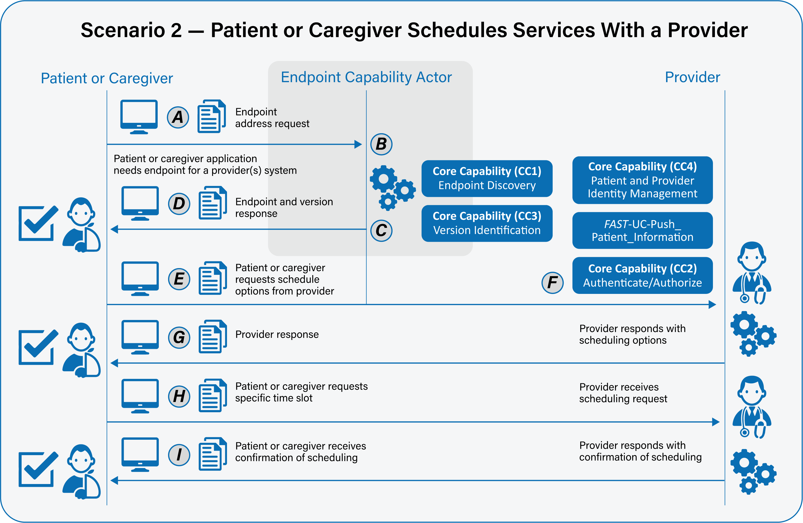

Scenario 3 – Payer schedules services with a provider
Primary Feature: As a payer, I need to be able to access and schedule calendar events with providers to improve outcomes and provide value-based care to patients and to optimize clinical and administrative workflow. “Providers” is not tightly defined for this use case. It could be a lab, a hospital system, a specialist, or a generalist.
Please note that core capabilities are defined in separate documents and referenced from here. Please see those documents for full details of the core capabilities.
- As a payer, I need my system to be able to securely determine the endpoint and version of a provider’s resource. Please see FAST-UC-Endpoint_Discovery-Core_Capability-CC1 and FAST-UC-Version_Identification-Core_Capability-CC3. (A:B:C:D)
- As a payer, I need to send the appropriate payload to the provider for processing. (E:F)
- As a payer, I need my system to be able to send the request for scheduling options to the provider’s endpoint in a trusted and secure way and to ensure proper authentication and authorization. See FAST-UC-Authentication_and_Authorization-Core_Capability-CC2. (E:F)
- As a payer, I need some interactions to be synchronous and some to be asynchronous, but not necessarily both. If asynchronous, the request and response will be FHIR-bulk data access compliant. (E:F:G)
- As a payer in the ecosystem, I need to be able to conform to the FAST-UC-Patient_and_Provider_Identity_Management-Core_Capability-CC4 use case and the FAST-UC-Push_Patient_Information use case to ensure the patient is uniquely identified and access to that patient’s health information is properly authorized. (F:)
- As a payer, I need the provider’s system to respond in an agreed upon time frame with scheduling options. (G:)
- As a payer, I need to be able to respond to the other provider’s system with a selected date/time for an appointment and receive a confirmation. (H:I:)
- As a payer, in the case of an error on the part of the mechanism of the provider system, I need a meaningful and useful response. (F:G)

Supporting Diagrams & Flows
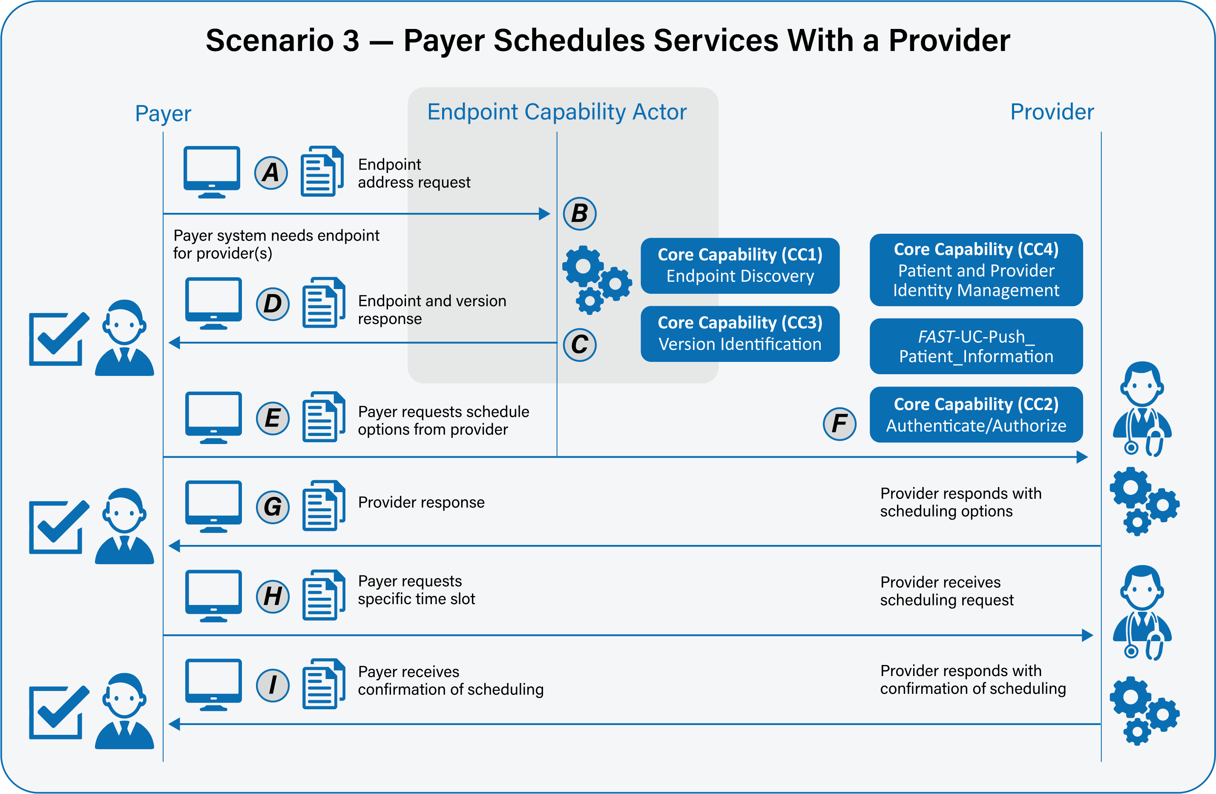

Scenario 4 – Provider schedules services with auxiliary services
Primary Feature: As a provider, I need to be able to access and schedule calendar events with an auxiliary service to improve outcomes and provide value-based care to patients and to optimize clinical and administrative workflow.
Please note that core capabilities are defined in separate documents and referenced from here. Please see those documents for full details of the core capabilities.
- As a provider, I need my system to be able to securely determine the endpoint and version of an auxiliary service’s resource. Please see FAST-UC-Endpoint_Discovery-Core_Capability-CC1 and FAST-UC-Version_Identification-Core_Capability-CC3. (A:B:C:D)
- As a provider, I need to send the appropriate payload to the auxiliary service for processing. (E:F)
- As a provider, I need my system to be able to send the request for scheduling options to the other auxiliary service’s endpoint in a trusted and secure way and to ensure proper authentication and authorization. See FAST-UC-Authentication_and_Authorization-Core_Capability-CC2. (E:F)
- As a provider, I need some interactions to be synchronous and some to be asynchronous, but not necessarily both. If asynchronous, the request and response will be FHIR-bulk data access compliant. (E:F:G)
- As a provider in the ecosystem, I need to be able to conform to the FAST-UC-Patient_and_Provider_Identity_Management-Core_Capability-CC4 use case and the FAST-UC-Push_Patient_Information use case to ensure the patient is uniquely identified and access to that patient’s health information is properly authorized. (F:)
- As a provider, I need the auxiliary service’s system to respond in an agreed upon time frame with scheduling options. (G:)
- As a provider, I need to be able to respond to the auxiliary service’s system with a selected date/time for an appointment and receive a confirmation. (H:I:)
- As a provider, in the case of an error on the part of the mechanism of the auxiliary service system, I need a meaningful and useful response. (F:G)
Supporting Diagrams & Flows
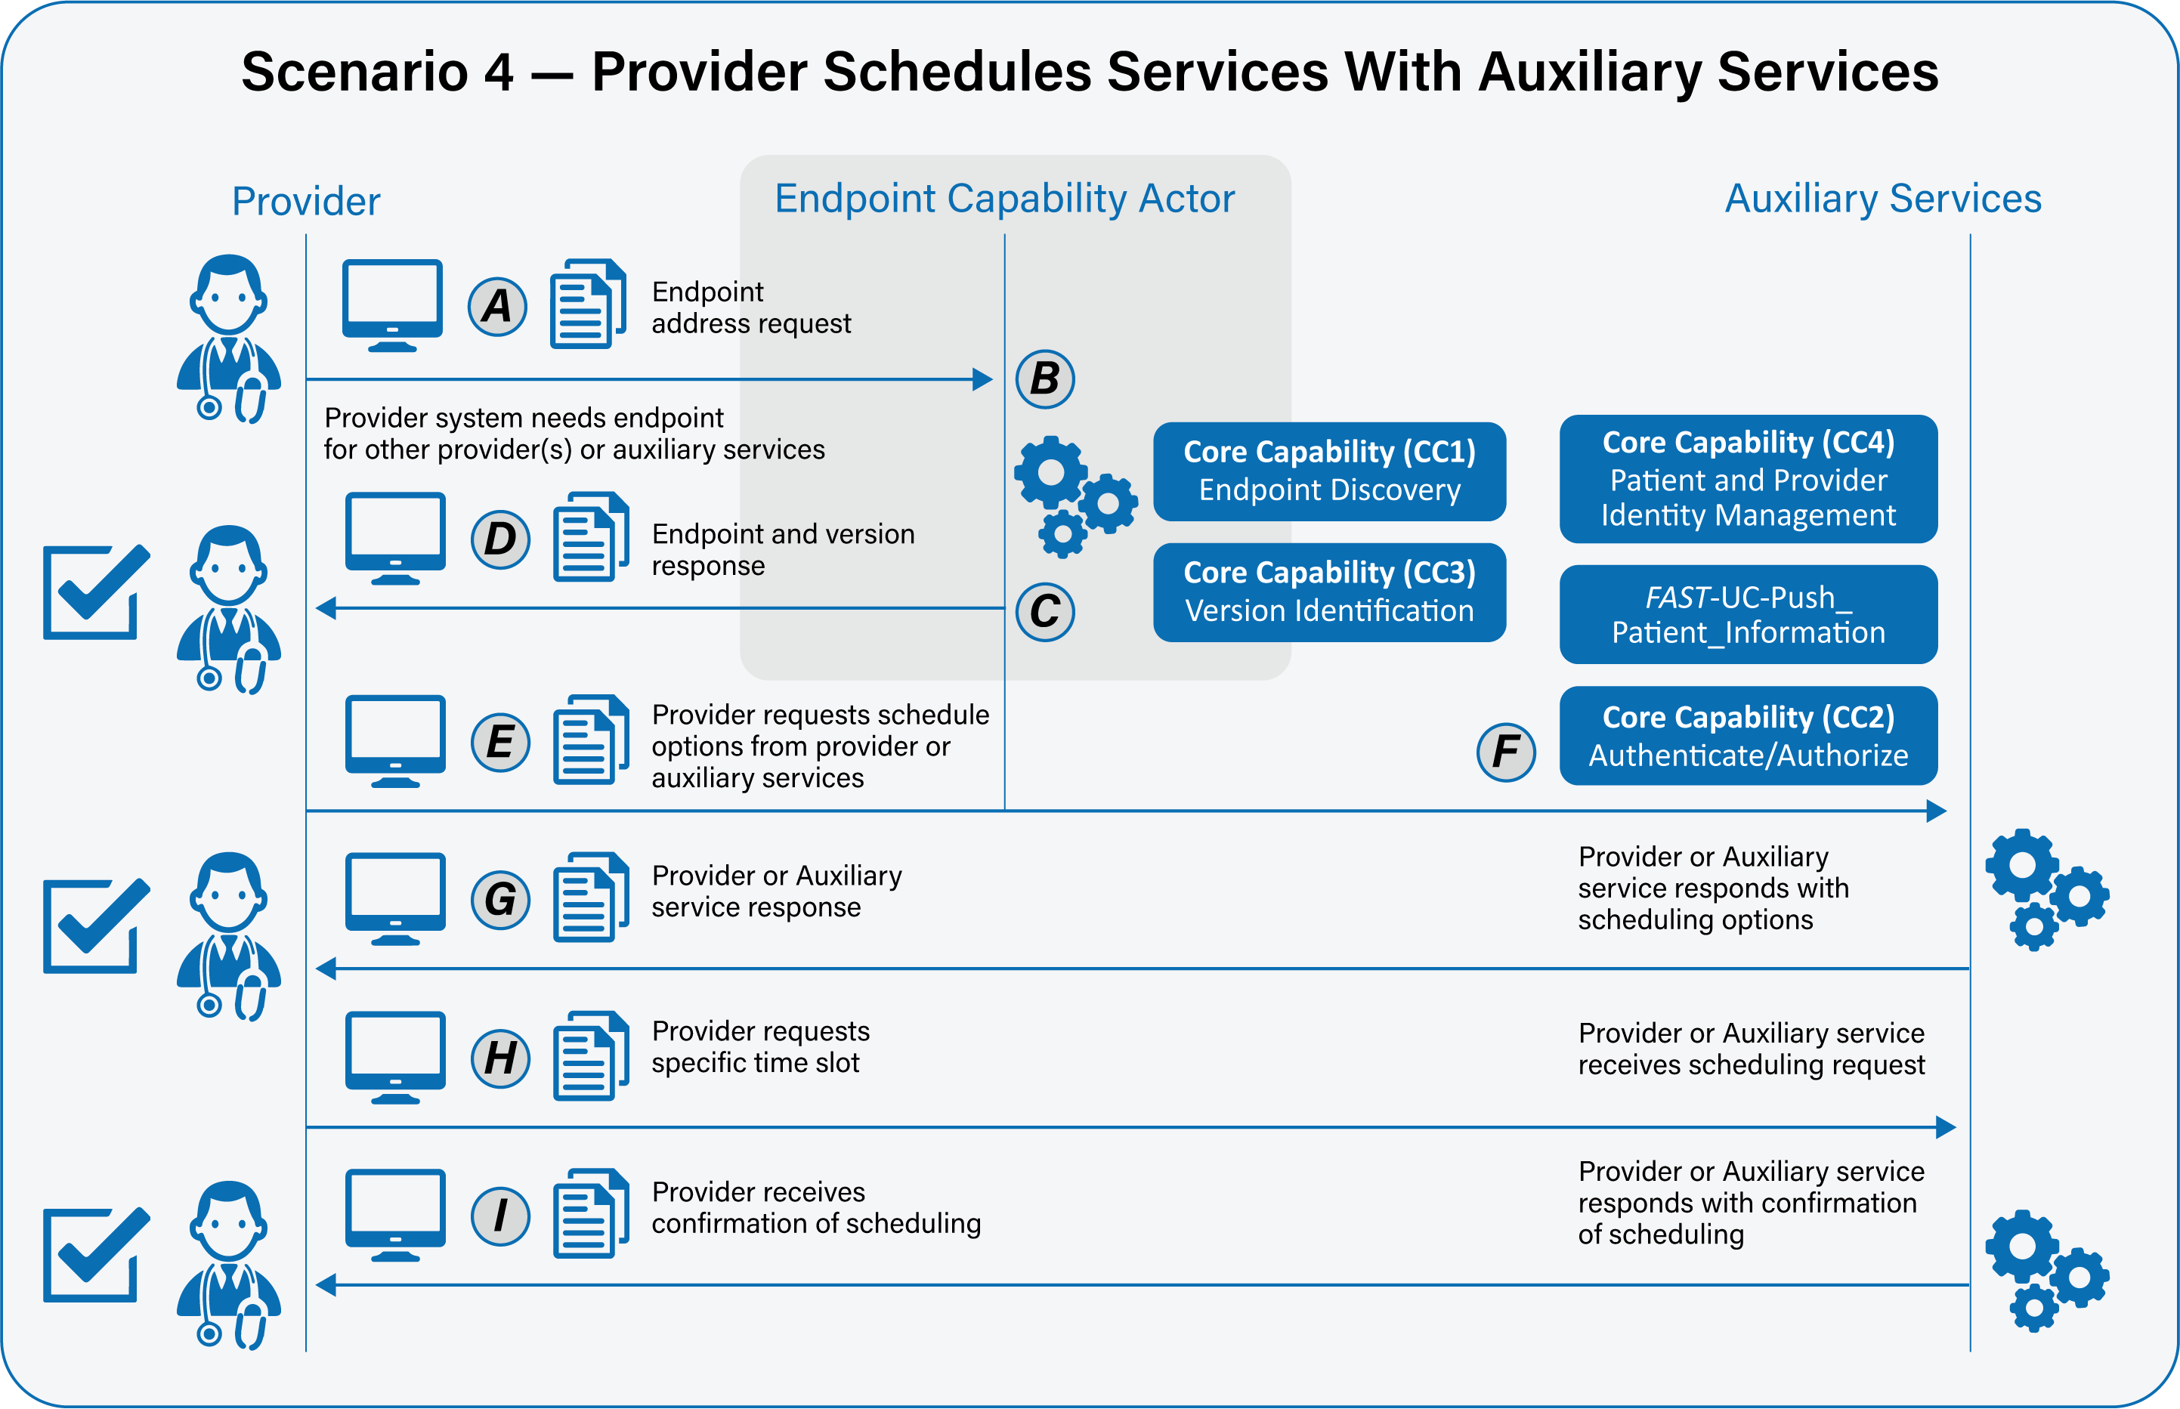

Scenario 5 – Patient or caregiver schedules services with auxiliary services
Primary Feature: As a patient or caregiver, I need to be able to access and schedule calendar events with an auxiliary service to improve outcomes for myself or my family member.
Please note that core capabilities are defined in separate documents and referenced from here. Please see those documents for full details of the core capabilities.
- As a patient or caregiver, I need my system to be able to securely determine the endpoint and version of an auxiliary service’s resource. Please see FAST-UC-Endpoint_Discovery-Core_Capability-CC1 and FAST-UC-Version_Identification-Core_Capability-CC3. (A:B:C:D)
- As a patient or caregiver, I need to send the appropriate payload to the auxiliary service for processing. (E:F)
- As a patient or caregiver, I need my system to be able to send the request for scheduling options to the auxiliary service’s endpoint in a trusted and secure way and to ensure proper authentication and authorization. See FAST-UC-Authentication_and_Authorization-Core_Capability-CC2. (E:F:)
- As a patient or caregiver, I need some interactions to be synchronous and some to be asynchronous, but not necessarily both. If asynchronous, the request and response will be FHIR- bulk data access compliant. (E:F:G)
- As a patient or caregiver in the ecosystem, I need to be able to conform to the FAST-UC-Patient_and_Provider_Identity_Management-Core_Capability-CC4 use case and the FAST-UC-Push_Patient_Information use case to ensure the patient is uniquely identified and access to that patient’s health information is properly authorized. (F:)
- As a patient or caregiver, I need the auxiliary service’s system to respond in an agreed upon time frame with scheduling options. (G)
- As a patient or caregiver, I need to be able to respond to the auxiliary service’s system with a selected date/time for an appointment and receive a confirmation. (H:I:)
- As a patient or caregiver, in the case of an error on the part of the mechanism of the auxiliary service system, I need a meaningful and useful response. (F:G)

Supporting Diagrams & Flows
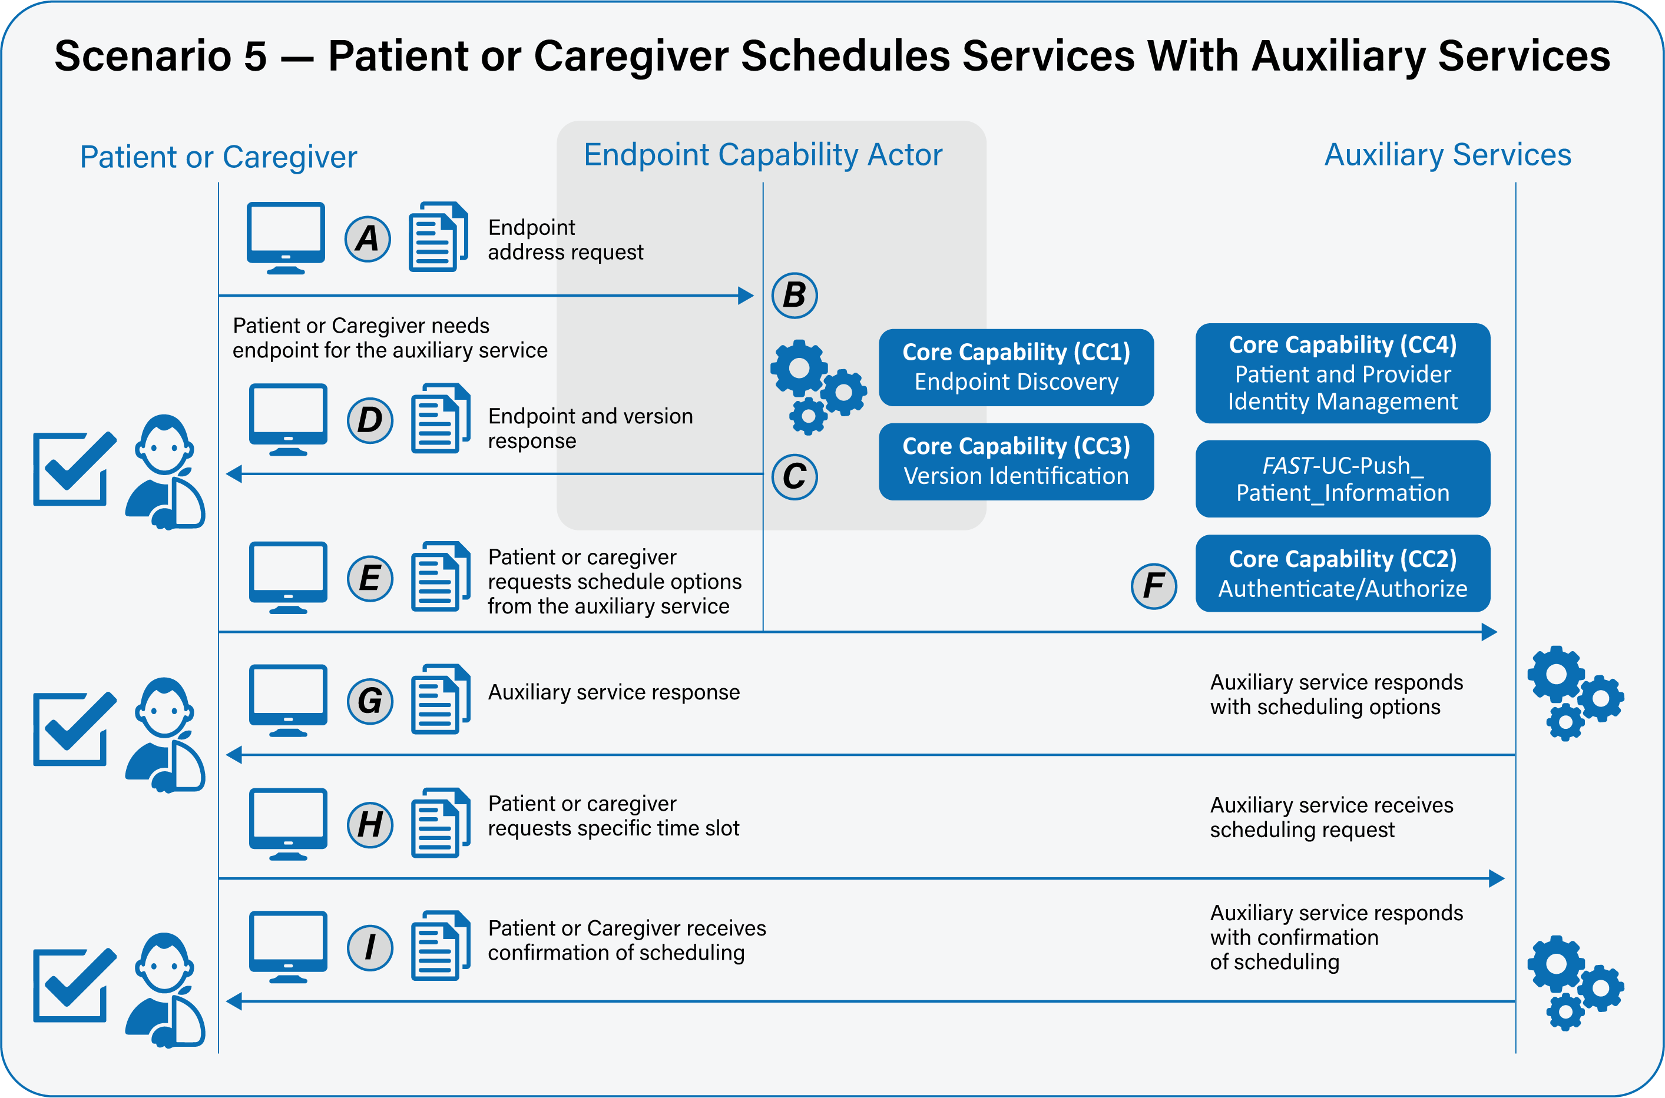

Scenario 6 – Payer schedules services with auxiliary services
Primary Feature: As a payer, I need to be able to access and schedule calendar events with auxiliary services to improve outcomes and provide value-based care to patients and to optimize clinical and administrative workflow.
Please note that core capabilities are defined in separate documents and referenced from here. Please see those documents for full details of the core capabilities.
- As a payer, I need my system to be able to securely determine the endpoint and version of an auxiliary service’s resource. Please see FAST-UC-Endpoint_Discovery-Core_Capability-CC1 and FAST-UC-Version_Identification-Core_Capability-CC3. (A:B:C:D)
- As a payer, I need to send the appropriate payload to the auxiliary service for processing. (E:F)
- As a payer, I need my system to be able to send the request for scheduling options to the auxiliary service’s endpoint in a trusted and secure way and to ensure proper authentication and authorization. See FAST-UC-Authentication_and_Authorization-Core_Capability-CC2. (E:F)
- As a payer, I need some interactions to be synchronous and some to be asynchronous, but not necessarily both. If asynchronous, the request and response will be FHIR-bulk data access compliant. (E:F:G)
- As a payer in the ecosystem, I need to be able to conform to the FAST-UC-Patient_and_Provider_Identity_Management-Core_Capability-CC4 use case and the FAST-UC-Push_Patient_Information use case to ensure the patient is uniquely identified and access to that patient’s health information is properly authorized. (F:)
- As a payer, I need the auxiliary service’s system to respond in an agreed upon time frame with scheduling options. (G)
- As a payer I need to be able to respond to the auxiliary service’s system with a selected date/time for an appointment and receive a confirmation. (H:I:)
- As a payer, in the case of an error on the part of the mechanism of the auxiliary service system, I need a meaningful and useful response. (F:G)
Supporting Diagrams & Flows
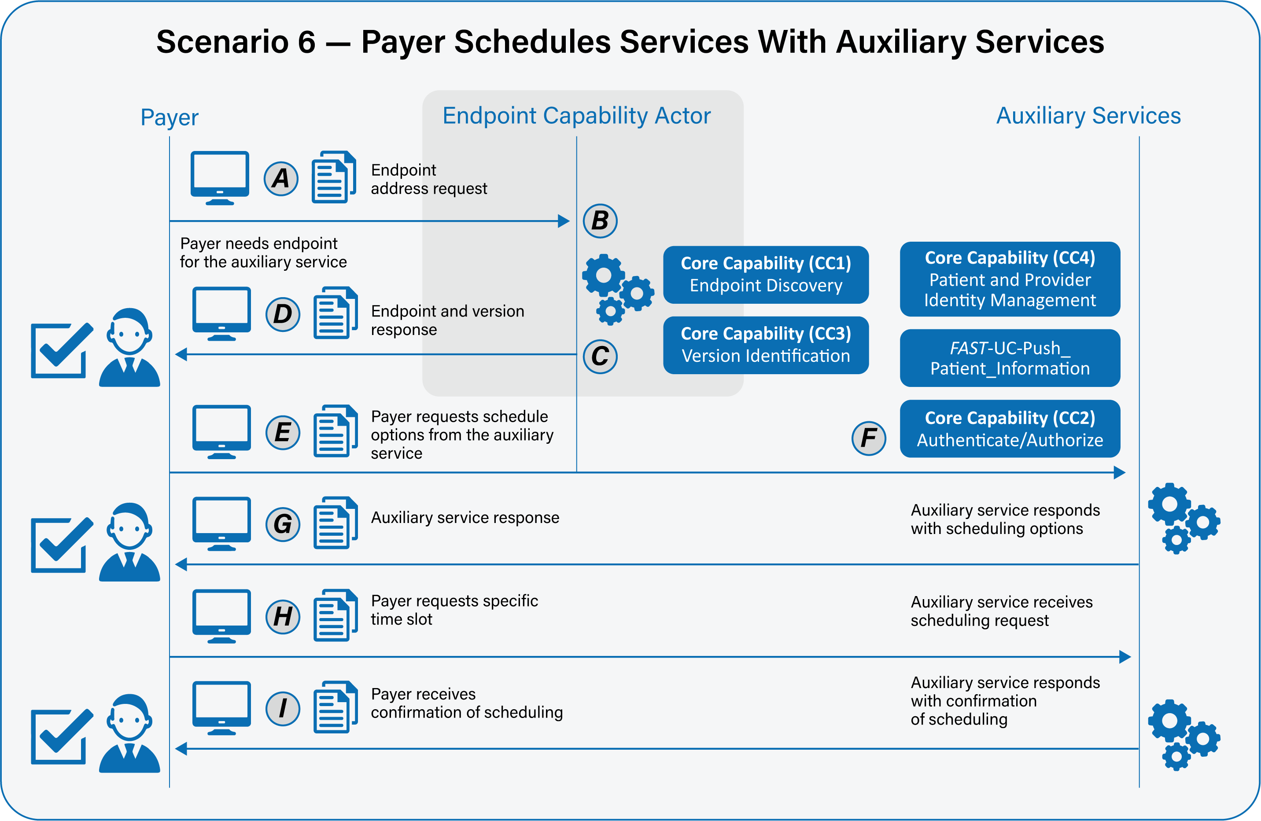

Scenario 7 – Provider queries other provider for scheduling information
Primary Feature: As a provider, I need to be able to query scheduling information with other providers to improve outcomes and provide value-based care to patients and to optimize clinical and administrative workflow. “Other providers” is not tightly defined for this use case. It could be a lab, a hospital system, a specialist, or a generalist.
Please note that core capabilities are defined in separate documents and referenced from here. Please see those documents for full details of the core capabilities.
- As a provider, I need my system to be able to securely determine the endpoint and version of another provider’s resource. Please see FAST-UC-Endpoint_Discovery-Core_Capability-CC1 and FAST-UC-Version_Identification-Core_Capability-CC3. (A:B:C:D)
- As a provider, I need to send the appropriate payload to the other provider for processing. (E:F)
- As a provider, I need my system to be able to request scheduling information from the other provider’s endpoint in a trusted and secure way and to ensure proper authentication and authorization. See FAST-UC-Authentication_and_Authorization-Core_Capability-CC2. (E:F)
- As a provider, I need some interactions to be synchronous and some to be asynchronous, but not necessarily both. If asynchronous, the request and response will be FHIR-bulk data access compliant. (E:F:G)
- As a provider in the ecosystem, I need to be able to conform to the FAST-UC-Patient_and_Provider_Identity_Management-Core_Capability-CC4 use case and the FAST-UC-Push_Patient_Information use case to ensure the patient is uniquely identified and access to that patient’s health information is properly authorized. (F)
- As a provider, I need the other provider’s system to respond in an agreed upon time frame with the scheduling information. (G)
- As a provider, in the case of an error on the part of the mechanism or other provider system, I need a meaningful and useful response. (F:G)

Supporting Diagrams & Flows
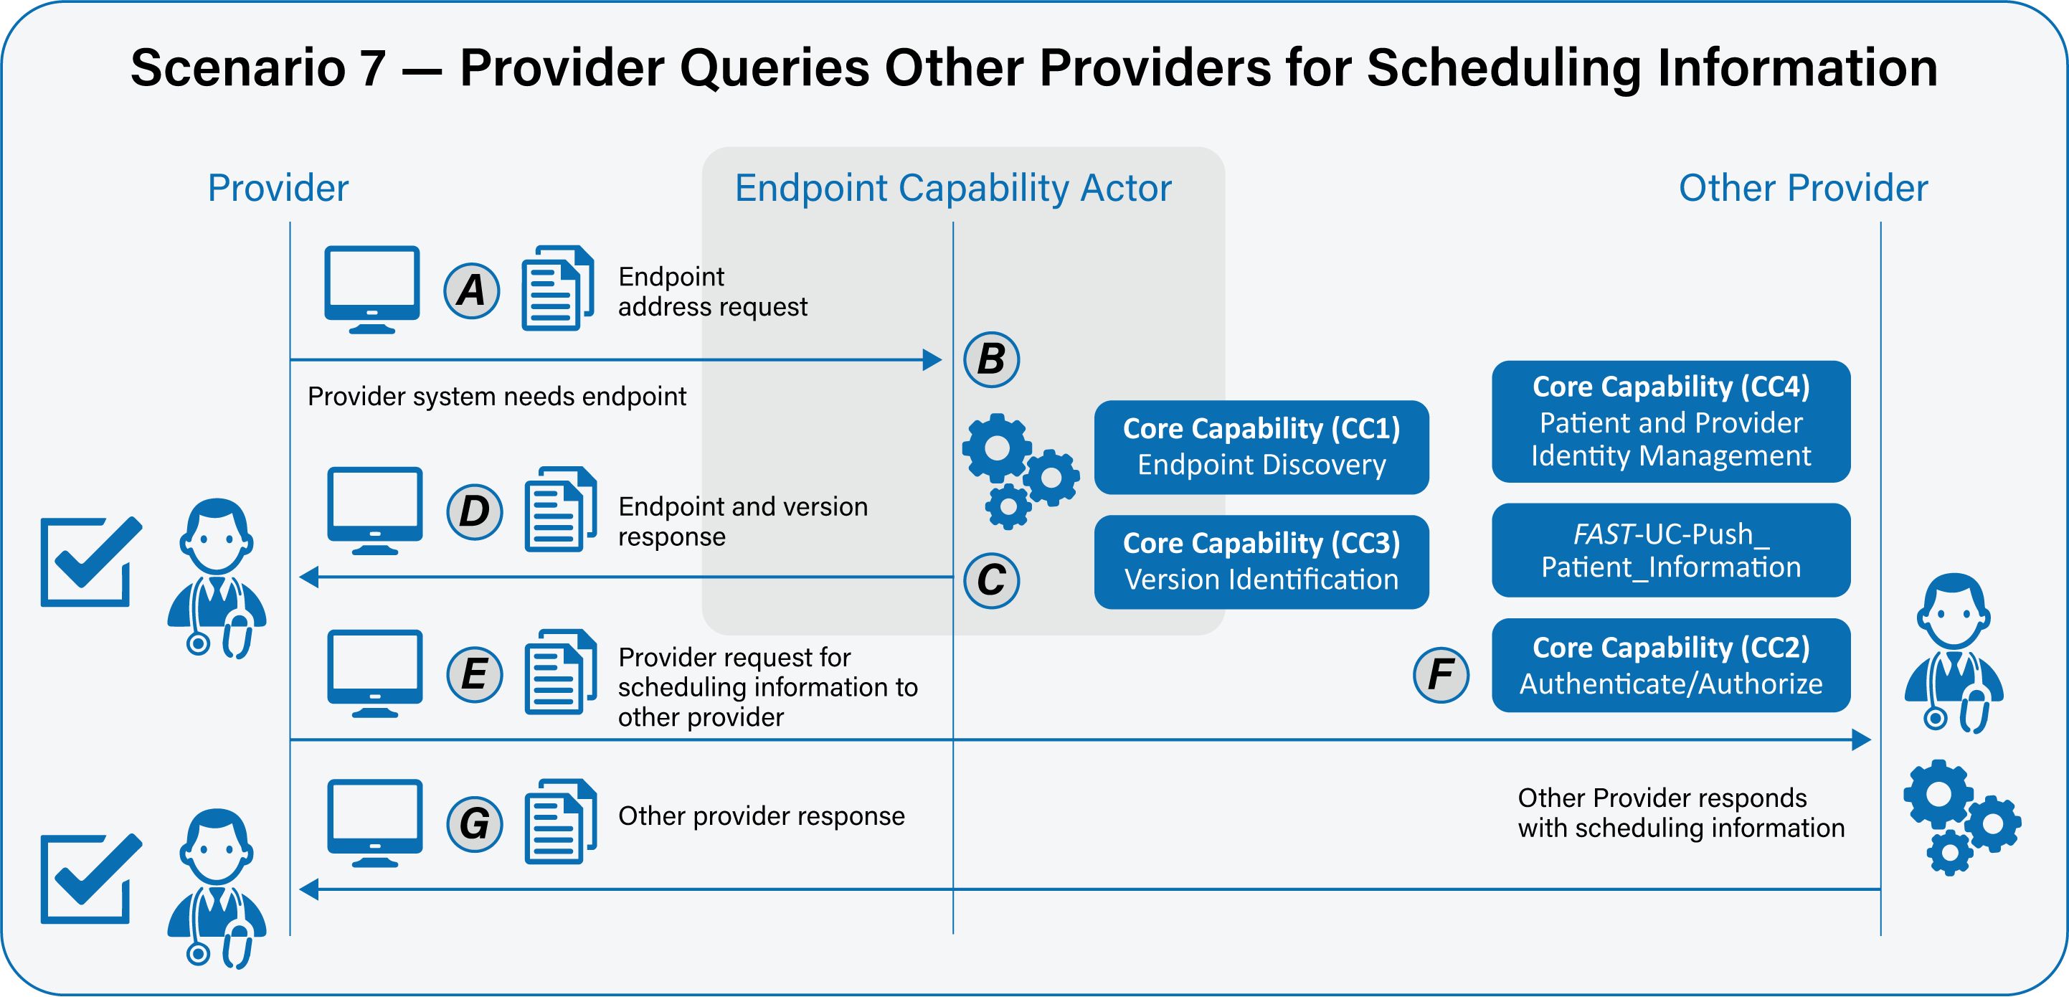

Scenario 8 – Payer queries provider for scheduling information
Primary Feature: As a payer, I need to be able to query scheduling information with providers to improve outcomes and provide value-based care to patients and to optimize clinical and administrative workflow. “Providers” is not tightly defined for this use case. It could be a lab, a hospital system, a specialist, or a generalist.
Please note that core capabilities are defined in separate documents and referenced from here. Please see those documents for full details of the core capabilities.
- As a payer, I need my system to be able to securely determine the endpoint and version of a provider’s resource. Please see FAST-UC-Endpoint_Discovery-Core_Capability-CC1 and FAST-UC-Version_Identification-Core_Capability-CC3. (A:B:C:D)
- As a payer, I need to send the appropriate payload to the provider for processing. (E:F)
- As a payer, I need my system to be able to request a scheduling confirmation from the provider’s endpoint in a trusted and secure way and to ensure proper authentication and authorization. See FAST-UC-Authentication_and_Authorization-Core_Capability-CC2. (E:F)
- As a payer, I need some interactions to be synchronous and some to be asynchronous, but not necessarily both. If asynchronous, the request and response will be FHIR-bulk data access compliant. (E:F:G)
- As a payer in the ecosystem, I need to be able to conform to the FAST-UC-Patient_and_Provider_Identity_Management-Core_Capability-CC4 use case and the FAST-UC-Push_Patient_Information use case to ensure the patient is uniquely identified and access to that patient’s health information is properly authorized. (F)
- As a payer, I need the provider’s system to respond in an agreed upon time frame with the scheduling information. (G)
- As a payer, in the case of an error on the part of the mechanism of the provider system, I need a meaningful and useful response. (F:G)
Supporting Diagrams & Flows
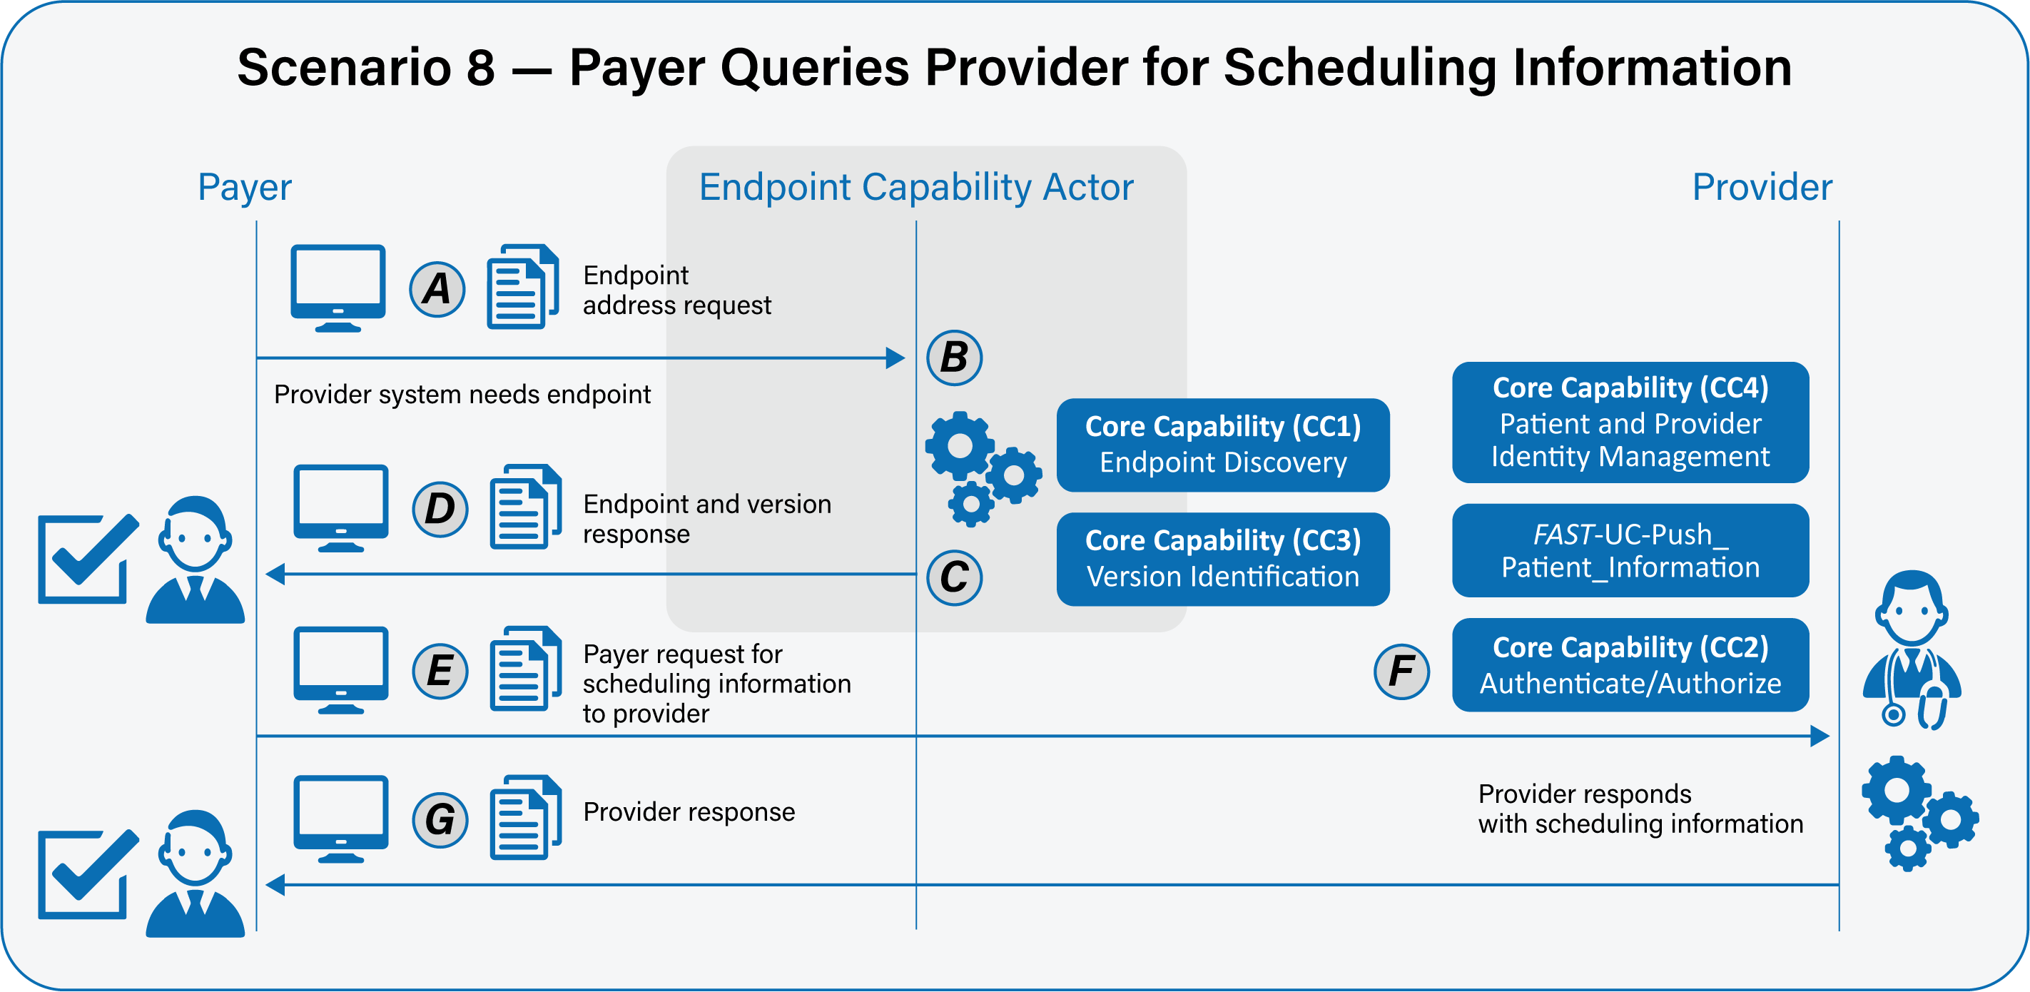

Scenario 9 – Patient or caregiver queries provider for scheduling information
Primary Feature: As a patient or caregiver, I need to be able to query scheduling information with providers to improve outcomes and provide value-based care to patients and to optimize clinical and administrative workflow. “Providers” is not tightly defined for this use case. It could be a lab, a hospital system, a specialist, or a Generalist.
Please note that core capabilities are defined in separate documents and referenced from here. Please see those documents for full details of the core capabilities.
- As a patient or caregiver, I need my system to be able to securely determine the endpoint and version of a provider’s resource. Please see FAST-UC-Endpoint_Discovery-Core_Capability-CC1 and FAST-UC-Version_Identification-Core_Capability-CC3. (A:B:C:D)
- As a patient or caregiver, I need to send the appropriate payload to the provider for processing. (E:F)
- As a patient or caregiver, I need my system to be able to request a scheduling information from the provider’s endpoint in a trusted and secure way and to ensure proper authentication and authorization. See FAST-UC-Authentication_and_Authorization-Core_Capability-CC2. (E:F)
- As a patient or caregiver, I need some interactions to be synchronous and some to be asynchronous, but not necessarily both. If asynchronous, the request and response will be FHIR bulk data access compliant. (E:F:G)
- As a patient or caregiver in the ecosystem I need to be able to conform to the FAST-UC-Patient_and_Provider_Identity_Management-Core_Capability-CC4 use case and the FAST-UC-Push_Patient_Information use case to ensure the patient is uniquely identified and access to that patient’s health information is properly authorized. (F)
- As a patient or caregiver, I need the provider’s system to respond in an agreed upon time frame with the scheduling information. (G)
- As a patient or caregiver, in the case of an error on the part of the mechanism of the provider system, I need a meaningful and useful response. (F:G)
Supporting Diagrams & Flows
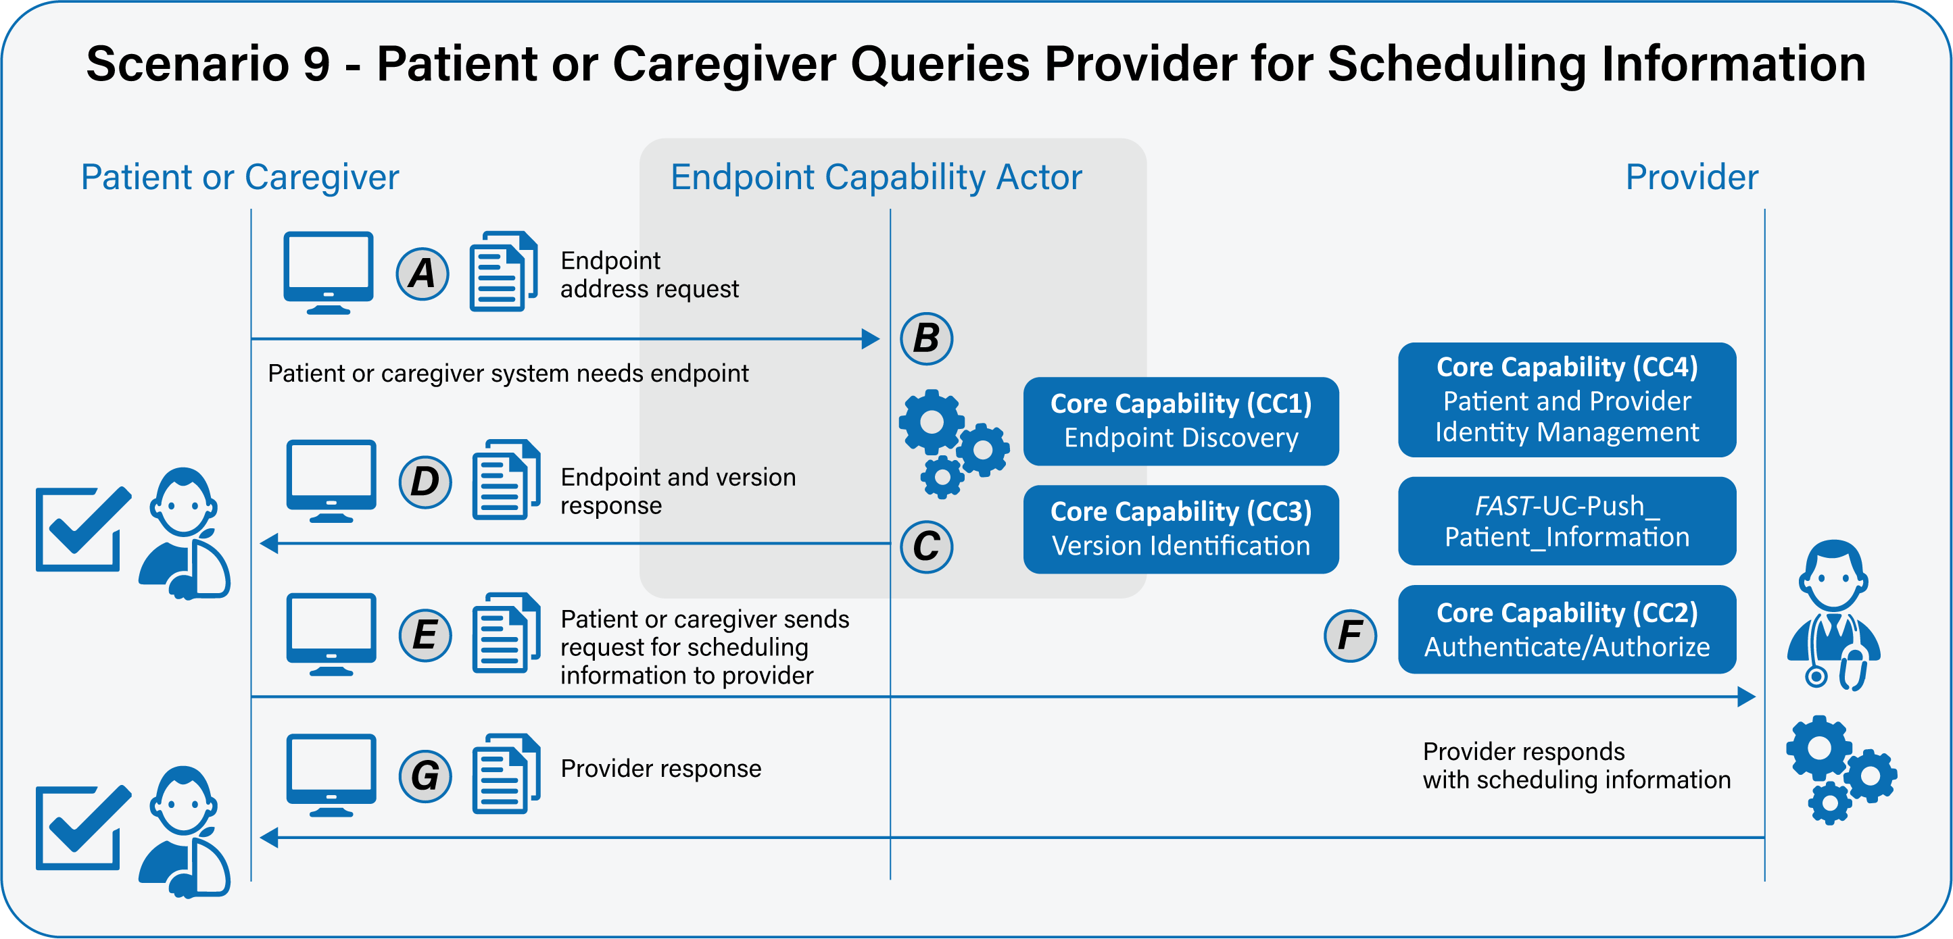

Scenario 10 – Provider queries auxiliary service for scheduling information
Primary Feature: As a provider, I need to be able to query scheduling information with auxiliary services to improve outcomes and provide value-based care to patients and to optimize clinical and administrative workflow.
Please note that core capabilities are defined in separate documents and referenced from here. Please see those documents for full details of the core capabilities.
- As a provider, I need my system to be able to securely determine the endpoint and version of an auxiliary service’s resource. Please see FAST-UC-Endpoint_Discovery-Core_Capability-CC1 and FAST-UC-Version_Identification-Core_Capability-CC3. (A:B:C:D)
- As a provider, I need to send the appropriate payload to the auxiliary service for processing. (E:F)
- As a provider, I need my system to be able to request scheduling information from the auxiliary service’s endpoint in a trusted and secure way and to ensure proper authentication and authorization. See FAST-UC-Authentication_and_Authorization-Core_Capability-CC2. (E:F:)
- As a provider, I need some interactions to be synchronous and some to be asynchronous, but not necessarily both. If asynchronous, the request and response will be FHIR bulk data access compliant. (E:F:G)
- As a provider in the ecosystem I need to be able to conform to the FAST-UC-Patient_and_Provider_Identity_Management-Core_Capability-CC4 use case and the FAST-UC-Push_Patient_Information use case to ensure the patient is uniquely identified and access to that patient’s health information is properly authorized. (F)
- As a provider, I need the auxiliary service’s system to respond in an agreed upon time frame with the scheduling information. (G)
- As a provider, in the case of an error on the part of the mechanism of the auxiliary service system, I need a meaningful and useful response. (F:G)
Supporting Diagrams & Flows
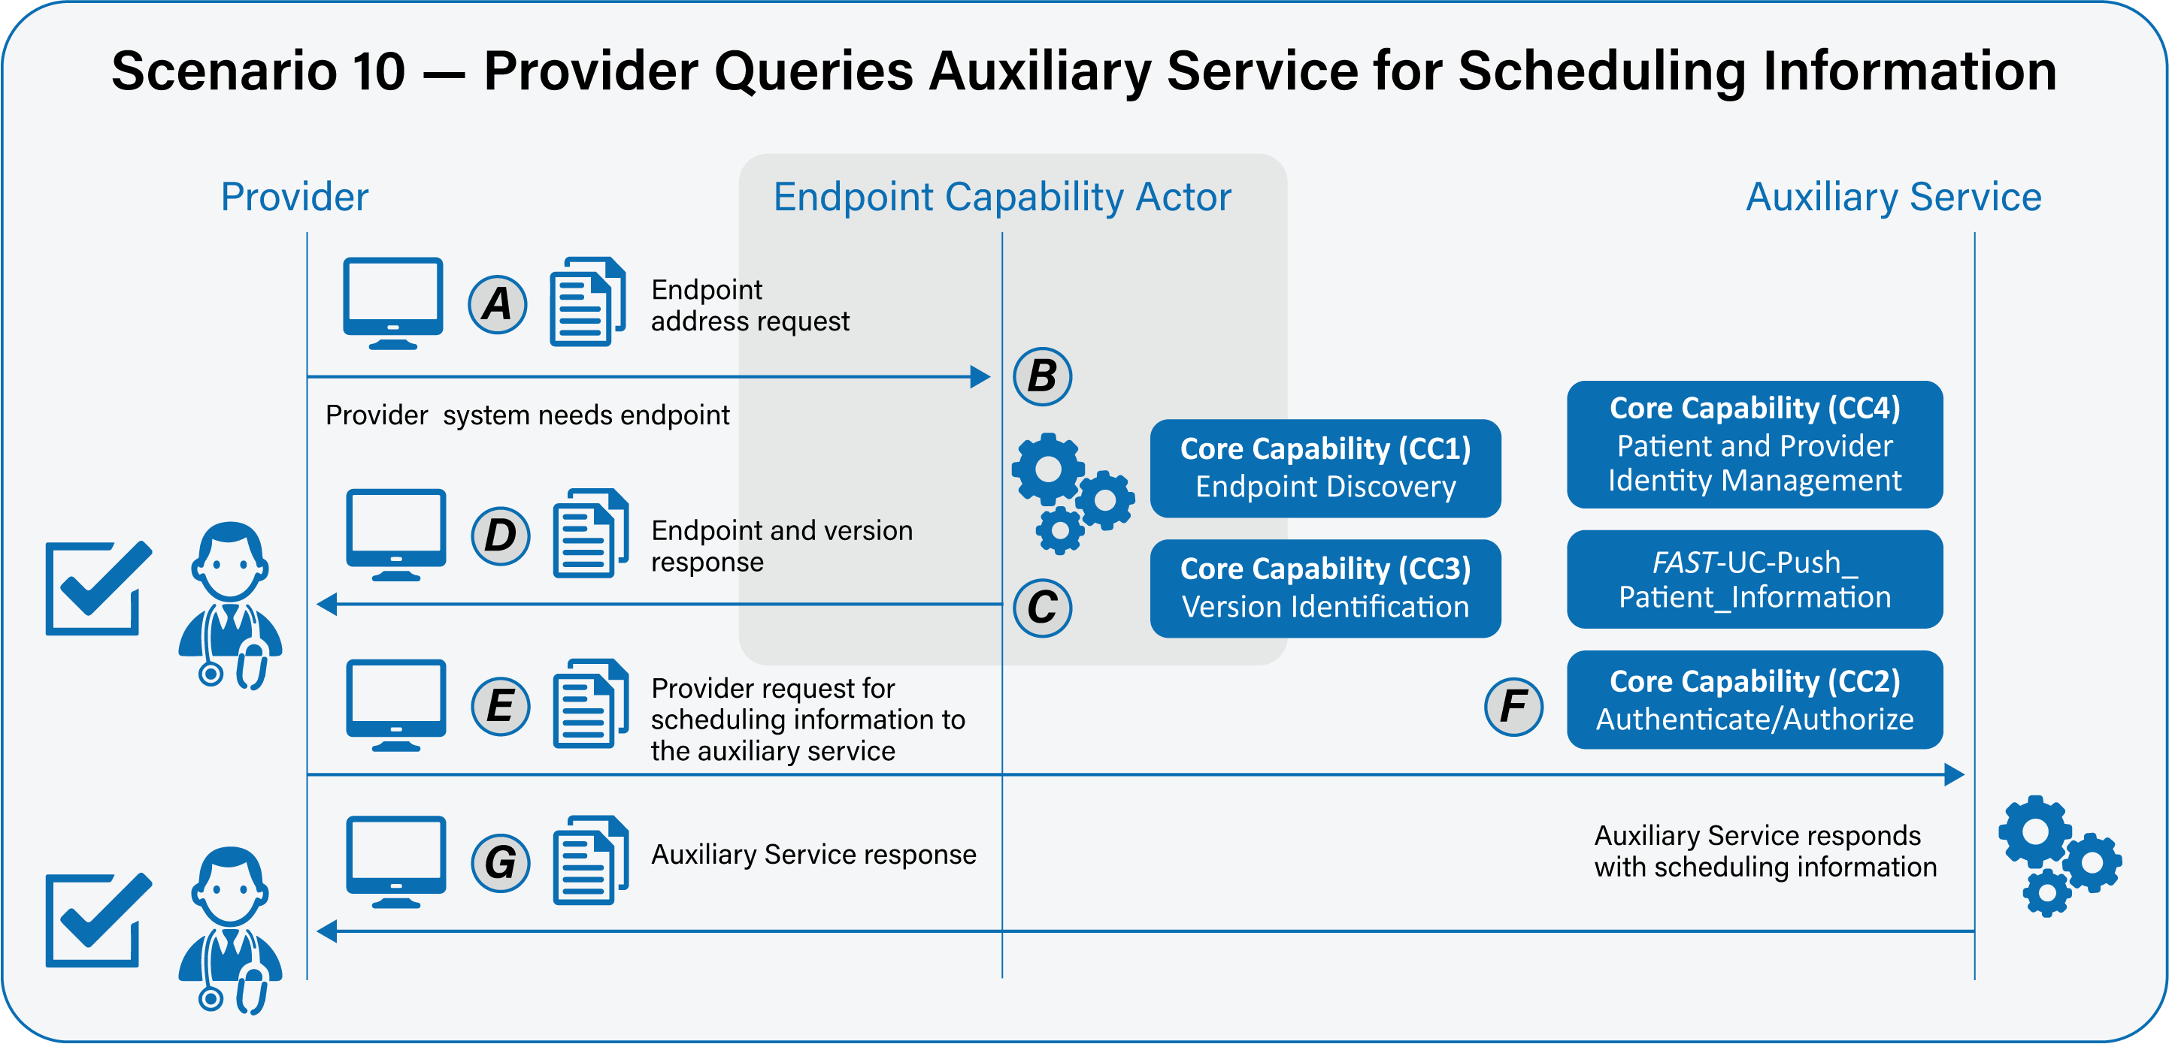

Scenario 11 – Payer queries auxiliary service for scheduling information
Primary Feature: As a payer, I need to be able to query scheduling information with auxiliary services to improve outcomes and provide value-based care to patients and to optimize clinical and administrative workflow.
Please note that core capabilities are defined in separate documents and referenced from here. Please see those documents for full details of the core capabilities.
- As a payer, I need my system to be able to securely determine the endpoint and version of a auxiliary service’s resource. Please see FAST-UC-Endpoint_Discovery-Core_Capability-CC1 and FAST-UC-Version_Identification-Core_Capability-CC3. (A:B:C:D)
- As a payer, I need to send the appropriate payload to the auxiliary service for processing. (E:F)
- As a payer, I need my sy stem to be able to request scheduling information from the other auxiliary service’s endpoint in a trusted and secure way and to ensure proper authentication and authorization. See FAST-UC-Authentication_and_Authorization-Core_Capability-CC2. (E:F)
- As a payer, I need some interactions to be synchronous and some to be asynchronous, but not necessarily both. If asynchronous, the request and response will be FHIR bulk data access compliant. (E:F:G)
- As a payer in the ecosystem I need to be able to conform to the FAST-UC-Patient_and_Identity_Management-Core_Capability-CC4 use case and the FAST-UC-Push_Patient_Information use case to ensure the patient is uniquely identified and access to that patient’s health information is properly authorized. (F)
- As a payer, I need the auxiliary service’s system to respond in an agreed upon time frame with the scheduling information. (G)
- As a payer,, in the case of an error on the part of the mechanism of the auxiliary service system, I need a meaningful and useful response. (F:G)
Supporting Diagrams & Flows
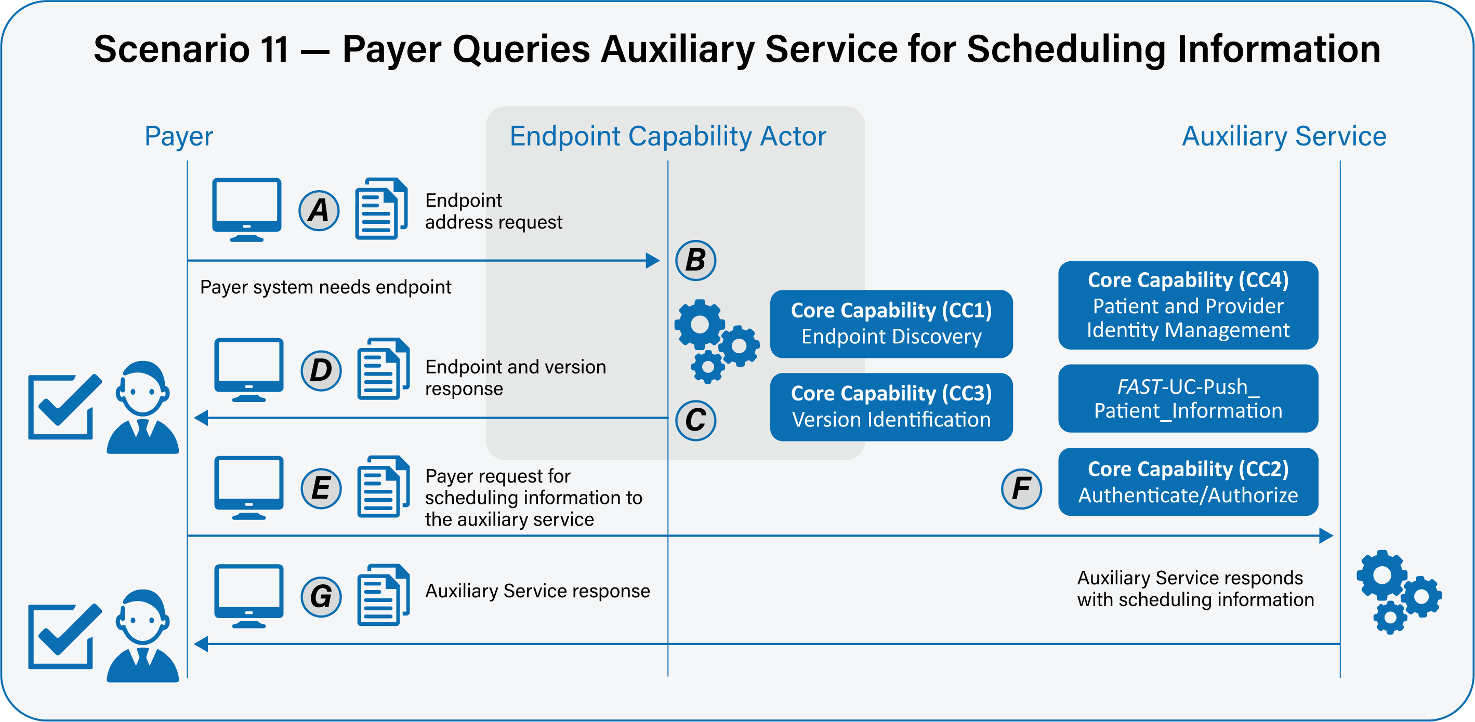

Scenario 12 – Patient or caregiver queries auxiliary service for scheduling information
Primary Feature: As a patient or caregiver, I need to be able to query scheduling information from auxiliary services to improve outcomes and provide value-based care to patients and to optimize clinical and administrative workflow.
Please note that core capabilities are defined in separate documents and referenced from here. Please see those documents for full details of the core capabilities.
- As a patient or caregiver, I need my system to be able to securely determine the endpoint and version of an auxiliary service’s resource. Please see FAST-UC-Endpoint_Discovery-Core_Capability-CC1 and FAST-UC-Version_Identification-Core_Capability-CC3. (A:B:C:D)
- As a patient or caregiver, I need to send the appropriate payload to the auxiliary service for processing. (E:F)
- As a patient or caregiver, I need my system to be able to request scheduling information from the auxiliary service’s endpoint in a trusted and secure way and to ensure proper authentication and authorization. See FAST-UC-Authentication_and_Authorization-Core_Capability-CC2. (E:F:)
- As a patient or caregiver, I need some interactions to be synchronous and some to be asynchronous, but not necessarily both. If asynchronous, the request and response will be FHIR bulk data access compliant. (E:F:G)
- As a patient or caregiver, I need to be able to conform to the FAST-UC-Patient_and_Identity_Management-Core_Capability-CC4 use case and the FAST-UC-Push_Patient_Information use case to ensure the patient is uniquely identified and access to that patient’s health information is properly authorized. (F)
- As a patient or caregiver, I need the auxiliary service’s system to respond in an agreed upon time frame with the scheduling information. (G)
- As a patient or caregiver, in the case of an error on the part of the mechanism of the auxiliary service system, I need a meaningful and useful response. (F:G)

Supporting Diagrams & Flows
