FHIR at Scale Taskforce (FAST)

Use Case — Patient Information Request: Provider to Plan

Table of Contents
Revision History 2
Introduction & Background 3
Overview & Description 4
Scenarios 4
In Scope 5
Out of Scope 5
Assumptions 5
Primary Actors 5
Supporting Actors 5
Stakeholders & Interests 6
Pre-Conditions 6
Post Conditions 6
Failure End Condition 7
Scenarios 7
Scenario 1 – Patient Information Request – Provider to Payer/Plan 7
Scenario 2 – Coverage Requirement Discovery 8
Scenario 3 – Full Clinical Record 9
Scenario 4 – Specific Clinical Record Section 11
Scenario 5 – Attributed Roster Request 12
Scenario 6 – Bulk Data Claims 13
Frequency 14

Revision History
Version | Date | Author | Description of Change
1.0 |  | Nancy Beavin  Patrick Murta  Ranjan Saxena | Initial published version of use case

Reference Documentation
- FAST-UC-Endpoint_Discovery-Core_ Capability-CC1
- FAST-UC-Authentication_and_ Authorization-Core_Capability-CC2
- FAST-UC-Version_Identification-Core_Capability-CC3
- FAST-UC-Patient_and_Provider_Identity_Management-Core_Capability-CC4
- FAST-UC-Patient_Information_Request_Plan_to_Provider

Introduction & Background
The purpose of the FHIR at Scale Taskforce (FAST) is to augment and support recent HL7® Fast Healthcare Interoperability Resources (FHIR®) efforts focused on ecosystem issues that, if mitigated, can accelerate adoption. One of the focus areas identified is the ability for providers to request patient information from plans.

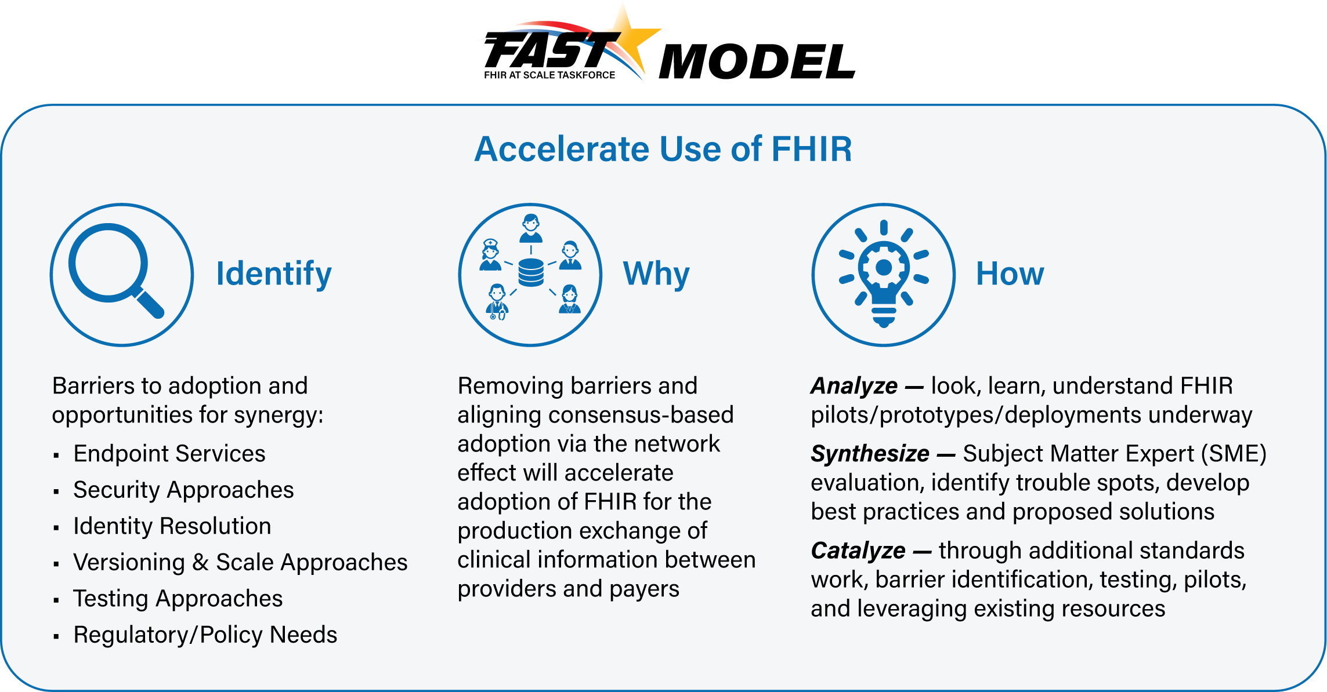

The FAST use case model is unique in that it describes ecosystem needs as opposed to specific functional needs. Use cases for FAST are derived in one of 3 approaches as described in the graphic below.
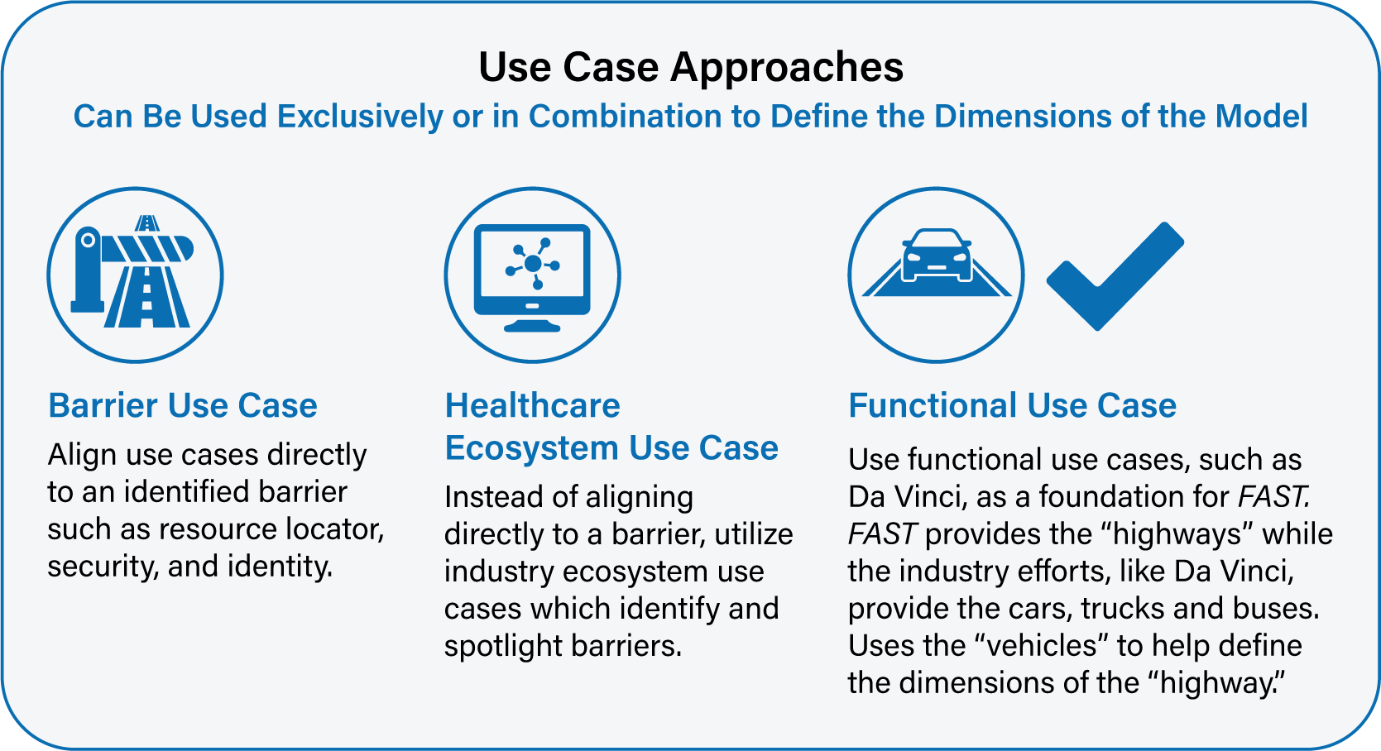

Overview & Description
This use case focuses on the ability for providers to be able to request and retrieve information from plans for the purposes of clinical and/or administrative optimization.
The focus is not on the clinical or administrative functionality (which is covered under other use cases such as those in the Da Vinci initiative) but is instead on the ecosystem which supports those specific functional use cases to ensure an efficient and scalable model.

Scenarios
This use case focuses on ecosystem functionality supporting provider to plan requests for patient information. Variations in the primary use case help to illustrate and define the desired functionality and include the following scenarios:
- Coverage requirements discovery
- Full plan clinical record
- Decomposed section of a plan clinical record
- Patient attribution/roster request
- Bulk data transfer of claims based upon provider roster

In Scope
- Coverage requirements discovery
- Full plan clinical record
- Decomposed section of a plan clinical record
- Patient attribution/roster request
- Bulk data transfer of claims based upon provider roster

Out of Scope
- Any HIPAA defined functional transactions
- Any patient’s consent process related to information sharing

Assumptions
- Other initiatives, such as Da Vinci, are covering the clinical or administrative functional use cases
- The primary goal of the use case is to describe ecosystem needs to support the functional use cases
- Transactions will explicitly be declared as synchronous or asynchronous
- HIPAA Minimum Necessary requirements will be addressed by core capability use cases
- Endpoint discovery (see FAST-UC-Endpoint_Discovery-Core_Capability-CC1), Authentication and Authorization (see FAST-UC-Authentication_and_Authorization-Core_Capability-CC2), Version Identification (see FAST-UC-Version_Identification-Core_Capability-CC3) and Patient and Provider Identity Management (see FAST-UC-Patient_and_Provider_Identity_Management-Core_Capability-CC4) are out of scope for this document
- Plans and Providers will comply with federal and state laws for sharing any information

Primary Actors
- Payer/Plan
- Treating clinician or organization
- Support staff working on behalf of treating clinician or organization

Supporting Actors
- Payer systems
- Patient/Member
- EHR
- Endpoint resolution capability

Stakeholders & Interests
- Payer/plan – As an active stakeholder, has interest in receiving timely, actionable, and accurate patient/member information to enable better care outcomes and participation in value-based care arrangements
- Provider – As an active stakeholder, has interest in providing timely, actionable, and accurate patient information to improve patient outcomes and provide value-based care
- Patient – As an active stakeholder, has interest in receiving optimized care and relies on the timely, actionable, and accurate exchange of information
- Caregiver (typically a family member) – As an active stakeholder, has interest in the patient receiving optimized care and relies on the timely, actionable, and accurate exchange of information
- Federal and State Govt. – As a stakeholder, in long term has interest to ensure that the exchange models are highly scalable and meet ecosystem needs to help enable interoperability and efficient data exchange for better outcomes for all stakeholders
- CMS – As an active stakeholder, has interest in Medicare/Medicaid patients benefitting from the timely, actionable, and accurate exchange of information
- EHR – As a stakeholder, in long term has interest to ensure that solutions work well in their systems and the health care network
- Standards Organization – As a stakeholder, in long term has interest to ensure that the exchange models are highly scalable and efficient
- Public Health Entities – As a stakeholder, in long term have interest in patients benefitting from timely, actionable, and accurate exchange of information that prevents diseases, prolongs life and promotes the human health of a community or society

Pre-Conditions
- The process is triggered by the clinician, supporting staff, or EHR on behalf of the clinician
- The provider system has the patient’s plan and identifier information prior to this execution of the use case
- The EHR or other clinical system has adopted the FHIR model, including those arising from the FAST initiative
- The payer/plan has adopted the FHIR model, including those arising from the FAST initiative

Post Conditions
- Provider has received the requested information or specific information otherwise from plan
- The information was received in a manner timely enough to be effective and as to not impact workflow
- The information is understandable by the clinical, support staff, or the machine
- The transaction did not cause undue burden in terms of wait time or unusable message
- In the event of an error, the information returned does not leave the clinician, support staff, or system in a state of not knowing the path forward

Failure End Condition
- The post conditions defined above are not met

Trigger
- The process is triggered by the clinician, supporting staff, or EHR on behalf of the clinician

Scenarios
Scenario 1 – Patient Information Request – Provider to Payer/Plan
Primary Feature: As a provider, I need to be able to access payer/plan information to improve outcomes and provide value-based care to patients and to optimize clinical and administrative workflow.
Please note that core capabilities are defined in separate documents and referenced from here. Please see those documents for full details of the core capabilities.
- As a provider, I need my system to be able to securely determine the endpoint and version of a payer’s resource. Please see FAST-UC-Endpoint_Discovery-Core_Capability-CC1 and FAST-UC-Version_Identification-Core_Capability-CC3. (A:B:C:D referencing CC1 and CC3)
- As a provider, I need to send the appropriate payload to the payer for processing. See FAST-UC-Authentication_and_Authorization-Core_Capability-CC2. (E:F referencing CC2)
- As a provider, I need my system to be able to send the request for data to the payer’s endpoint in a trusted and secure way and to ensure proper authentication and authorization. See FAST-UC-Authentication_and_Authorization-Core_Capability-CC2. (E:F:G referencing CC2)
- As a provider, I need to be able to conform to the FAST -UC-Patient_and_Provider_Identity_Management-Core_Capability-CC4 use case to ensure the patient is uniquely identified and access to that patient’s health information is properly authorized. (F referencing CC4)
- As a provider, I need some interactions to be synchronous and some to be asynchronous, but not necessarily both. If asynchronous, the request and response will be FHIR-bulk data access compliant. (E:F:G)
- As a provider, I need the payer’s system to respond in an agreed upon time frame. (F:G)
- As a provider, in the case of an error on the part of the mechanism or payer, I need a meaningful and useful response. (F:G)

Supporting Diagrams & Flows
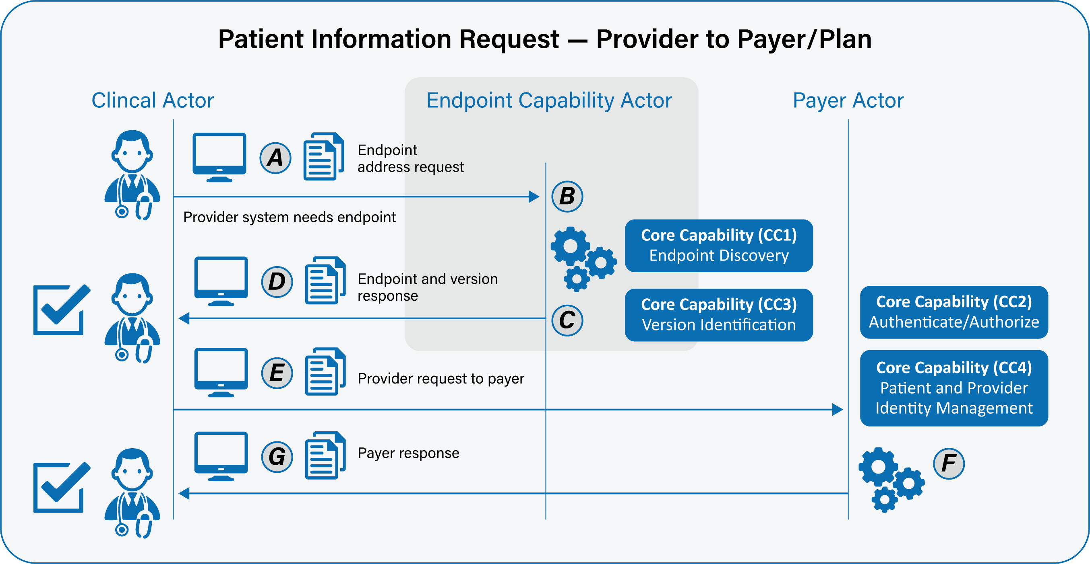

Scenario 2 – Coverage Requirements Discovery
Primary Feature: As a provider, I need my clinical workflow system to understand that when a clinical event is underway, it should request coverage information from the respective payer to determine if a payer-specific requirement applies to the respective clinical event.
The flow for this scenario is the same as the Scenario 1 flow but does include that the response back from the payer can be a CDS Hooks Card, text (eg, reminder) or message (eg, determine need for prior authorization), a FHIR-structured resource, FHIR binary resource, or FHIR-based record locations (eg, links for docs, plugins, etc). This scenario can operate only synchronously.
- As a provider, I need my system to be able to securely determine the endpoint and version of a payer’s resource. Please see FAST-UC-Endpoint_Discovery-Core_Capability-CC1 and FAST-UC-Version_Identification-Core_Capability-CC3. (A:B:C:D referencing CC1 and CC3)
- As a provider, I need to send the appropriate payload to the payer for processing. See FAST-UC-Authentication_and_Authorization-Core_Capability-CC2. (E:F referencing CC2)
- As a provider, I need my system to be able to send the request for data to the payer’s endpoint in a trusted and secure way and to ensure proper authentication and authorization. See FAST-UC-Authentication_and_Authorization-Core_Capability-CC2. (E:F:G referencing CC2)
- As a provider, I need to be able to conform to the FAST -UC-Patient_and_Provider_Identity_Management-Core_Capability-CC4 use case to ensure the patient is uniquely identified and access to that patient’s health information is properly authorized. (F referencing CC4)
- As a provider, I need some interactions to be synchronous and some to be asynchronous, but not necessarily both. If asynchronous, the request and response will be FHIR-bulk data access compliant. (E:F:G)
- As a provider, I need the payer’s system to respond in an agreed upon time frame. (F:G)
- As a provider, in the case of an error on the part of the mechanism or payer, I need a meaningful and useful response. (F:G)
Supporting Diagrams & Flows
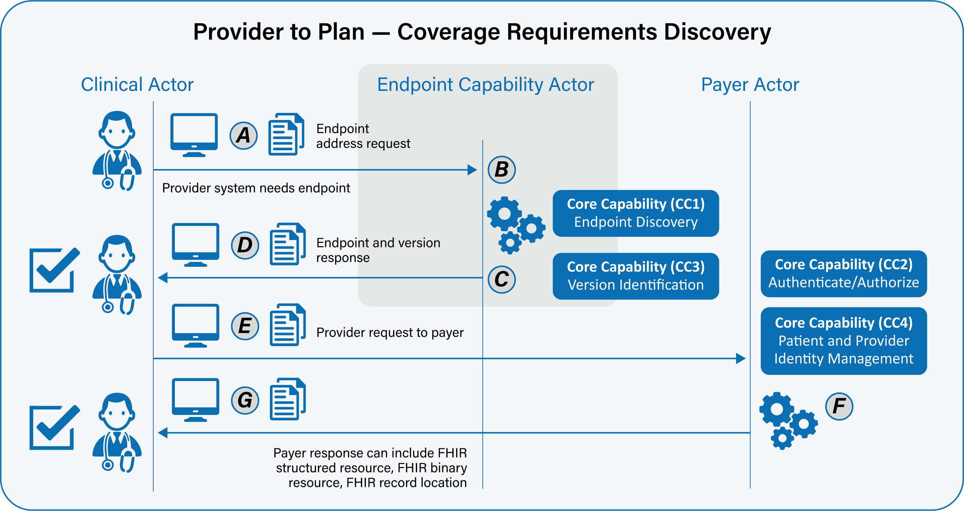

Scenario 3 – Full Clinical Record
Primary Feature: As a provider, I need my clinical workflow system to understand that a clinical document may be available for a patient from a payer and that it should be automatically requested, or provide an option for the clinician to manually request it, so the information can be retrieved at the appropriate time in workflow.
The flow for this scenario is the same as the Scenario 1 flow but does include that the response back from the payer can be CCDA over FHIR, a FHIR-structured document, a FHIR binary resource, or a SMART on FHIR App. The content of the deliverable is a full payer summary.
This scenario can operate synchronously or asynchronously.
- As a provider, I need my system to be able to securely determine the endpoint and version of a payer’s resource. Please see FAST-UC-Endpoint_Discovery-Core_Capability-CC1 and FAST-UC-Version_Identification-Core_Capability-CC3. (A:B:C:D referencing CC1 and CC3)
- As a provider, I need to send the appropriate payload to the payer for processing. See FAST-UC-Authentication_and_Authorization-Core_Capability-CC2. (E:F referencing CC2)
- As a provider, I need my system to be able to send the request for data to the payer’s endpoint in a trusted and secure way and to ensure proper authentication and authorization. See FAST-UC-Authentication_and_Authorization-Core_Capability-CC2. (E:F:G referencing CC2)
- As a provider, I need to be able to conform to the FAST -UC-Patient_and_Provider_Identity_Management-Core_Capability-CC4 use case to ensure the patient is uniquely identified and access to that patient’s health information is properly authorized. (F referencing CC4)
- As a provider, I need some interactions to be synchronous and some to be asynchronous, but not necessarily both. If asynchronous, the request and response will be FHIR-bulk data access compliant. (E:F:G)
- As a provider, I need the payer’s system to respond in an agreed upon time frame. (F:G)
- As a provider, in the case of an error on the part of the mechanism or payer, I need a meaningful and useful response. (F:G)
Supporting Diagrams & Flows
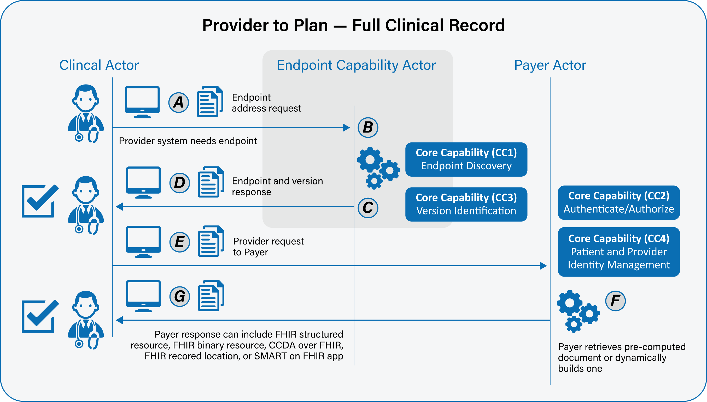

Scenario 4 – Specific Clinical Record Section
Primary Feature: As a provider, I need my clinical workflow system to identify that a clinical document may be available for a patient from a payer and that it should be automatically requested, or provide an option for the clinician to manually request it, so the information can be retrieved at the appropriate time in workflow.
The flow for this scenario is the same as the Scenario 1 flow but does include that the response back from the payer can be CCDA over FHIR, a FHIR-structured document, a FHIR binary resource, or a SMART on FHIR App. The content of the deliverable is a specific section of data such as medications, labs, gaps in care, etc.
- As a provider, I need my system to be able to securely determine the endpoint and version of a payer’s resource. Please see FAST-UC-Endpoint_Discovery-Core_Capability-CC1 and FAST-UC-Version_Identification-Core_Capability-CC3. (A:B:C:D referencing CC1 and CC3)
- As a provider, I need to send the appropriate payload to the payer for processing. See FAST-UC-Authentication_and_Authorization-Core_Capability-CC2. (E:F referencing CC2)
- As a provider, I need my system to be able to send the request for data to the payer’s endpoint in a trusted and secure way and to ensure proper authentication and authorization. See FAST-UC-Authentication_and_Authorization-Core_Capability-CC2. (E:F:G referencing CC2)
- As a provider, I need to be able to conform to the FAST -UC-Patient_and_Provider_Identity_Management-Core_Capability-CC4 use case to ensure the patient is uniquely identified and access to that patient’s health information is properly authorized. (F referencing CC4)
- As a provider, I need some interactions to be synchronous and some to be asynchronous, but not necessarily both. If asynchronous, the request and response will be FHIR-bulk data access compliant. (E:F:G)
- As a provider, I need the payer’s system to respond in an agreed upon time frame. (F:G)
- As a provider, in the case of an error on the part of the mechanism or payer, I need a meaningful and useful response. (F:G)

Supporting Diagrams & Flows
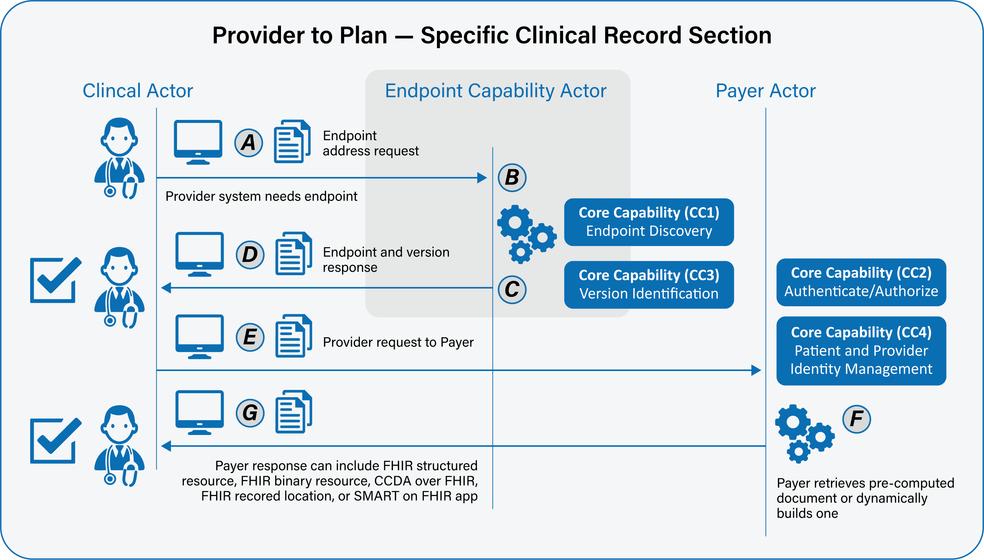

Scenario 5 – Attributed Roster Request
Primary Feature: As a provider, I need my clinical system to be able to request an attributed patient roster so that I can better understand who the payer considers to be my panel. This helps in value- based care arrangements.
The flow for this scenario is the same as the Scenario 1 flow but does include that the response back from the payer is a FHIR-structured document. The content of the deliverable is a payer created list of attributed members/patients to a clinical entity.
- As a provider, I need my system to be able to securely determine the endpoint and version of a payer’s resource. Please see FAST-UC-Endpoint_Discovery-Core_Capability-CC1 and FAST-UC-Version_Identification-Core_Capability-CC3. (A:B:C:D referencing CC1 and CC3)
- As a provider, I need to send the appropriate payload to the payer for processing. See FAST-UC-Authentication_and_Authorization-Core_Capability-CC2. (E:F referencing CC2)
- As a provider, I need my system to be able to send the request for data to the payer’s endpoint in a trusted and secure way and to ensure proper authentication and authorization. See FAST-UC-Authentication_and_Authorization-Core_Capability-CC2. (E:F:G referencing CC2)
- As a provider, I need to be able to conform to the FAST -UC-Patient_and_Provider_Identity_Management-Core_Capability-CC4 use case to ensure the patient is uniquely identified and access to that patient’s health information is properly authorized. (F referencing CC4)
- As a provider, I need some interactions to be synchronous and some to be asynchronous, but not necessarily both. If asynchronous, the request and response will be FHIR-bulk data access compliant. (E:F:G)
- As a provider, I need the payer’s system to respond in an agreed upon time frame. (F:G)
- As a provider, in the case of an error on the part of the mechanism or payer, I need a meaningful and useful response. (F:G)
Supporting Diagrams & Flows
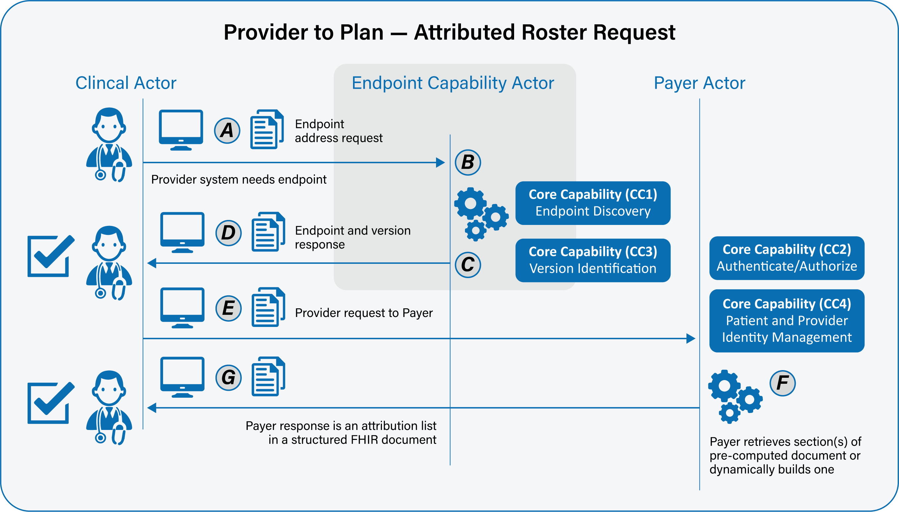

Scenario 6 – Bulk Data Claims
Primary Feature: As a provider, I need my clinical system to be able to request claims information for my panel.
The flow for this scenario is the same as the Scenario 1 flow but does include that the response back from the payer is an asynchronous FHIR-structured document bundle including resources such as claim, coverage, and patient
The operation will follow the FHIR Bulk Data Access model and specifically the roster/claims interaction model
- As a provider, I need my system to be able to securely determine the endpoint and version of a payer’s resource. Please see FAST-UC-Endpoint_Discovery-Core_Capability-CC1 and FAST-UC-Version_Identification-Core_Capability-CC3. (A:B:C:D referencing CC1 and CC3)
- As a provider, I need to send the appropriate payload to the payer for processing. See FAST-UC-Authentication_and_Authorization-Core_Capability-CC2. (E:F referencing CC2)
- As a provider, I need my system to be able to send the request for data to the payer’s endpoint in a trusted and secure way and to ensure proper authentication and authorization. See FAST-UC-Authentication_and_Authorization-Core_Capability-CC2. (E:F:G referencing CC2)
- As a provider, I need to be able to conform to the FAST -UC-Patient_and_Provider_Identity_Management-Core_Capability-CC4 use case to ensure the patient is uniquely identified and access to that patient’s health information is properly authorized. (F referencing CC4)
- As a provider, I need some interactions to be synchronous and some to be asynchronous, but not necessarily both. If asynchronous, the request and response will be FHIR-bulk data access compliant. (E:F:G)
- As a provider, I need the payer’s system to respond in an agreed upon time frame. (F:G)
- As a provider, in the case of an error on the part of the mechanism or payer, I need a meaningful and useful response. (F:G)
Supporting Diagrams & Flows
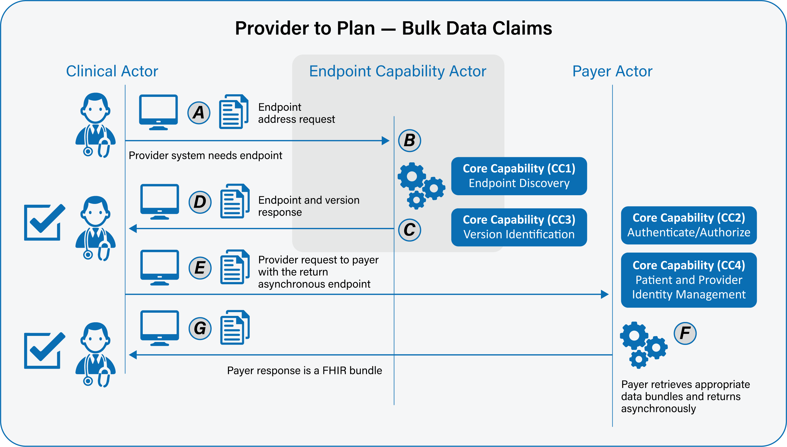

Frequency: 25 Million per Day

