FHIR at Scale Taskforce (FAST)

Use Case — Documentation Templates and Rules Processing

Table of Contents
Revision History 2
Introduction & Background 3
Overview & Description 4
Scenarios 4
In Scope 5
Out of Scope 5
Assumptions 5
Primary Actors 5
Supporting Actors 5
Stakeholders & Interests 6
Pre-Conditions 6
Post Conditions 6
Failure End Condition 7
Trigger 7
Scenarios 7
Scenario 1 – Documentation Templates and Rules Processing 7
Scenario 2 – Prior Authorization 8
Frequency 9
Constraints 10

Revision History
Version | Date | Author | Description of Change
1.0 |  | Terrence Cunningham | Initial published version of use case

Reference Documentation
- FAST-UC-Endpoint_Discovery-Core_Capability-CC1
- FAST-UC-Authentication_and_ Authorization-Core_
Capability-CC2
- FAST-UC-Version_Identification-Core_Capability-CC3
- FAST-UC-Patient_and_Provider_Identity_ Management-Core_Capability-CC4
- FAST-UC-Patient_Information_Request_Provider_ to_Plan

Introduction & Background
The purpose of the FHIR at Scale Taskforce (FAST) is to augment and support recent HL7® Fast Healthcare Interoperability Resources (FHIR®) efforts focused on ecosystem issues that, if mitigated, can accelerate adoption. One of the focus areas identified is the ability for providers to submit document templates and rules to health plans for processing.
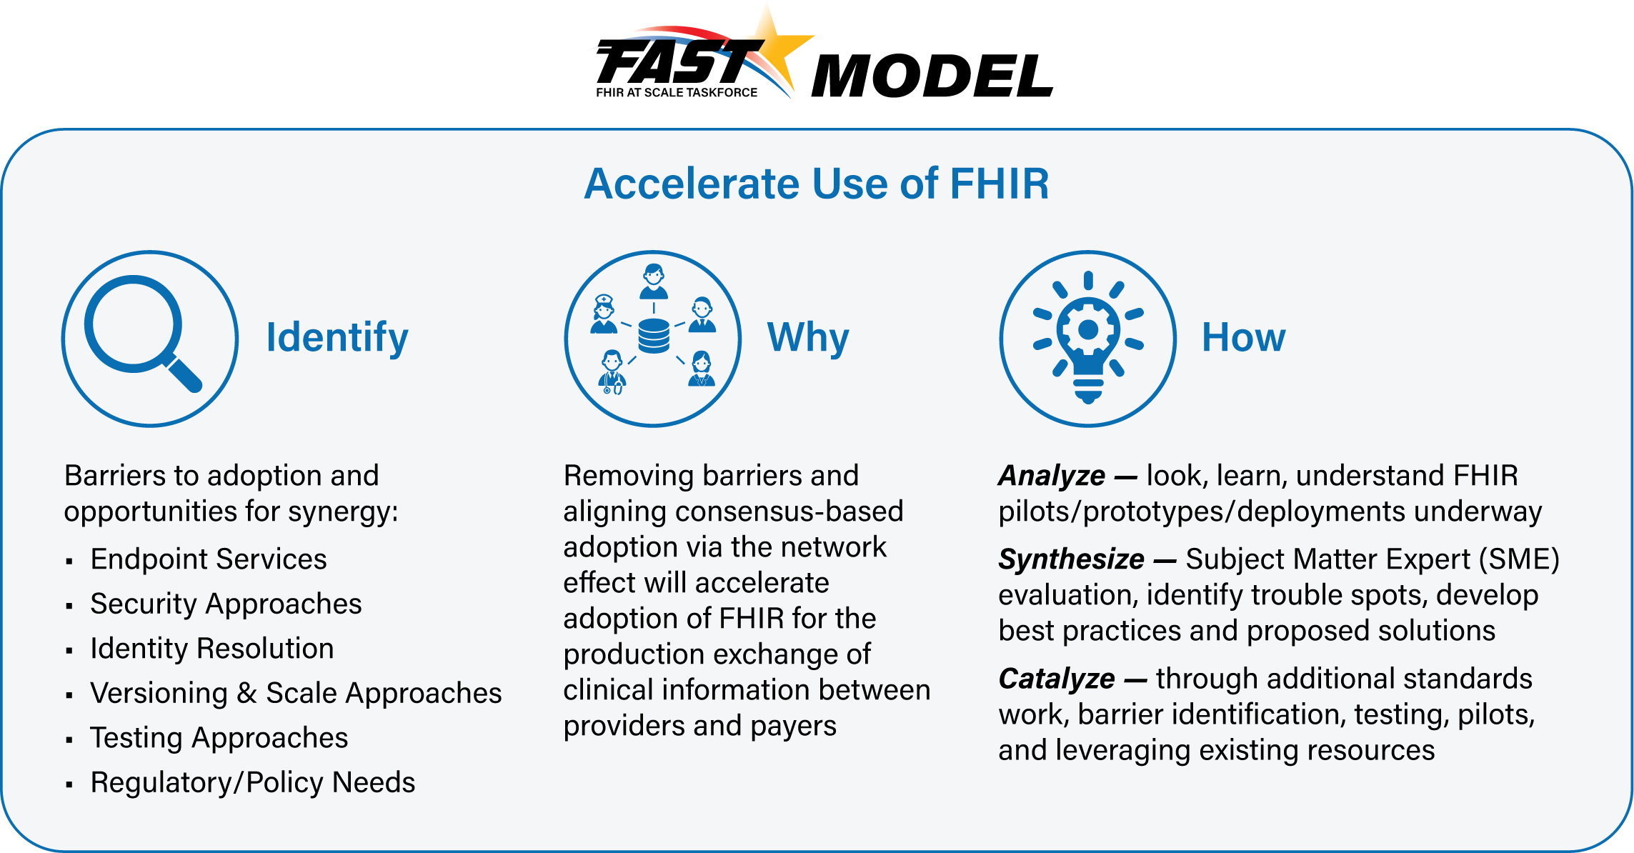

The FAST use case model is unique in that it describes ecosystem needs as opposed to specific functional needs. Use cases for FAST are derived in one of 3 approaches as described in the graphic below.
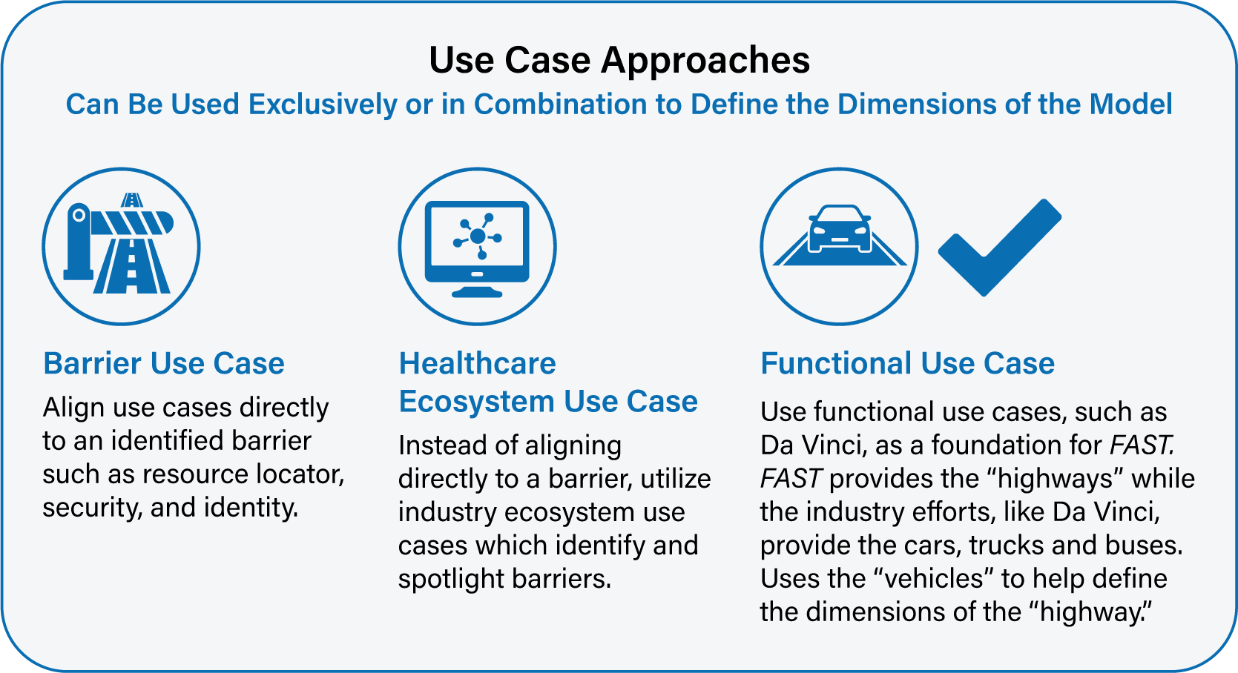

Overview & Description
This use case focuses on the ability for provider EHR to complete (populate) and submit a Documentation Template and/or Rule received from a health plan. This may include prior authorization forms, medical necessity information, quality reporting data, or others. The focus is not on the clinical or administrative functionality of the use case (which is covered under other use cases such as those in the Da Vinci initiative) but is instead on the ecosystem which supports those specific functional use cases to ensure an efficient and scalable model.

Scenarios
This use case focuses on ecosystem functionality supporting the ability for a provider to submit a Documentation Template and/or Rule received from a health plan. Variations in the primary use case help to illustrate and define the desired functionality and include the following scenario:
- Prior Authorization

In Scope
- Exchange of necessary patient information to enable processing of rules and templates
- Patient information exchange
- Patient attribution/roster request

Out of Scope
- Coverage Requirements Discovery (see FAST-UC-Patient_Information_Request_Provider_to_Plan)
- Documentation and Rules Templates (see FAST-UC-Patient_Information_Request_Plan_to_Provider)
- Bulk data transfer
- Endpoint Discovery (see FAST-UC-Endpoint_Discovery-Core_Capability-CC1)
- Security (see FAST-UC-Authentication_and_Authorization-Core_Capability-CC2)
- Versioning (see FAST-UC-Version_Identification-Core_Capability-CC3)
- Patient Provider Identification (see FAST-UC-Patient_and_Provider_Identity_Management-Core_Capability-CC4)
- X12 transactions

Assumptions
- Other initiatives, such as Da Vinci, are covering the clinical or administrative functional use cases
- The primary goal of the use case is to describe ecosystem needs to support the functional use cases
- HIPAA Minimum Necessary requirements and all other regulations will be adhered to by requesting and submitting entities

Primary Actors
- Treating clinician or organization
- Support staff working on behalf of treating clinician or organization
- Payer/plan

Supporting Actors
- Patient/Member
- Provider systems (eg, EHR)
- Payer systems
- Endpoint resolution capability
- Utilization Management entities (eg, benefit managers)

Stakeholders & Interests
- Provider – As an active stakeholder, has interest in efficiently completing document templates and rules relevant to patient care, such as prior authorization and quality reporting. Additionally, has an interest in timely submission and health plan determination for use cases impacting potential care to enable discussion of treatment options with patient
- Payer/plan – As an active stakeholder, has interest in receiving timely, actionable, accurate responses to Documentation Templates or Rules sent to a provider to enable better care, patient outcomes, increased quality, adherence to plan protocols, and increased financial transparency
- Patient – As an active stakeholder, has interest in receiving actionable financial information, timely and optimized care, and increased awareness of coverage decisions to foster patient-centered care decision-making
- Federal and State Govt. – As a stakeholder, in long term has interest to ensure that the exchange models are highly scalable and meet ecosystem needs to help enable interoperability and efficient data exchange for better outcomes for all stakeholders
- CMS – As an active stakeholder, has interest in Medicare/Medicaid patients benefitting from the timely, actionable, and accurate exchange of Documentation Templates and Rules
- EHR – As a stakeholder, in long term has interest to ensure that solutions work well in their systems and the health care network
- Standards Organizations – As a stakeholder, in long term has interest to ensure that the exchange models are highly scalable and efficient

Pre-Conditions
- The process is triggered by a clinician system’s receipt of actionable Documentation Templates or Rules from a health plan or other trusted entity
- The provider system has the patient’s plan and identifier information prior to this execution of the use case
- The EHR or other clinical system has adopted the FHIR model, including those arising from the FAST initiative
- The payer/plan has the adopted the FHIR model, including those arising from the FAST initiative

Post Conditions
- Health Plan has received completed template or rule from the provider
- The information was received in a manner timely enough to be effective and as to not hinder workflow
- The information is understandable by the clinician, support staff, or their EHR
- The transaction did not cause undue burden in terms of wait time or unusable messaging
- In the event of an error, the information returned does not leave the clinician, support staff, or system in a state of not knowing the path forward
- Any necessary decisions are returned to the submitting provider (eg, prior authorization approval/denial)

Failure End Condition
- The post conditions defined above are not met

Trigger
- The process is triggered by a clinician system’s receipt of an actionable Documentation Template or Rule from a health plan

Scenarios
Scenario 1 – Documentation Templates and Rules Processing
Primary Feature: As a provider, I need my system to be able to process an actionable template or rule received from a health plan. This would include populating the relevant information, generating a response transaction to be submitted, and flagging any additional information that is not readily available.
- As a requestor, I need my system to be able to locate a FHIR endpoint for a service. See FAST-UC-Endpoint_Discovery-Core-Capability-CC1. (A:B:C:D referencing CC1)
- As a requestor, I need the version of FHIR services available at the endpoint services returned to my system. See FAST-UC-Version_Identification-CC3. (A:B:C:D referencing CC3)
- As a provider, I need to be able to query health plans to receive a rule or template based on clinical and claims requirements. (E)
- As a payer, I need to be able to receive a request for a rule or template from a provider via my FHIR endpoint, identify the patient and the provider, and authorize the access. See FAST-UC-Authentication_and_Authorization-Core_Capability-CC2 and FAST-UC-Patient_and_Provider_Identity_Management-Core_Capability-CC4. (F referencing CC2 and CC4)
- As a payer, I need to be able to respond to the provider with the appropriate rule/template. (G)
- As a provider I need to be able to receive the rule/template and instructions for additional clinical information from the payer. (H)
- As a provider, I need to be able to respond to the payer with a rule/template completed with the requested clinical information. This would include populating the relevant information, generating a response transaction to be submitted, and flagging any additional information that is not readily available. (I)
- As a payer, I need to be able to receive the completed rule/template from the provider. (J)

Supporting Diagrams & Flows
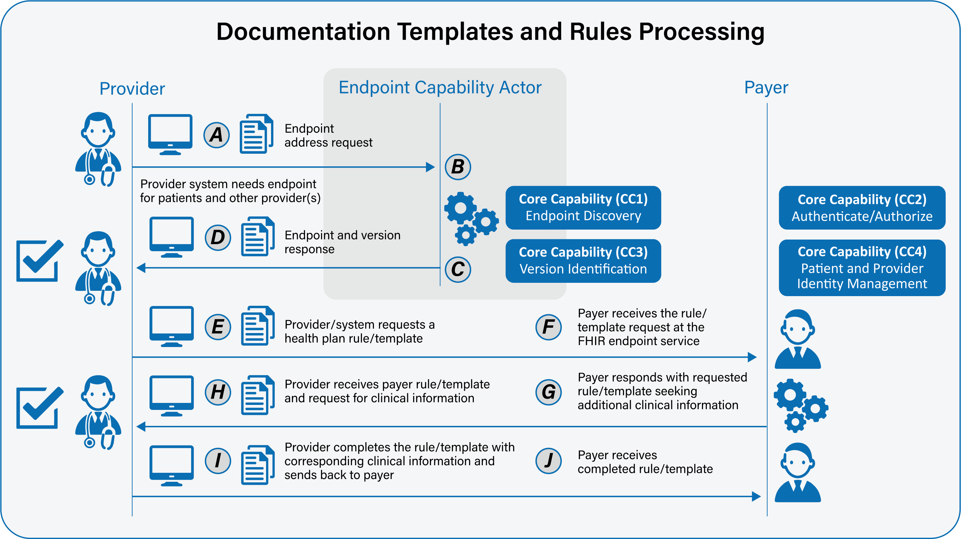

Scenario 2 — Prior Authorization
Primary Feature: As a provider, I need to be able to efficiently request prior authorization and receive health plan decisions for care involving medical services (and potentially pharmacy at a future date) to improve patient-centered care, to transparently provide cost of value-based treatment options to patients, and to optimize clinical and administrative workflow.
This scenario uses the same transaction flow as the main scenario, but has an additional step requiring the health plan to respond to the prior authorization with an approval or a denial.
Please note that core capabilities are defined in separate documents and referenced from here. Please see those documents for full details of the core capabilities.
- As a requestor, I need my system to be able to locate a FHIR endpoint for a service. See FAST-UC-Endpoint_Discovery-Core_Capability-CC1. (A:B:C:D referencing CC1)
- As a requestor, I need the version of FHIR services available at the endpoint services returned to my system. See FAST-UC-Version_Identification-Core-Capability-CC3. (A:B:C:D referencing CC3)
- As a provider, I need to be able to query health plans to receive a prior authorization rule or template based on clinical and claims requirements. (E)
- As a payer, I need to be able to receive a request for a prior authorization rule or template from a provider via my FHIR endpoint, identify the patient and the provider, and authorize the access. See FAST-UC-Authentication_and_Authorization-Core-Capability-CC2 and FAST-UC-Patient_and_Provider_Identity_Management-Core_Capability-CC4. (F referencing CC2 and CC4)
- As a payer, I need to be able to respond to the provider with the appropriate prior authorization rule/template. (G)
- As a provider I need to be able to receive the prior authorization rule or template and instructions for additional clinical information from the payer. (H)
- As a provider, I need to be able to respond to the payer with a prior authorization rule or template completed with the requested clinical information. This would include populating the relevant information, generating a response transaction to be submitted, and flagging any additional information that is not readily available. (I)
- As a payer, I need to be able to receive the completed prior authorization rule or template from the provider. (J)
- As a payer, I need to be able to communicate the determination or decision related to the prior authorization request back to the provider. (K)
- As a provider, I need to be able to receive the final determination of the prior authorization request from the payer. (L)
Supporting Diagrams & Flows
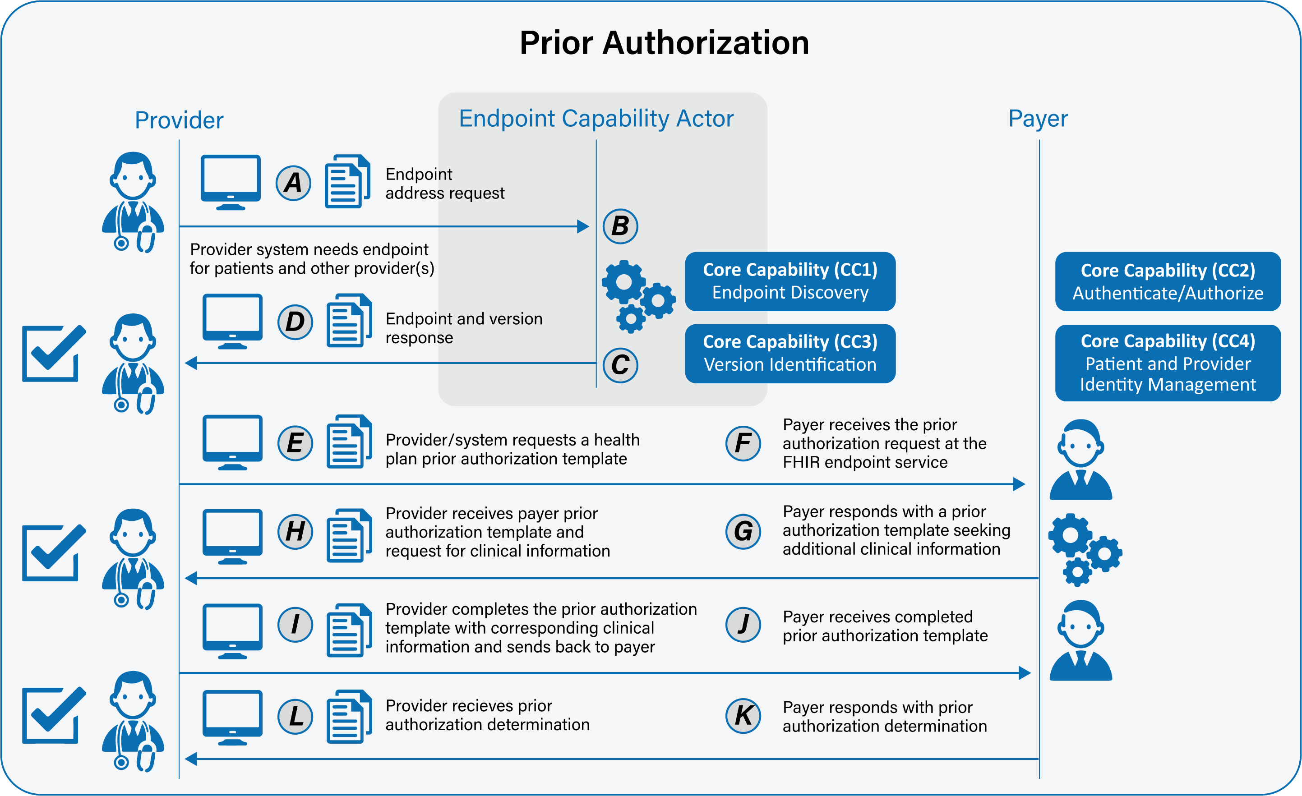

Frequency
- As needed, ad-hoc

Constraints
- As a provider, I need the payer’s system to respond with a final determination as soon as possible and no later than 48 hours after the submission of a completed request

