Text field in MADie:
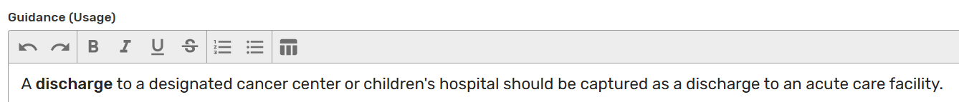

View Human Readable:
