Diagnosis of Chronic, continuous use of opioids
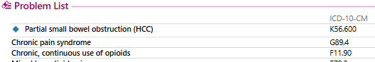
Meets Denominator Exclusion for “Diagnosis: Opioid Use Disorder”
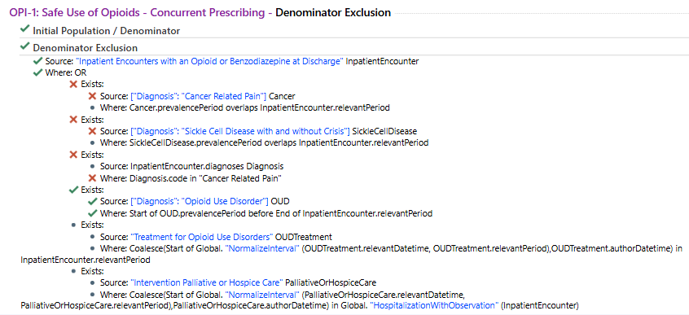
No order for Medication for Opioid Use Disorder (MOUD)
