CMS 1244 Logic Issues
Initial logic permits both numerator union "Boarded Time Greater Than 240 Minutes" and union "ED Length of Stay Greater Than 480 Minutes" pass when Boarded > 480 minutes. For a single encounter the desire is for only one part of the numerator to pass.
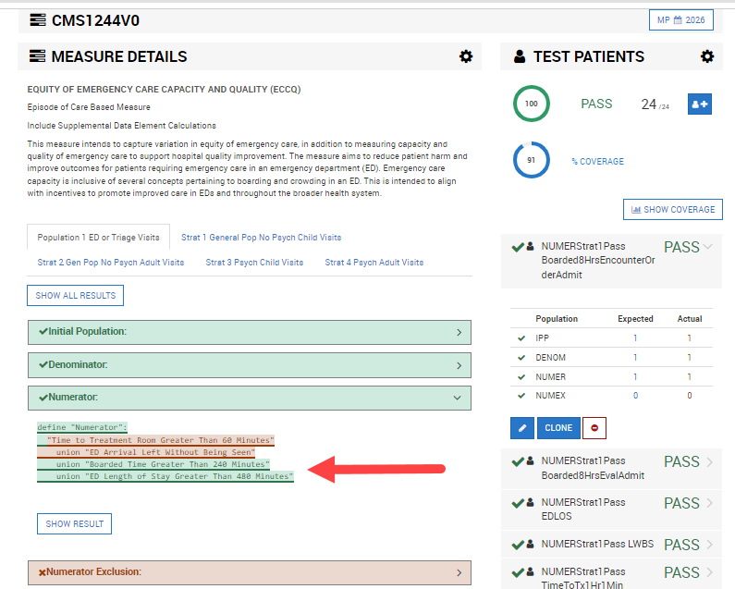

Revised the logic
define "Discharged from ED Encounter":
"Denominator" EDEncounter
without ["Encounter, Performed": "Encounter Inpatient"] Encounter
such that EDEncounter.relevantPeriod ends 1 hour or less before or on start of Encounter.relevantPeriod

define "ED Length of Stay Greater Than 480 Minutes":
"Discharged from ED Encounter" EDEncounter
where "EDArrivalTime"(EDEncounter) 481 minutes or more before "EDDepartureTime"(EDEncounter)
Which resulted in this –

