MADiE QDM v 5.6
CMS 1244 Equity of Emergency Care Capacity and Quality (ECCQ)
https://madie.cms.gov/measures/65e8dfcd8d4db20549cabc83/edit/test-cases/65f1f8cc80319060e1fd854b
- Missing Encounter Performed: “Encounter Inpatient” from the test case elements
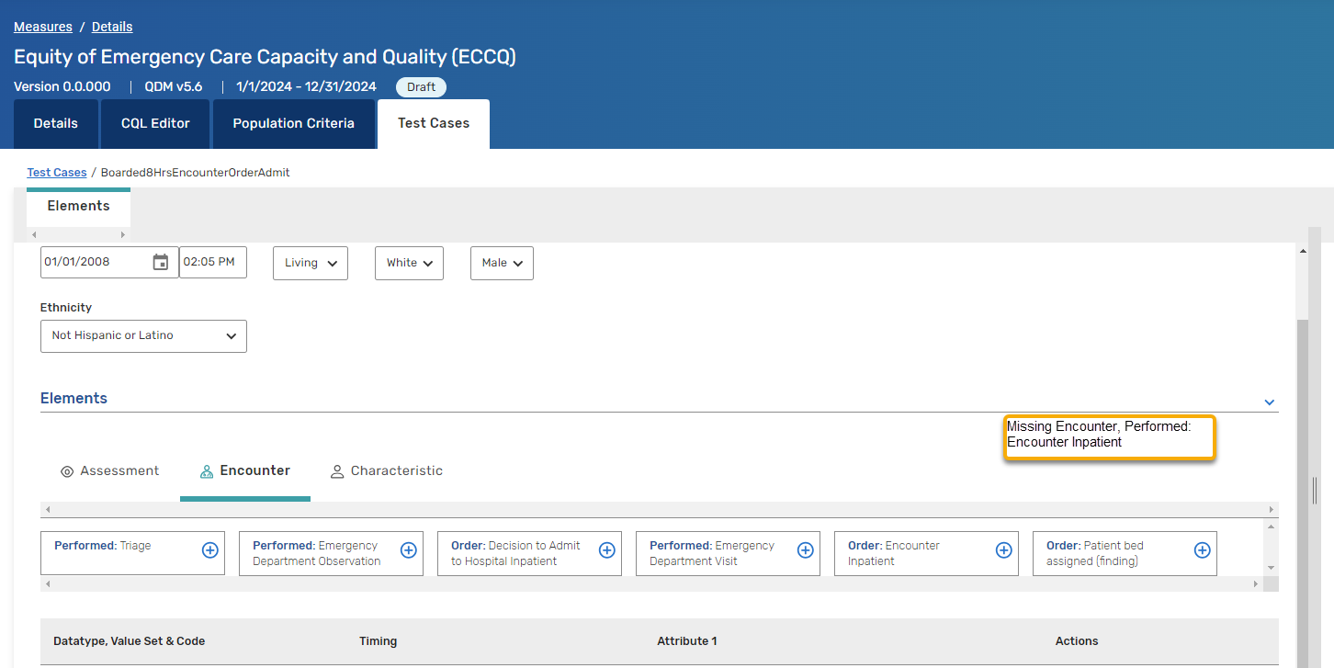
define function "HoldingInEDAfterAdmission"(EncounterInpatient "Encounter, Performed"):
Last(["Encounter, Performed": "Encounter Inpatient"] AdmittedInpatient
let LastEDVisit: "LastEDEncounter"(EncounterInpatient)
where start of AdmittedInpatient.relevantPeriod 241 minutes or more before "EDDepartureTime"(LastEDVisit)
sort by start of relevantPeriod
)
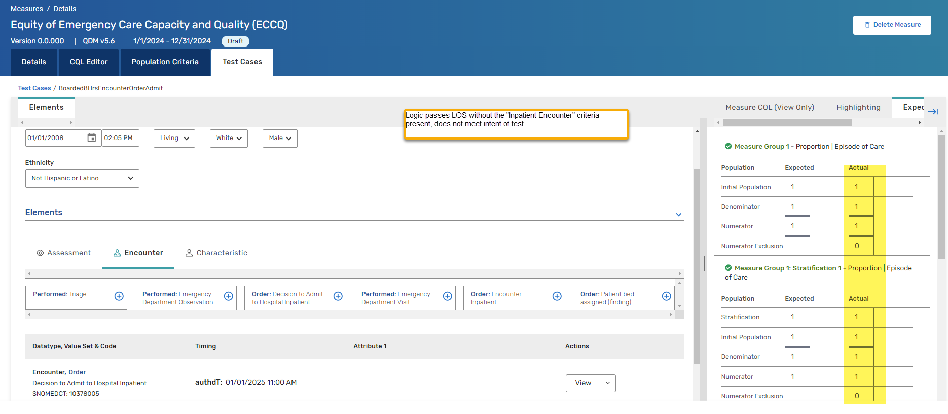

define "Order to Admit Inpatient or Bed Assignment":
Global."Inpatient Encounter" Inpatient
where "AdmitInpatientOrBedAssignmentEncounterOrder"(Inpatient).authorDatetime during "Measurement Period"

Second Test: NUMERStrat1Pass, LWBS
- Missing Discharge Disposition, terminology option (SNOMED CT) and code (SNOMEDCT: 21541000119102, left without being seen)

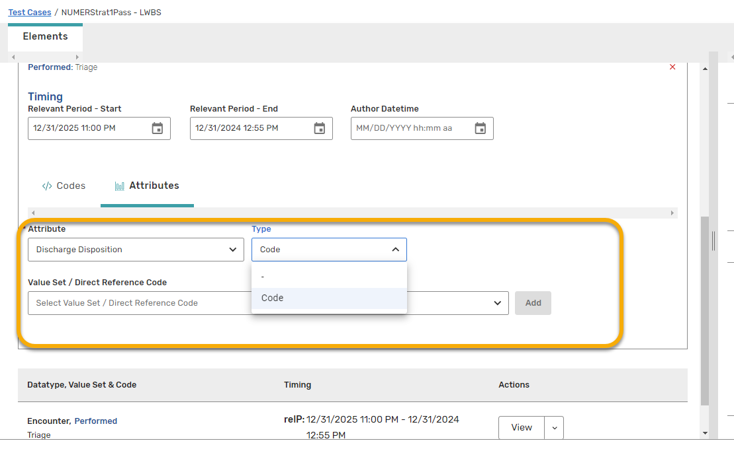

- Missing Measurement Period

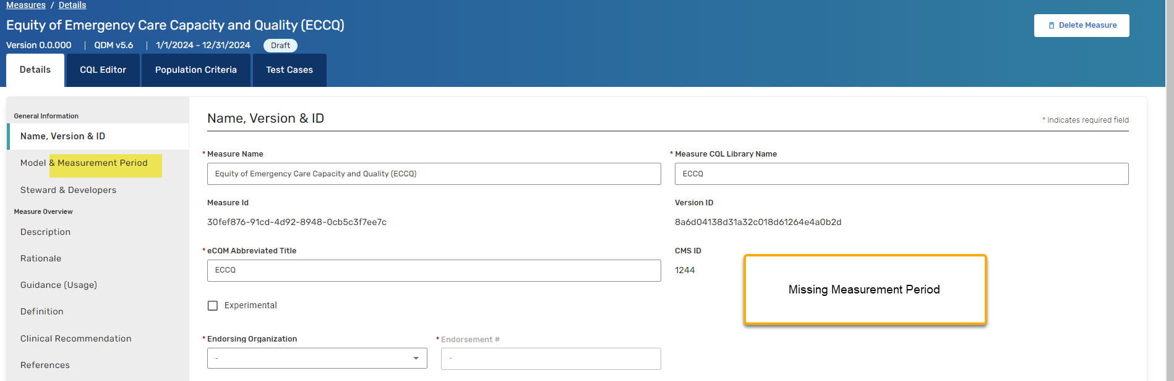

This literally changed before my eyes----
