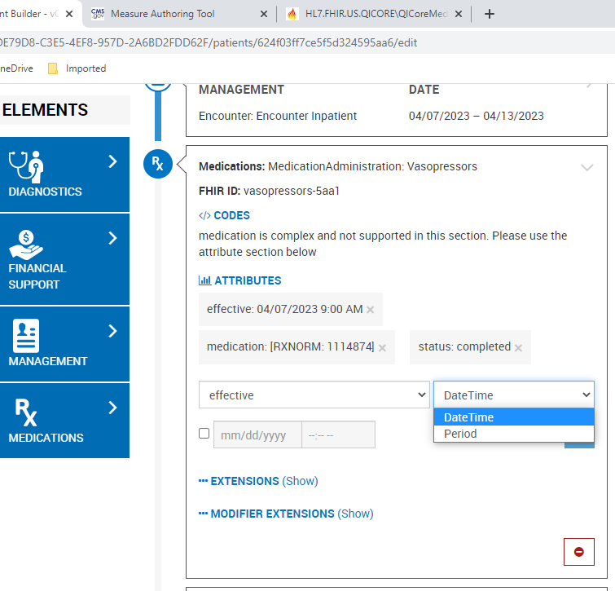
Bonnie FHIR supports the MedicationAdministration.effective DateTime and effective Period (see screenshot above), and aligns with the FHIR QI-Core R4 specification:
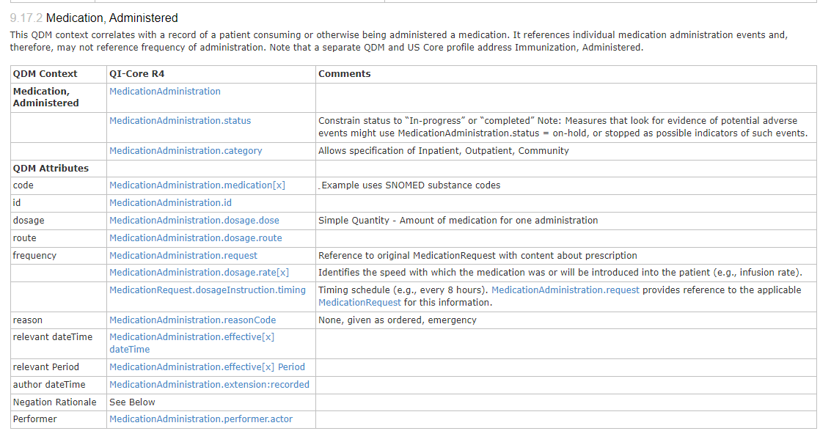
It does not appear MAT supports these timing elements. Below is a screenshot that shows the define statement that uses only the .effective attribute, without either the DateTime or Period timing element:
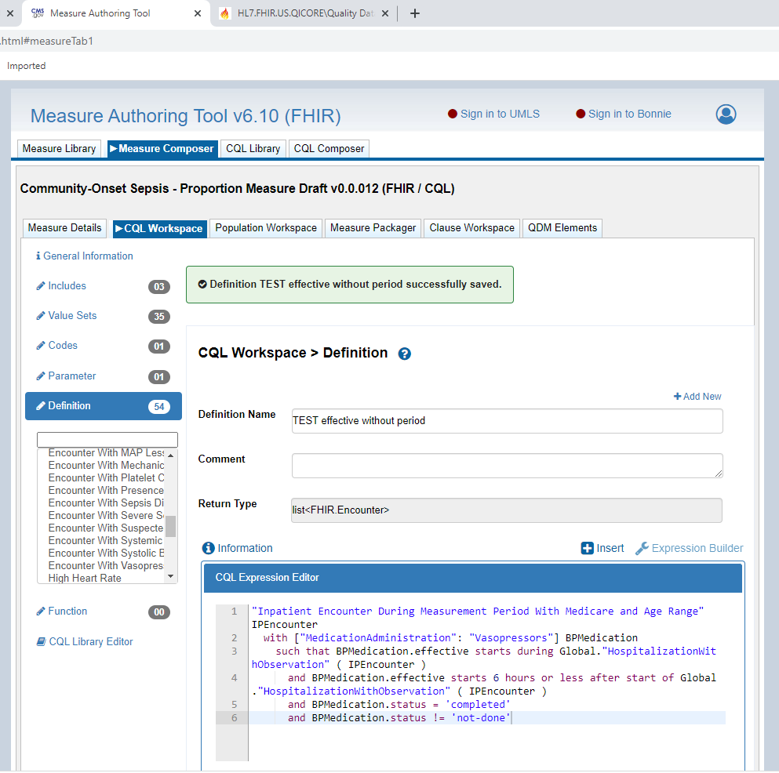
But when either timing element is added, it is not accepted in MAT. Here’s a screenshot when Period was added:
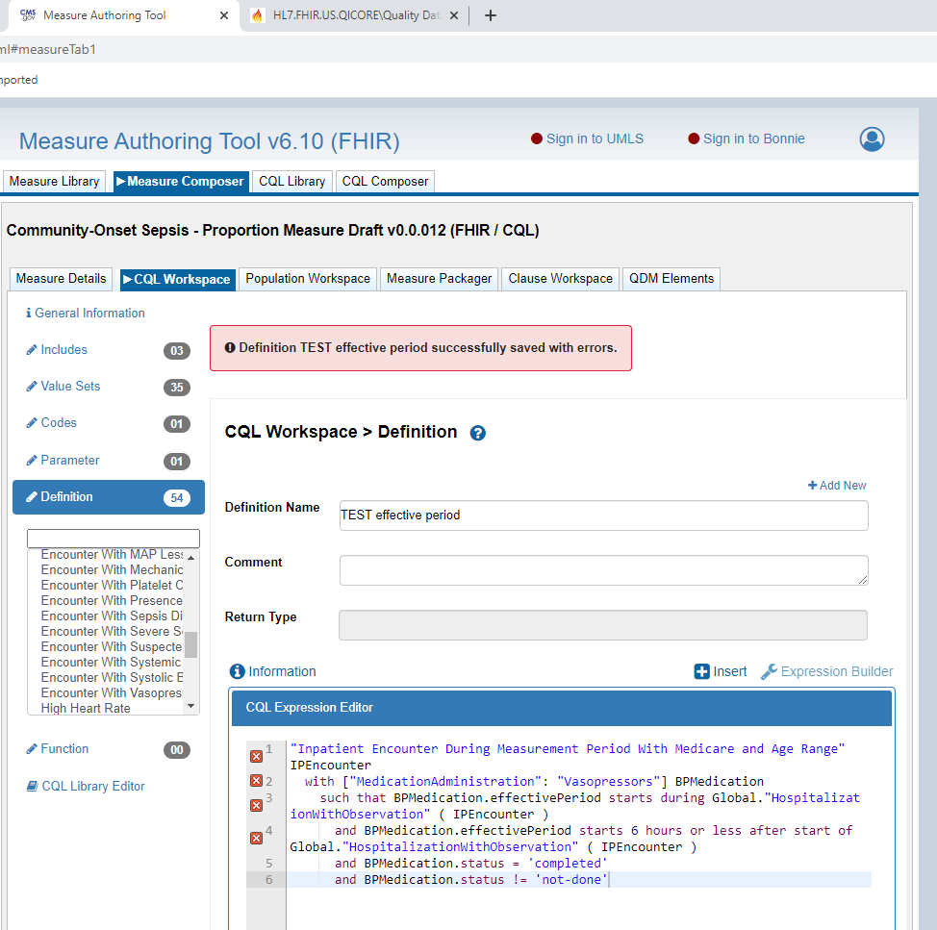
One of the errors displayed reads: “ERROR: Member Period not found for the type choice<FHIR.dateTime,FHIR.Period>.”
Is this a known misalignment between MAT and Bonnie, and if so, are there plans to resolve? Thank you.

