Hello,

I work for the Cerner Corporation and we are developing software to electronically calculate the Proportion of days covered for measure D-12 (Medication adherence to diabetes medications). My question is how do you calculate the PDC if the patient is on multiple anti-diabetic medications? Here is an example of a medication profile below.
EXAMPLE 1
- Is this patient’s PDC 100% or is it only counted on the days the patient had metformin, glipizide and sitagliptin? (30 days/180 days)
- Do you start counting on first fill during the study period (arrow) or do you look back to the last fill prior to that time period?
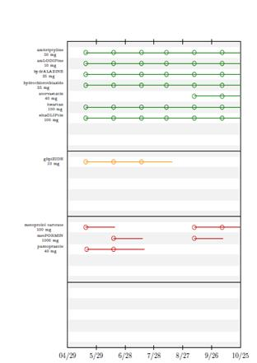

EXAMPLE 2
If you have a patient that is on Metformin, then switched to Metformin-sitagliptin and there is overlap (example 10 days)? Do you calculate it similar to the anti-hypertensive measures, where you assume the person finished the original metformin and push the 10 days of overlap out, like this example below:

(The study period is defined as January 1-30)
Metformin 15 days’ supply dispensed on 1/1
Metformin-sitagliptin 19 days’ supply dispensed on 1/6

- Is the PDC for anti-diabetic meds in this example calculated as 30/30 (100%) or 24/30 (80%)

