I have done the following steps to install Cypress……

- Downloaded and install VMware Workstation in Windows 7 64bit OS.
- Download and unzip “Cypress_v2.4.0_Public_VM”
- Click on “Open Virtual Machine” Link to import“Cypress_2.4.0_Public_VM.ovf” file.

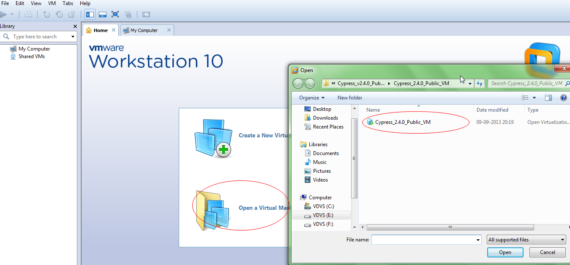

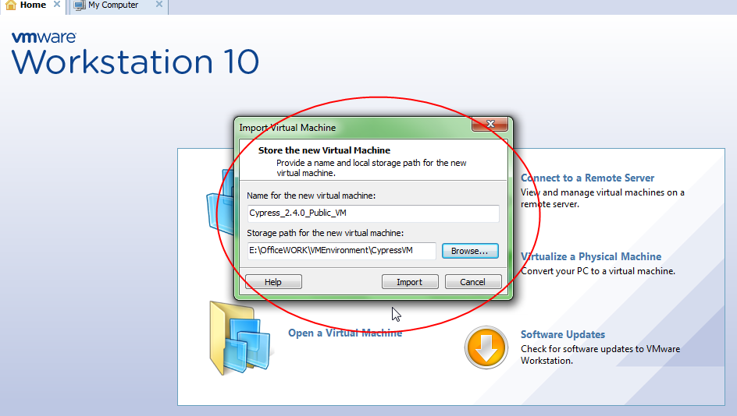

- If I click “Import” I receive the following error Message.

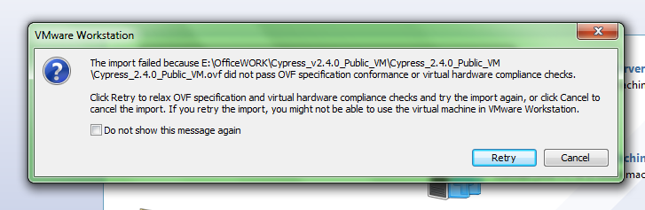

- If I Click “Retry”, then I receive the following Error Message

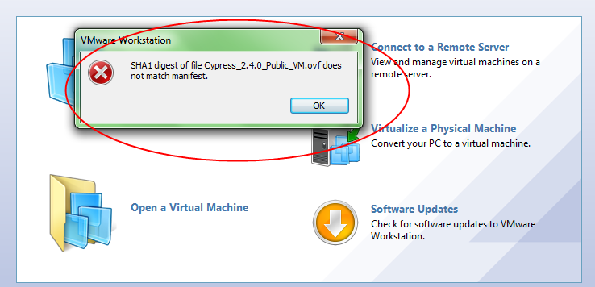

I tried the above steps for Work Station 10,9,8 versions Compatibility also. But I received the same error.
So I tried in different Way. Here the details…

- Set Work Station Compatible Version as 9 and Select option “Create a New Virtual Machine” and create the New Virtual Machine with the following way…
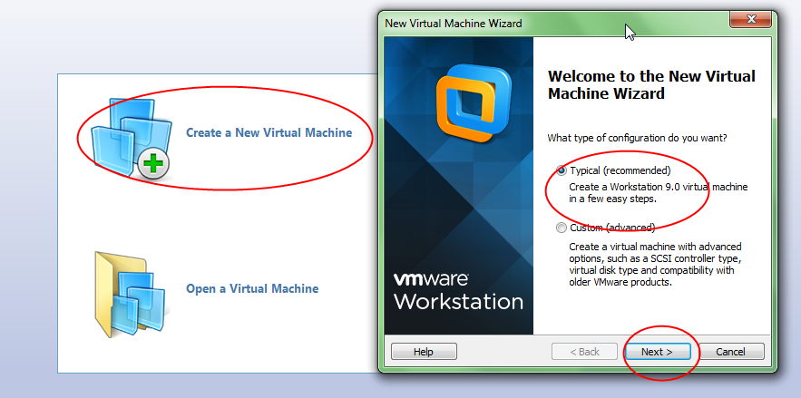

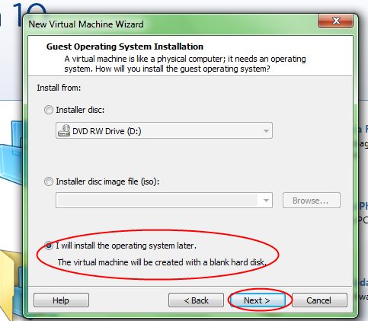

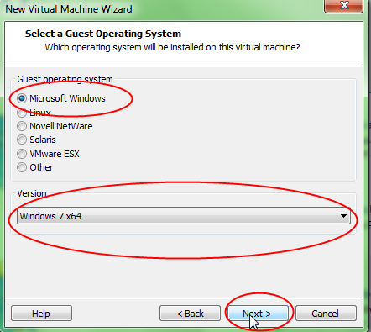

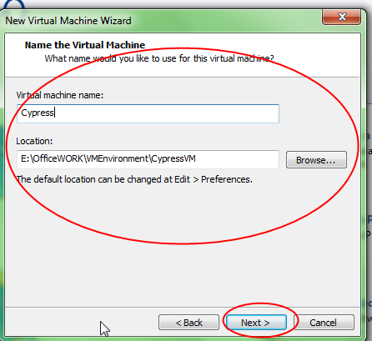

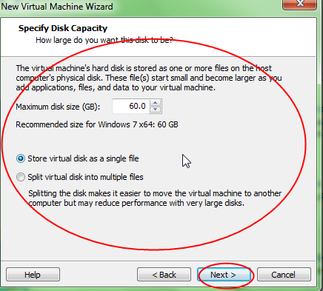

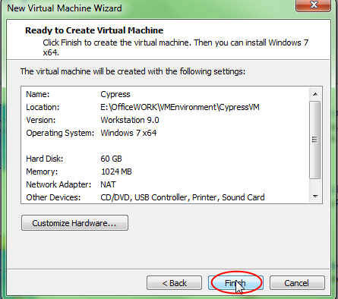

Next I Clicked on “Edit Virtual machine Settings”
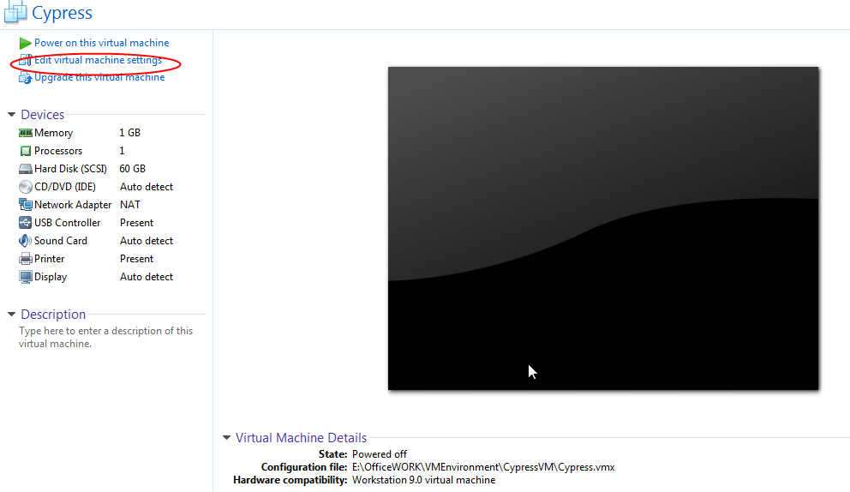

Upgraded Memory to 2GB (2048) as follows…
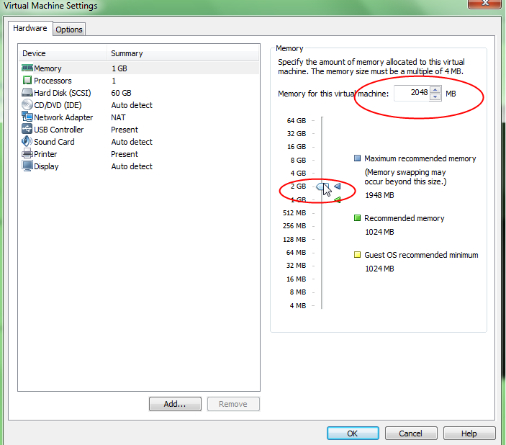

Changed “Processor” as below…
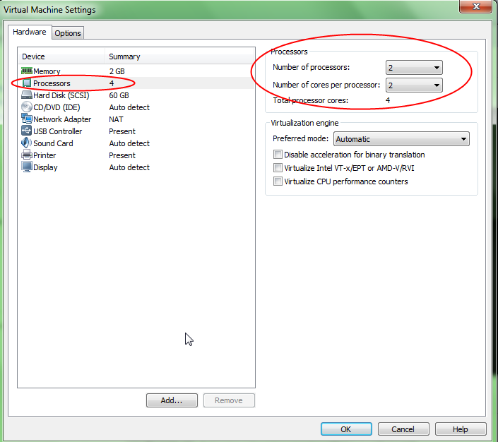

Now Attaching the downloaded and Unzipped Cypress file as below.

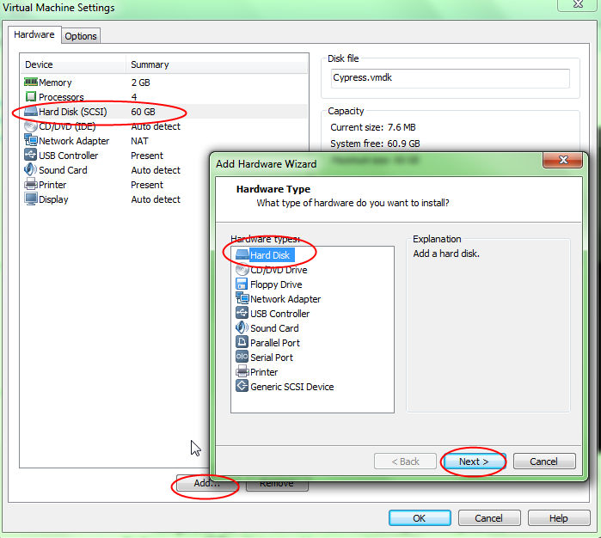

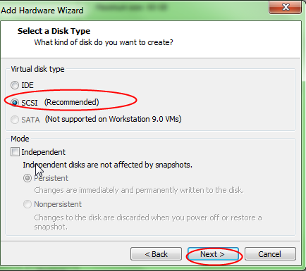

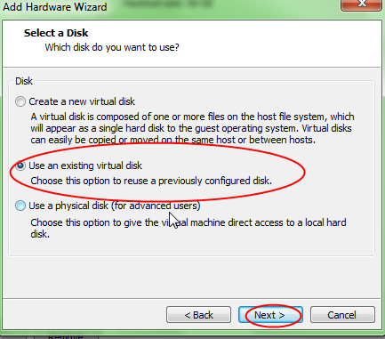

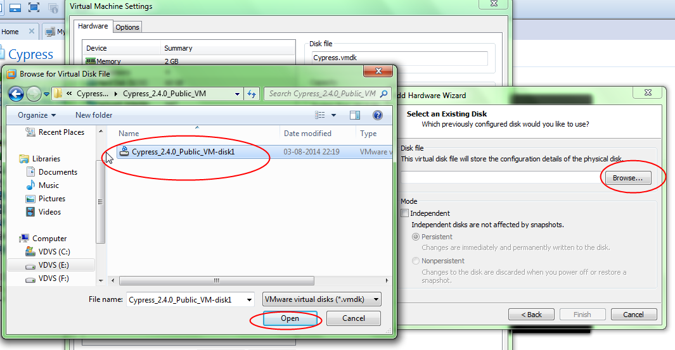

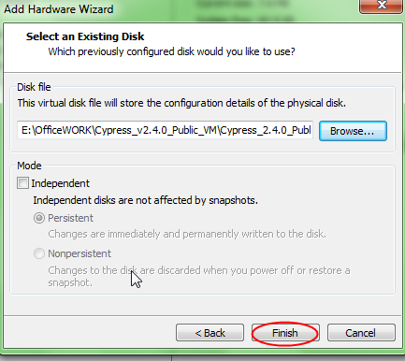

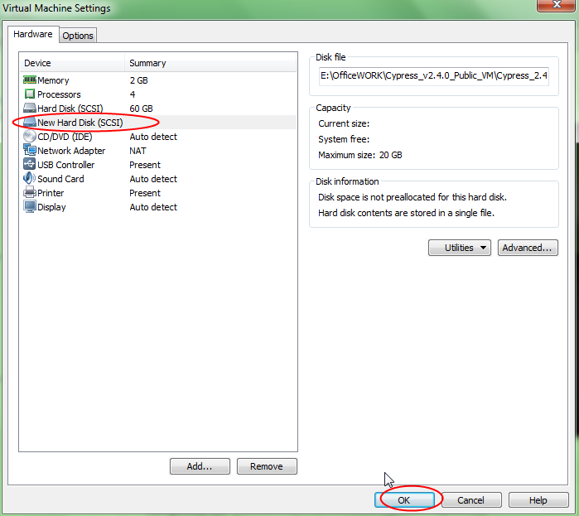

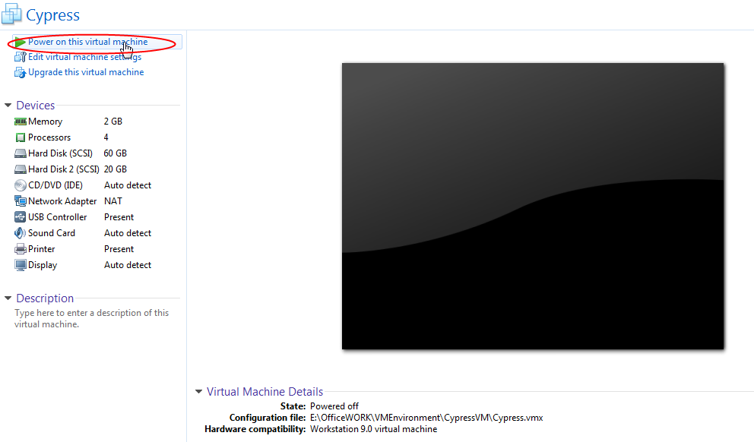

After done the above steps I receive the following error
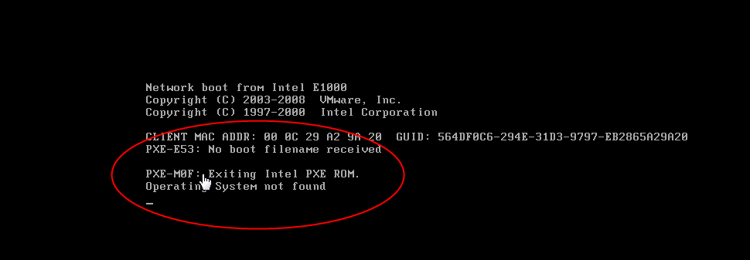

So I did the following changes…
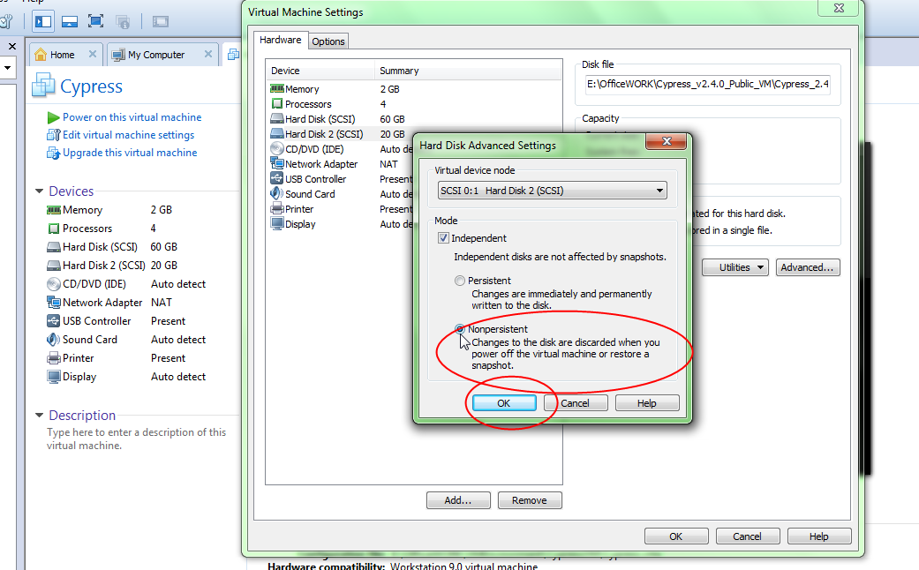

Removed 60GB created Hard Disk and set the above settings….

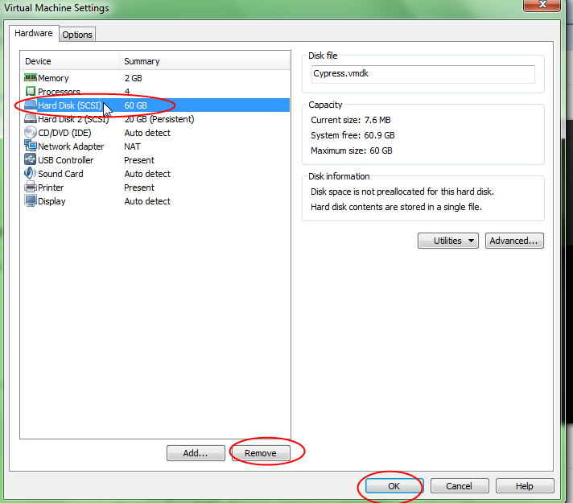

Now Click on “Power On Button” then the following screen shot displayed and I selected “Allowed All”…
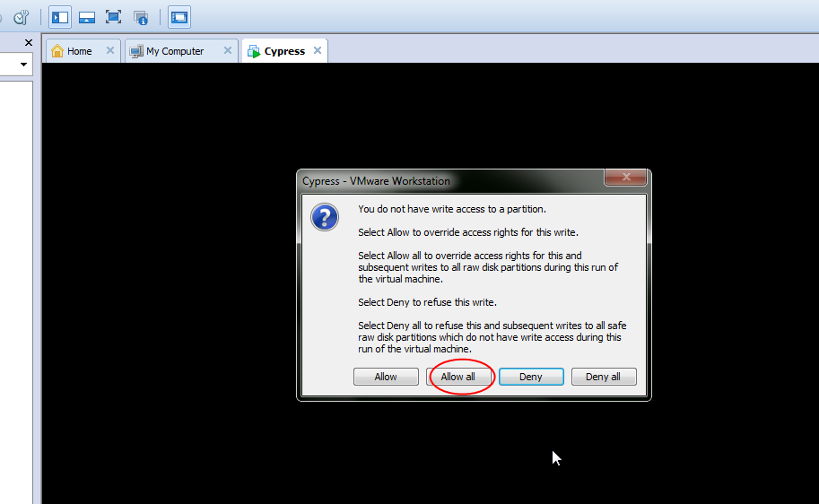

Then I receive the following…
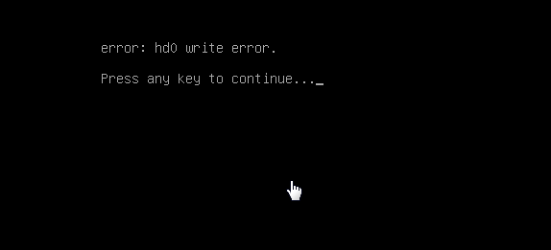

If I Selected Hard Disk Mode as “Independent” and “Non Persistant” then I was able to get login information as…

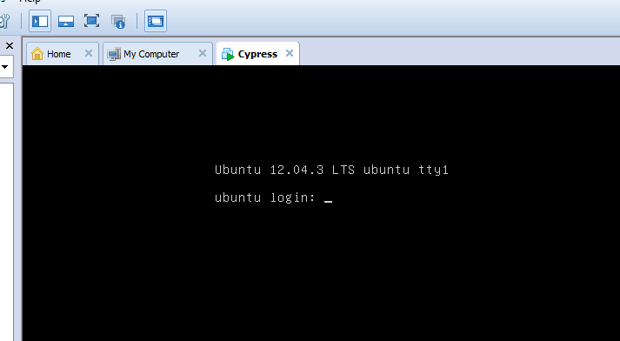

And After successful login execute the remaining as give given in the following Url:
https://github.com/projectcypress/cypress/wiki/Cypress-v2.4.0-Installation
And then upgraded with the following link
https://github.com/projectcypress/cypress/wiki/Cypress-v2.4.1-Installation-Upgrade-Instructions

But Once I shutdown the Virtual Machine then I lost total data because of selecting the option “Non Persistent”

Please help me how to install and access Patient Data in Cypress.

