The numerator criteria include inpatient where the patient is prescribed OR is continuing to take at discharge.
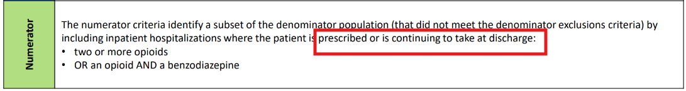
Timeline:
12/14/2025 15:58 OxyCODONE 5mg oral capsule (prescribed)
12/14/2025 15:58 Percocet 5mg-325 mg oral tablet (canceled/discontinued)
12/12/2025 13:11 Patient discharge Home
12/14/2025 10:59 Percocet 5mg-325 mg oral tablet (prescribed)
However, both Oxycodone & Percocet were included in the numerator

Most current Discharge Reconciliation 12/12/25 1558 - only 1 opioid (Oxycodone) prescribed. Percocet discontinued.
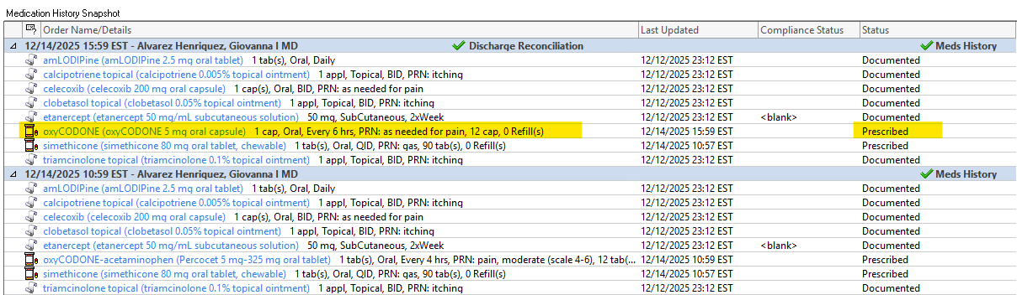

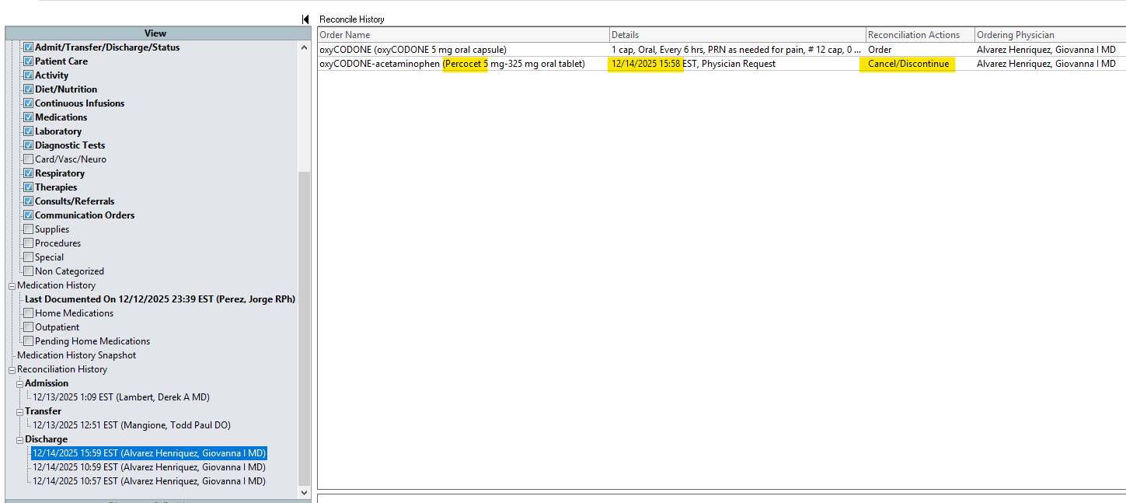

Looks like the report takes into consideration ANY AND ALL Reconciliation actions - this patient had 3 discharge medication reconciliation completed.

And in two of them 12/14/25 1059 - the provider included the orders (duplicate)
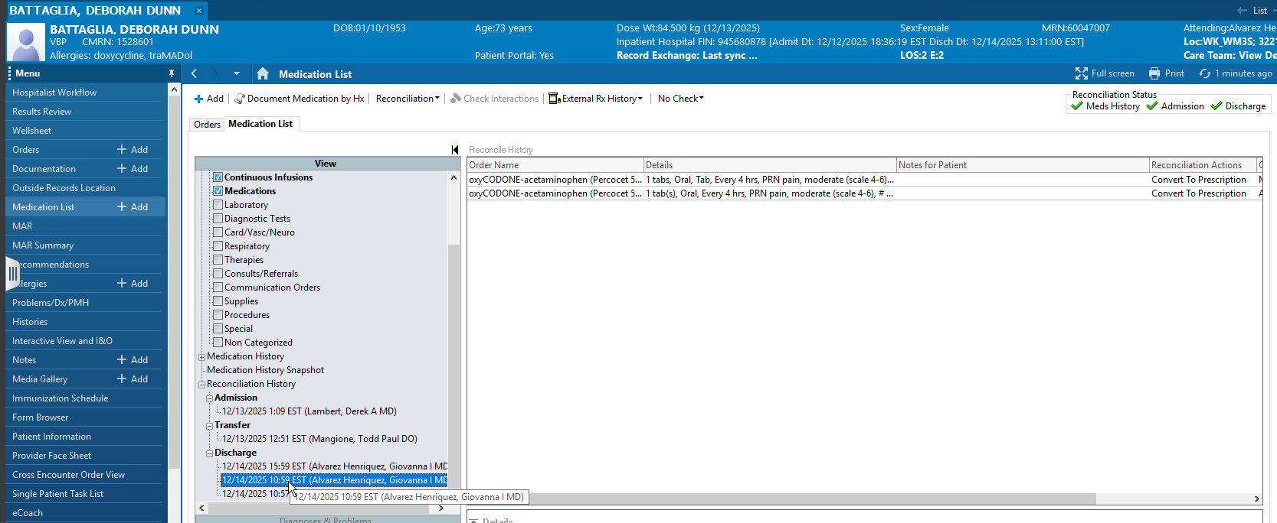

Solution: The logic should select only the most current or most recently completed discharge reconciliation, rather than ALL reconciliations, because the latest prescribed discharge reconciliation is the one sent to the pharmacy for the patient to continue at home

